

**Quizlet project**

**Final Release Document**

– Hanoi, Jul 2022 –

**Table of Contents**

I. Deliverable Package 8

II. Installation Guides 8

*1.* Step 1: Open gitlab int this link and click download source code of project 8

*2.* Step 2: Unzip the file and save in a storage 9

*3.* Step 3: Open Apache Netbeans to open a project 9

*5.* Step 5: Open The script SWP-Project.sql And run it on Microsoft SQL server (you must install Microsoft SQL Server to run) 11

*6.* Step 6: Click run project or you can click on green rectangle on top. 12

*7.* Step 7: After running you the website will display on local web. Now you can use the local web and test all function of website. 13

III. User Manual 14

1.Overview 14

*Quizlet is an online learning platform that offers a variety of study tools and resources for students and educators. It enables users to create their own interactive flashcards, study guides, and quizzes, or access ones that have been created by others. Quizlet features a vast library of study materials, including over 400 million user-generated flashcard sets, for a wide range of subjects, from languages and science to history and math. Additionally, Quizlet offers various study modes, such as Learn, Match, Test, and Gravity, which help users to master their material in different ways.* 14

2.Work flow 14

1. Register 14

a. Class Diagram 14

b. Class Specifications 15

c. Sequence Diagram(s) 16

d. Database Queries 16

2. Login 17

a. Class Diagram 17

b. Class Specifications 18

User Class 18

c. Sequence Diagram(s) 19

d. Database Queries 20

*select * from [User]* 20

3. Logout 20

a. Class Diagram 20

b. Class Specifications 20

User Class 20

c. Sequence Diagram(s) 21

d. Database Queries 21

4. Search study sets by name 22

a. Class Diagram 22

b. Class Specifications 23

c. Sequence Diagram(s) 23

d. Database Queries 24

*Select * from StudySet* 24

5. Verify code 24

a. Class Diagram 24

b. Class Specifications 25

User Class 25

c. Sequence Diagram(s) 26

d. Database Queries 26

6. FlashCard 27

a. Class Diagram 27

b. Class Specifications 27

User Class 27

Card Class 28

c. Sequence Diagram(s) 29

d. Database Queries 29

7.Create StudySet 30

a. Class Diagram 31

b. Class Specifications 31

User Class 31

Card Class 33

c. Sequence Diagram(s) 33

d. Database Queries 33

8.Delete StudySet 34

a. Class Diagram 34

b. Class Specifications 35

User Class 35

Card Class 36

c. Sequence Diagram(s) 36

d. Database Queries 37

9.Add Studied Cards 38

a. Class Diagram 38

b. Class Specifications 39

User Class 39

Card Class 40

c. Sequence Diagram(s) 40

d. Database Queries 40

10.Forget password 41

a. Class Diagram 42

b. Class Specifications 43

User Class 43

c. Sequence Diagram(s) 44

d. Database Queries 44

11.Change password 45

a. Class Diagram 45

b. Class Specifications 46

User Class 46

c. Sequence Diagram(s) 47

d. Database Queries 47

12.Update studyset 47

a. Class Diagram 47

b. Class Specifications 48

User Class 48

Card Class 49

c. Sequence Diagram(s) 49

d. Database Queries 50

13.Home 51

a. Class Diagram 51

b. Class Specifications 52

User Class 52

Folder Class 53

Class Class 53

c. Sequence Diagram(s) 54

d. Database Queries 54

14.Class set 55

a. Class Diagram 56

b. Class Specifications 56

User Class 56

Class Class 58

c. Sequence Diagram(s) 58

d. Database Queries 58

15.Folder set 59

a. Class Diagram 59

b. Class Specifications 60

User Class 60

Folder Class 61

c. Sequence Diagram(s) 62

d. Database Queries 62

16.Study set list 62

a. Class Diagram 62

b. Class Specifications 63

User Class 63

Folder Class 64

Class Class 64

Card Class 65

c. Sequence Diagram(s) 65

d. Database Queries 66

17.Controller folder set 67

a. Class Diagram 68

b. Class Specifications 68

User Class 68

Folder Class 69

c. Sequence Diagram(s) 70

d. Database Queries 70

18.Controller class set 71

a. Class Diagram 72

b. Class Specifications 72

User Class 72

Class Class 73

c. Sequence Diagram(s) 74

d. Database Queries 74

19. Create class 75

a. Class Diagram 76

b. Class Specifications 77

User Class 77

Class Class 78

c. Sequence Diagram(s) 79

d. Database Queries 79

20. Create folder 80

a. Class Diagram 81

b. Class Specifications 82

User Class 82

Folder Class 83

c. Sequence Diagram(s) 83

d. Database Queries 84

21. Reset studied Cards 84

a. Class Diagram 84

b. Class Specifications 85

User Class 85

Card Class 86

c. Sequence Diagram(s) 86

d. Database Queries 87

22. Send email 87

a. Class Diagram 87

b. Class Specifications 88

User Class 88

c. Sequence Diagram(s) 89

d. Database Queries 90

23. Study 90

a. Class Diagram 90

b. Class Specifications 91

User Class 91

Card Class 92

c. Sequence Diagram(s) 92

d. Database Queries 93

23. Study 94

a. Class Diagram 94

b. Class Specifications 95

User Class 95

Card Class 96

c. Sequence Diagram(s) 96

d. Database Queries 97

24. Test 98

a. Class Diagram 98

b. Class Specifications 99

User Class 99

Card Class 100

c. Sequence Diagram(s) 100

d. Database Queries 101

# Deliverable Package

| **No.** | **File** | **Notes** |
| --- | --- | --- |
| 1 | Quizlet.sql | Database, including both table structures and table data |
| 2 | SWP391_Group1_Se1642_SRS.docx | Final SRS (Requirement) Document |
| 3 | SWP391_Group1_Se1642_SDS Document.docx | Final SDS (Design) Document |
| 4 | SWP391_Group1_Se1642_Project Tracking.xlsx | Final status for the application functions, which include:  - Function name, feature, roles, function description (changes compared to the original requirements are highlighted)  - In Charge, Planned iteration & Actual iteration  - Final status & note on the update you made  - The links to the SRS & SDS are tracked |
| 5 | SWP391_Group1_Se1642_IssuesReport.xlsx | Final issues tracking list of the whole project |

Other related deliverables:

* Tagged source codes: <https://gitlab.com/hungbmhe161538/projectswp.git>

# Installation Guides

1. Step 1: Open gitlab int this link and click download source code of project

Link: <https://gitlab.com/hungbmhe161538/projectswp.git>

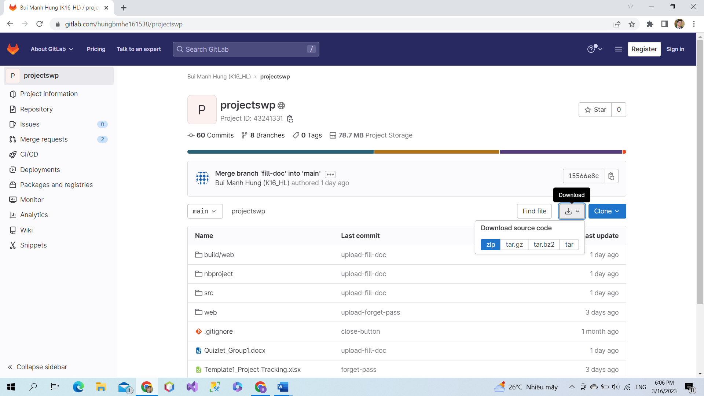

1. Step 2: Unzip the file and save in a storage

*Right click in file zip, choose extract file to unzip.*

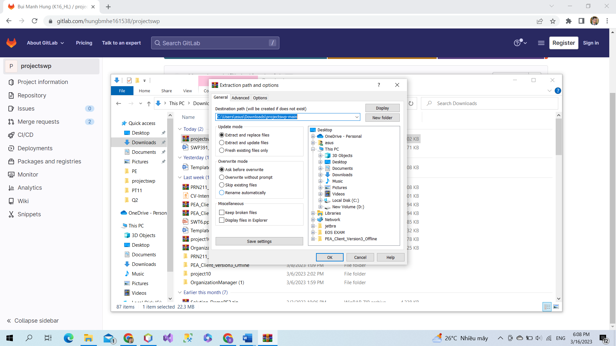

1. Step 3: Open Apache Netbeans to open a project



1. Step 4: Select “file” at the top left of the screen. Then choose “Open project” then select the project you saved in the folder before. And click Open Project.

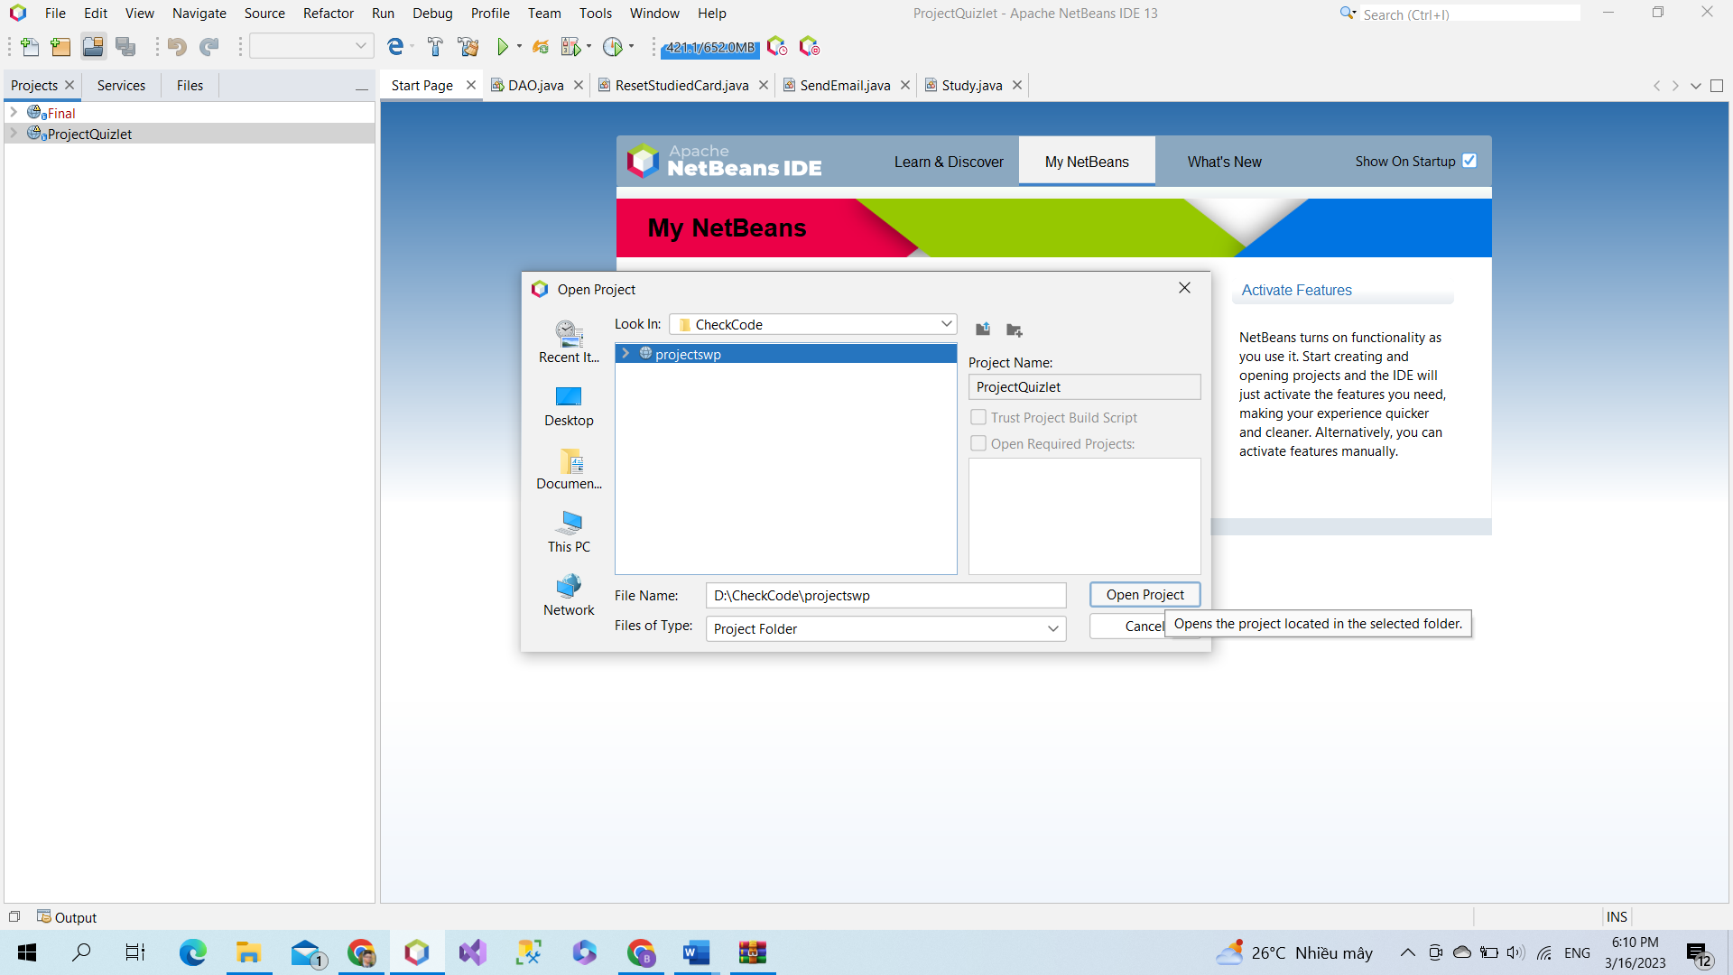

1. Step 5: Open The script SWP-Project.sql And run it on Microsoft SQL server (you must install Microsoft SQL Server to run)

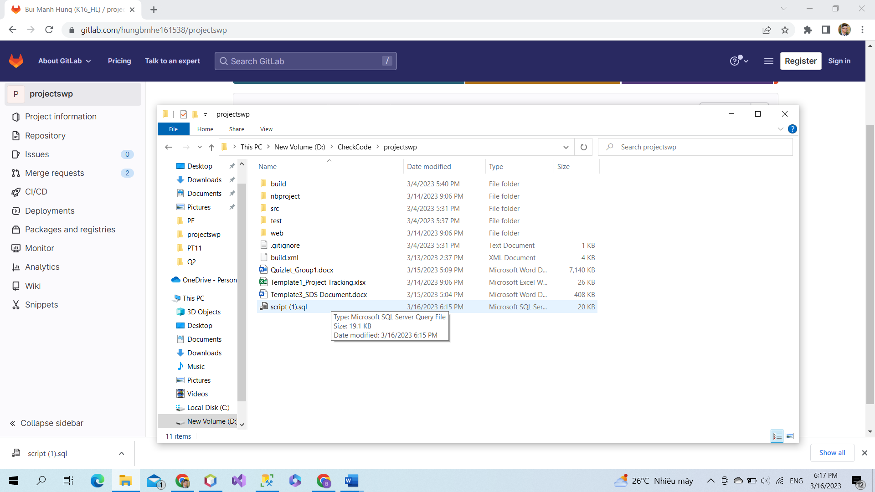

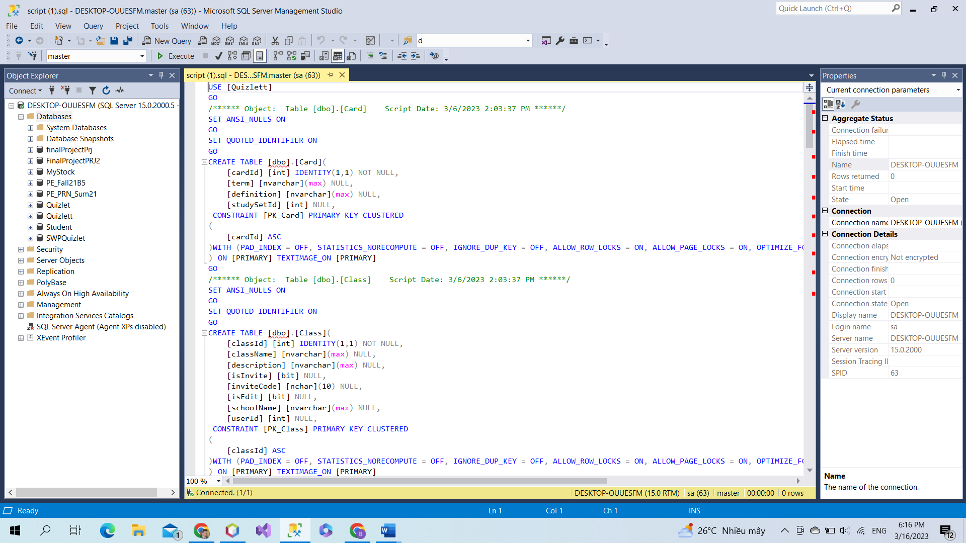

1. Step 6: Click run project or you can click on green rectangle on top.

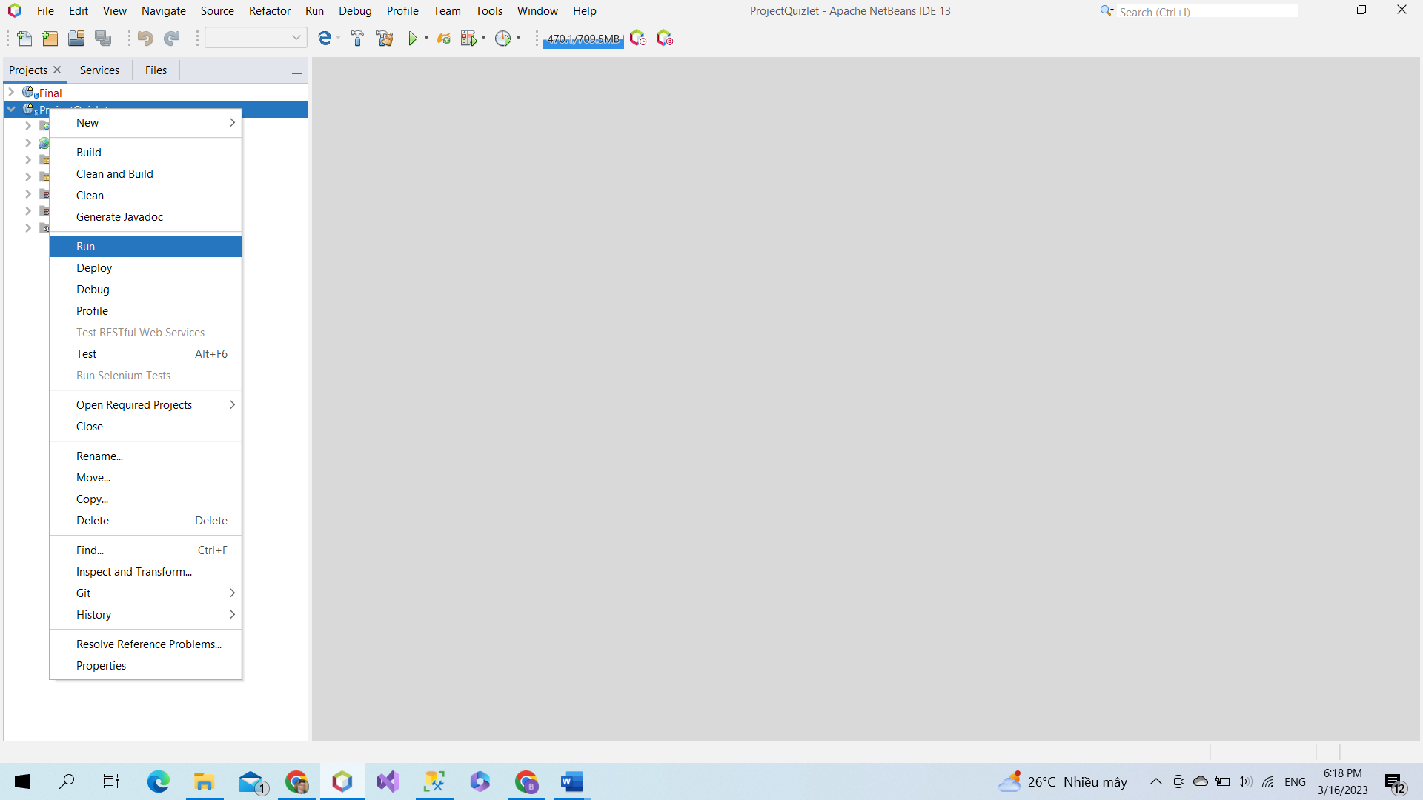

1. Step 7: After running you the website will display on local web. Now you can use the local web and test all function of website.

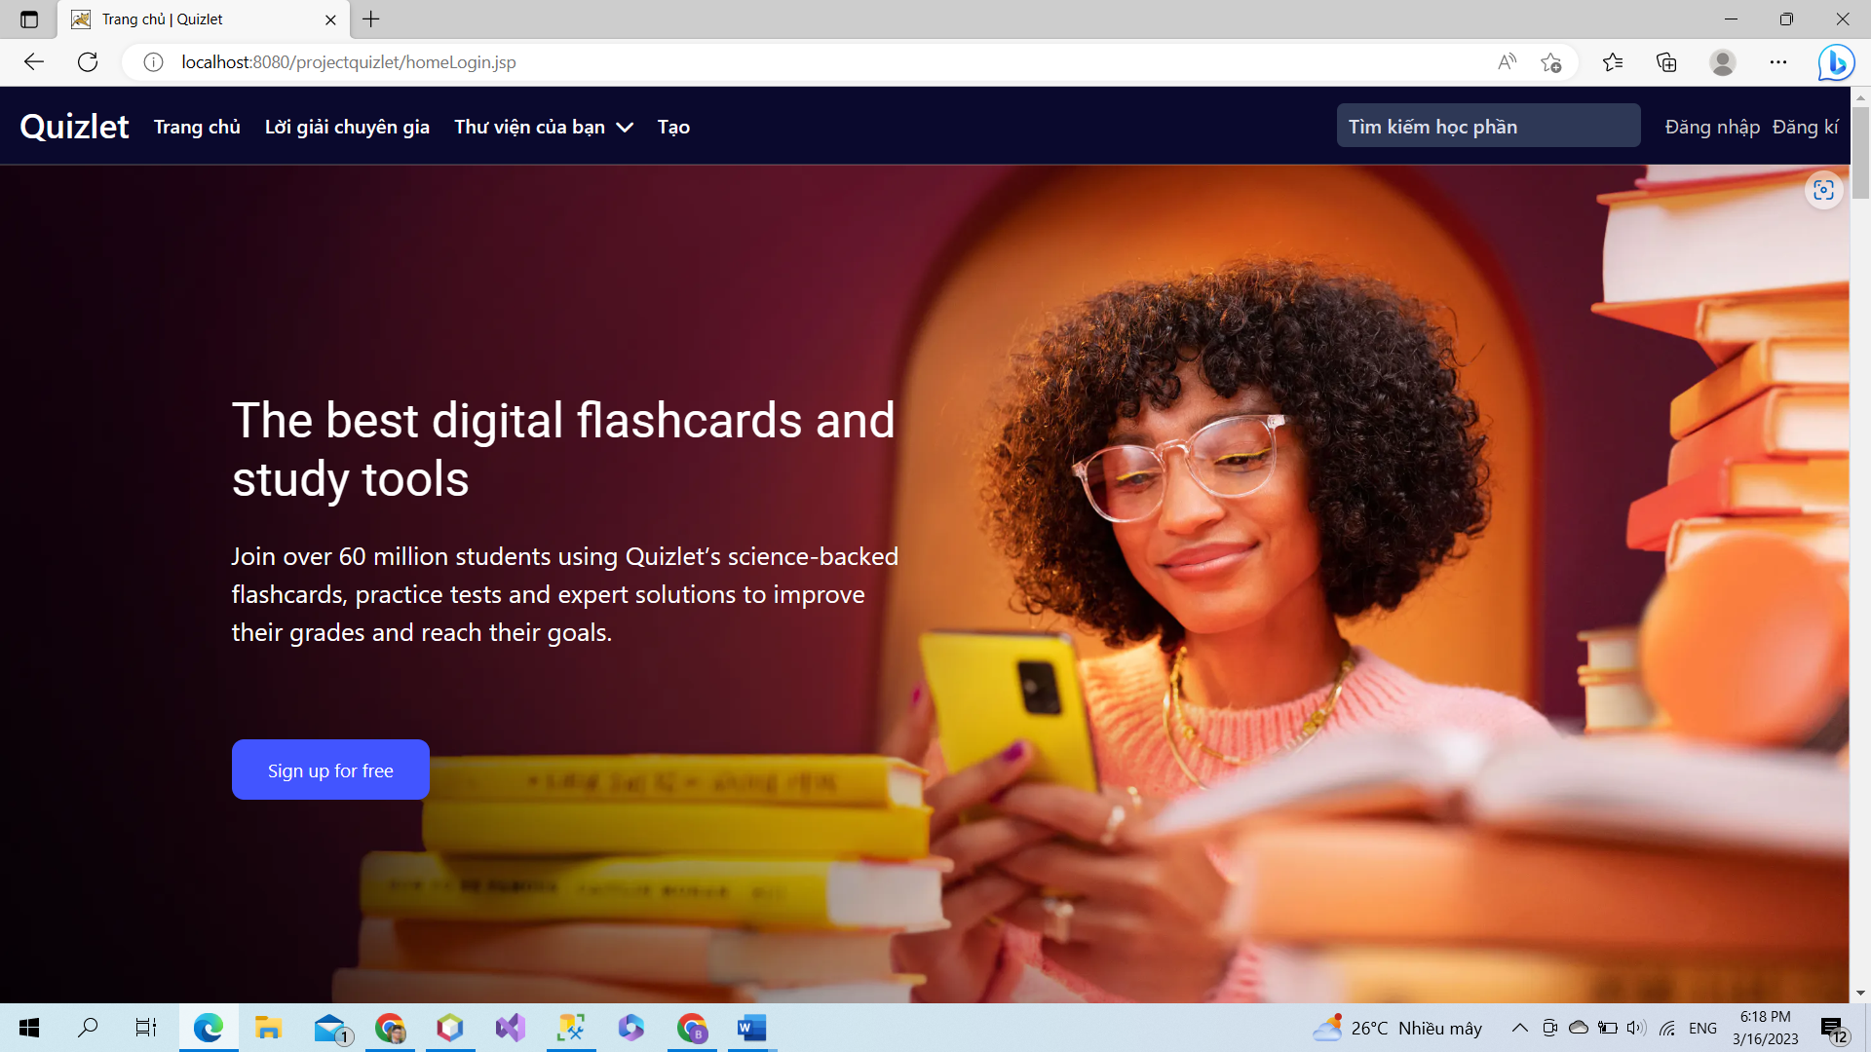

# User Manual

## 1.Overview

## *Quizlet is an online learning platform that offers a variety of study tools and resources for students and educators. It enables users to create their own interactive flashcards, study guides, and quizzes, or access ones that have been created by others. Quizlet features a vast library of study materials, including over 400 million user-generated flashcard sets, for a wide range of subjects, from languages and science to history and math. Additionally, Quizlet offers various study modes, such as Learn, Match, Test, and Gravity, which help users to master their material in different ways.*

## 

## 2.Work flow

## 1. Register

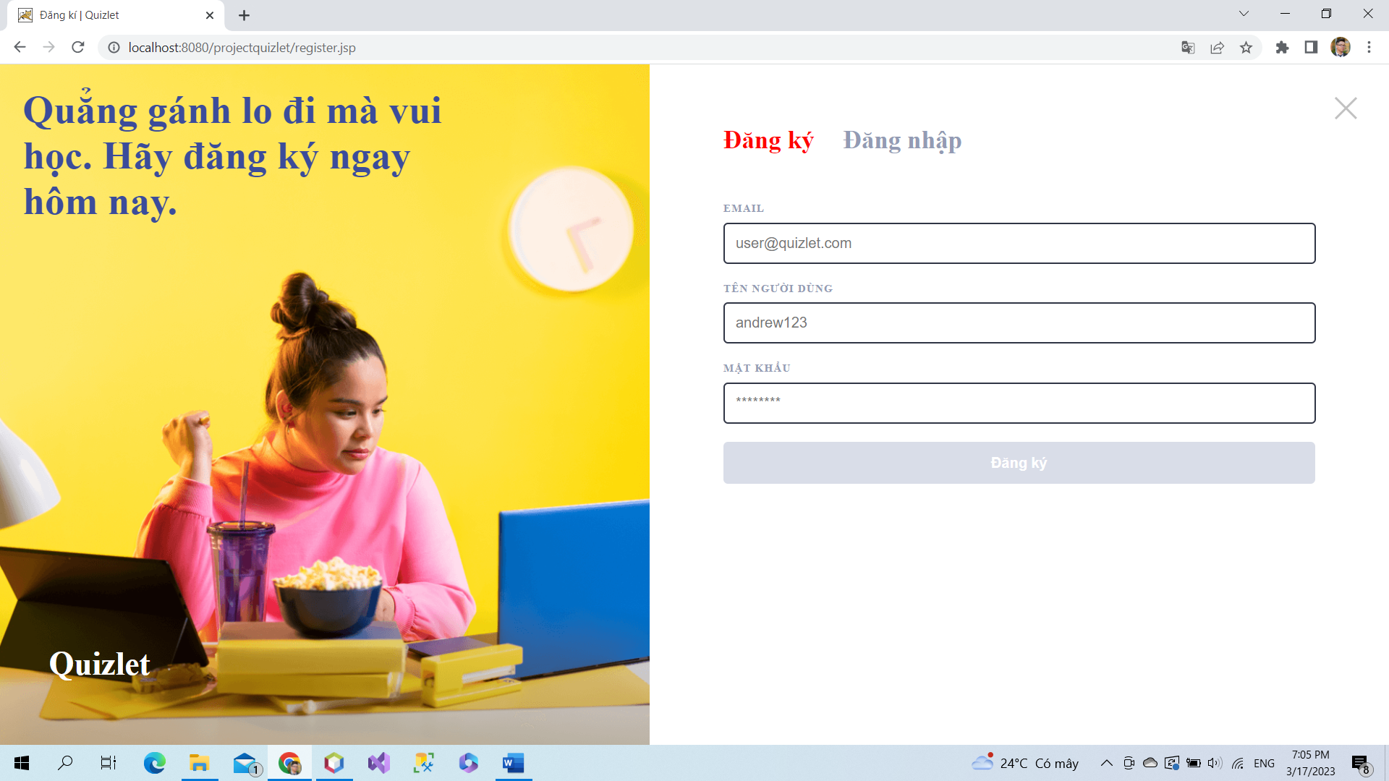

To register an account, user must input email, username and password. Note: your input must be valid. Email: [example1@gmail.com](mailto:example1@gmail.com), length of username and password must be > 4 and < 12. User can not use existed email to register.

### a. Class Diagram

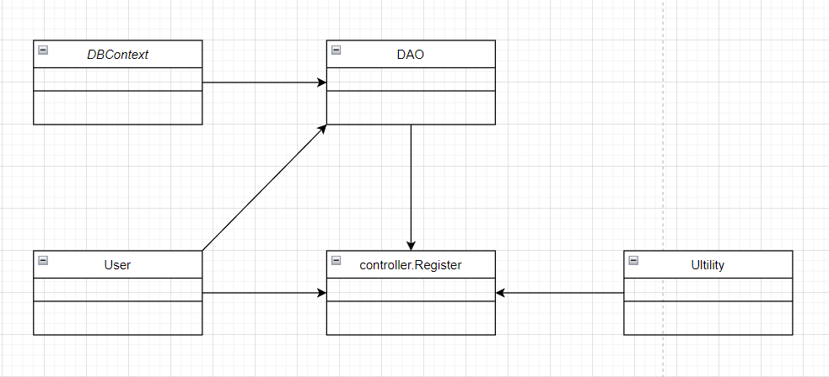

### b. Class Specifications

#### User Class

|  |  |  |
| --- | --- | --- |
| **No** | **Method** | **Description** |
| *01* | *User(){}* | Default constructor |
| *02* | *User(….){}* | *Parameterized constructor* |
| *03* | *getName(){}* | *Getter of Name* |
| *04* | *setName(string name){}* | *Setter of Name* |
| *05* | *getPass(){}* | *Getter of Pass* |
| *06* | *setPass(string pass){}* | *Setter of Pass* |
| *07* | *getEmail(){}* | *Getter email* |
| *08* | *setEmail(string email){}* | *Setter of email* |
| *09* | *isIsActive(){}* | *Getter of isActive* |
| *10* | *setIsActive(Boolean isActive){}* | *Setter of isActive* |
| *11* | *getAvatar(){}* | *Getter of avatar* |
| *12* | *setAvatar(string avatar)* | *Setter of avatar* |
| *13* | *getLanguage(){}* | *Getter of language* |
| *14* | *setLanguage(string language){}* | *Setter of language* |

#### Ultilities Class

***Class Methods***

|  |  |  |
| --- | --- | --- |
| **No** | **Method** | **Description** |
| *01* | *isBlank(string u){}* | *Check string is blank* |
| *02* | *checkExistEmail(string email){}* | *Check existed email* |
| *03* | *ValidInputRequire(string e, string p, string u){}* | *Check valid input* |
| *04* | *validEmail(string e){}* | *Check valid email* |
| *05* | *validUsername(string u){}* | *Check valid username* |
| *06* | *validPassword(string p){}* | *Check valid password* |

#### DAO Class

***Class Methods***

|  |  |  |
| --- | --- | --- |
| **No** | **Method** | **Description** |
| *01* | *register(user u){}* | *Insert new user to database* |
|  |  |  |

#### Register Controller Class

***Class Methods***

*[Provide the detailed description for the class methods]*

|  |  |  |
| --- | --- | --- |
| **No** | **Method** | **Description** |
| *01* | *Doget()* | *Sendredirect to register.jsp* |
| *02* | *doPost()* | *Check input and register* |

#### DBContext Class

***Class Methods***

*[Provide the detailed description for the class methods]*

|  |  |  |
| --- | --- | --- |
| **No** | **Method** | **Description** |
| *01* | *DBContext(){}* | *Connect to database* |

### c. Sequence Diagram(s)

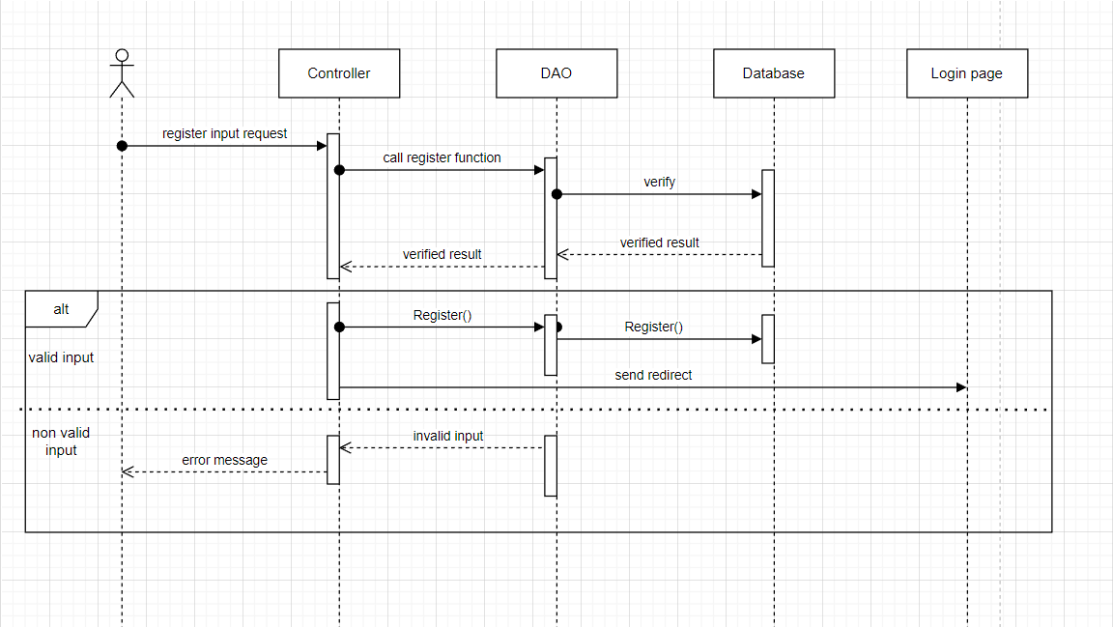

### d. Database Queries

*String sql = "INSERT INTO [dbo].[User]\n"*

*+ " ([name]\n"*

*+ " ,[password]\n"*

*+ " ,[gmail]\n"*

*+ " ,[isActive]\n"*

*+ " ,[avatar]\n"*

*+ " ,[language])\n"*

*+ " VALUES (?, ?, ?, ?, ?, ?)";*

## 2. Login

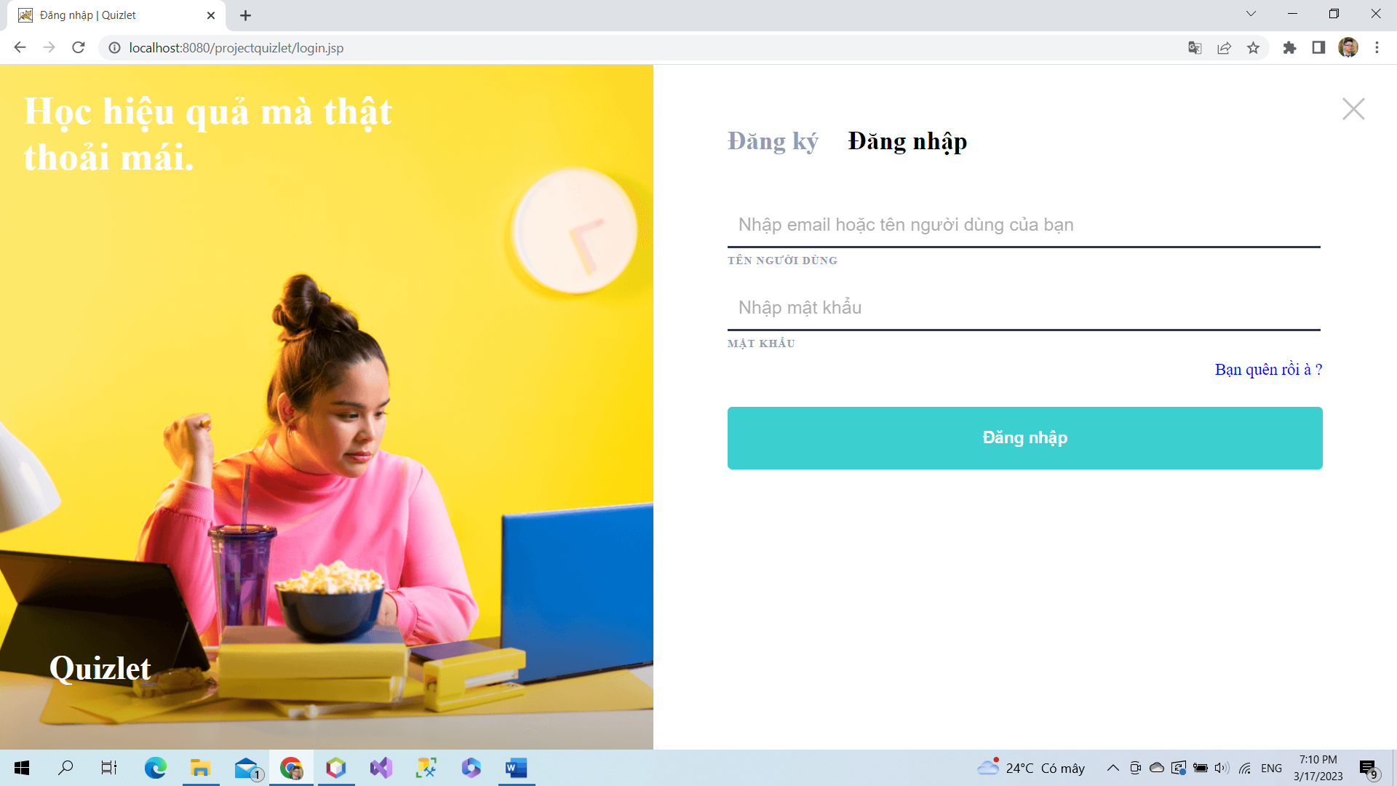

To login, users must have an existed account. If users did not have it, they can register. Note: Users must input correctly email and password to login.

### a. Class Diagram

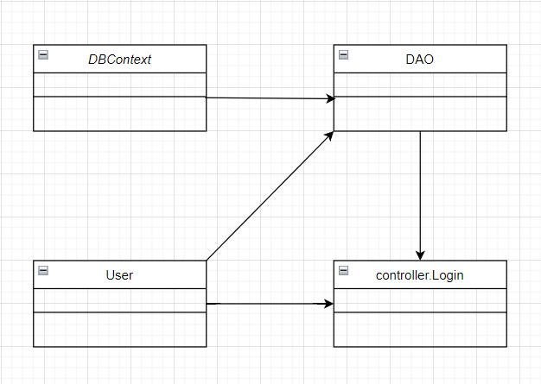

### b. Class Specifications

### User Class

|  |  |  |
| --- | --- | --- |
| **No** | **Method** | **Description** |
| *01* | *User(){}* | Default constructor |
| *02* | *User(….){}* | *Parameterized constructor* |
| *03* | *getName(){}* | *Getter of Name* |
| *04* | *setName(string name){}* | *Setter of Name* |
| *05* | *getPass(){}* | *Getter of Pass* |
| *06* | *setPass(string pass){}* | *Setter of Pass* |
| *07* | *getEmail(){}* | *Getter email* |
| *08* | *setEmail(string email){}* | *Setter of email* |
| *09* | *isIsActive(){}* | *Getter of isActive* |
| *10* | *setIsActive(Boolean isActive){}* | *Setter of isActive* |
| *11* | *getAvatar(){}* | *Getter of avatar* |
| *12* | *setAvatar(string avatar)* | *Setter of avatar* |
| *13* | *getLanguage(){}* | *Getter of language* |
| *14* | *setLanguage(string language){}* | *Setter of language* |

#### DBContext Class

|  |  |  |
| --- | --- | --- |
| **No** | **Method** | **Description** |
| *01* | *DBContext(){}* | *Connect to database* |

#### Register Controller Class

|  |  |  |
| --- | --- | --- |
| **No** | **Method** | **Description** |
| *01* | *Doget()* | *Get session and Send redirect to login.jsp* |
| *02* | *doPost()* | *Check input and login* |

#### DAO Class

|  |  |  |
| --- | --- | --- |
| **No** | **Method** | **Description** |
| *01* | *checkUser(username, password)* | *Check user have username, email, pass to login* |
| *02* | *GetAllUser()* | *Get all user in database* |

### c. Sequence Diagram(s)

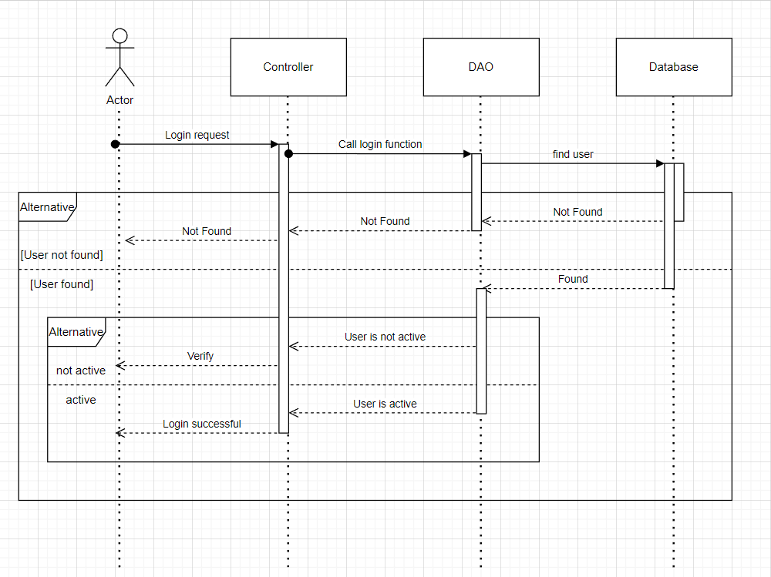

### d. Database Queries

## *select * from [User]*

## 

## 3. Logout

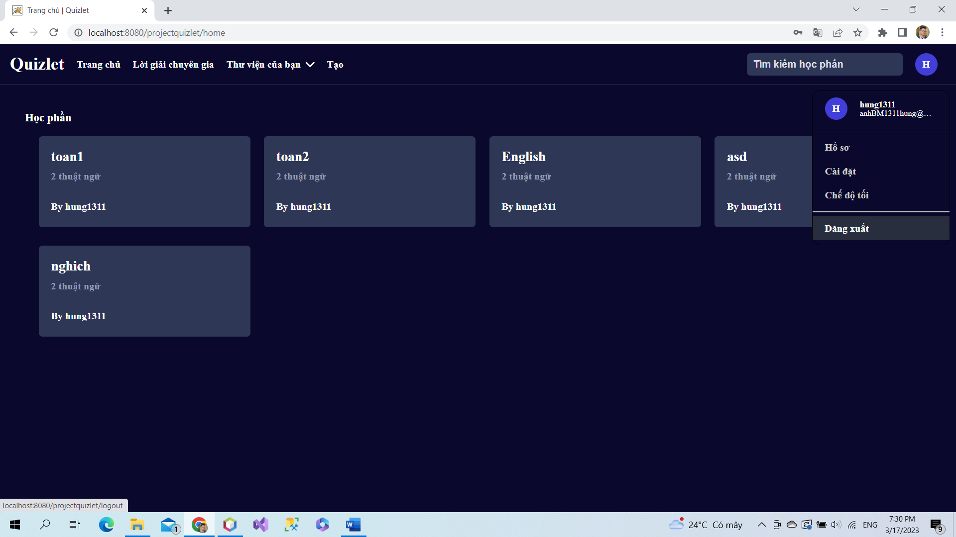

Click in logout if user want to leave page.

### a. Class Diagram

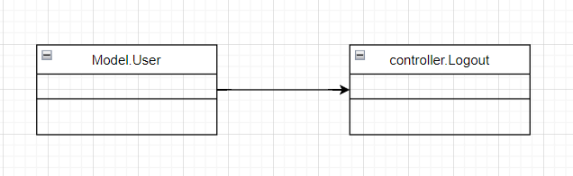

### b. Class Specifications

### User Class

|  |  |  |
| --- | --- | --- |
| **No** | **Method** | **Description** |
| *01* | *User(){}* | Default constructor |
| *02* | *User(….){}* | *Parameterized constructor* |
| *03* | *getName(){}* | *Getter of Name* |
| *04* | *setName(string name){}* | *Setter of Name* |
| *05* | *getPass(){}* | *Getter of Pass* |
| *06* | *setPass(string pass){}* | *Setter of Pass* |
| *07* | *getEmail(){}* | *Getter email* |
| *08* | *setEmail(string email){}* | *Setter of email* |
| *09* | *isIsActive(){}* | *Getter of isActive* |
| *10* | *setIsActive(Boolean isActive){}* | *Setter of isActive* |
| *11* | *getAvatar(){}* | *Getter of avatar* |
| *12* | *setAvatar(string avatar)* | *Setter of avatar* |
| *13* | *getLanguage(){}* | *Getter of language* |
| *14* | *setLanguage(string language){}* | *Setter of language* |

#### Register Controller Class

|  |  |  |
| --- | --- | --- |
| **No** | **Method** | **Description** |
| *01* | *Doget()* | *Remove session to logout* |

### c. Sequence Diagram(s)

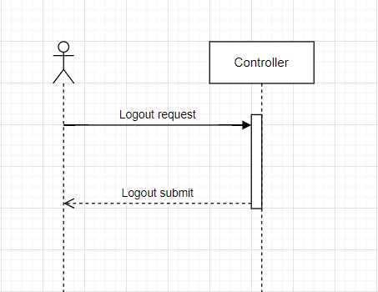

### d. Database Queries

*Logout function do not use database queries.*

## 4. Search study sets by name

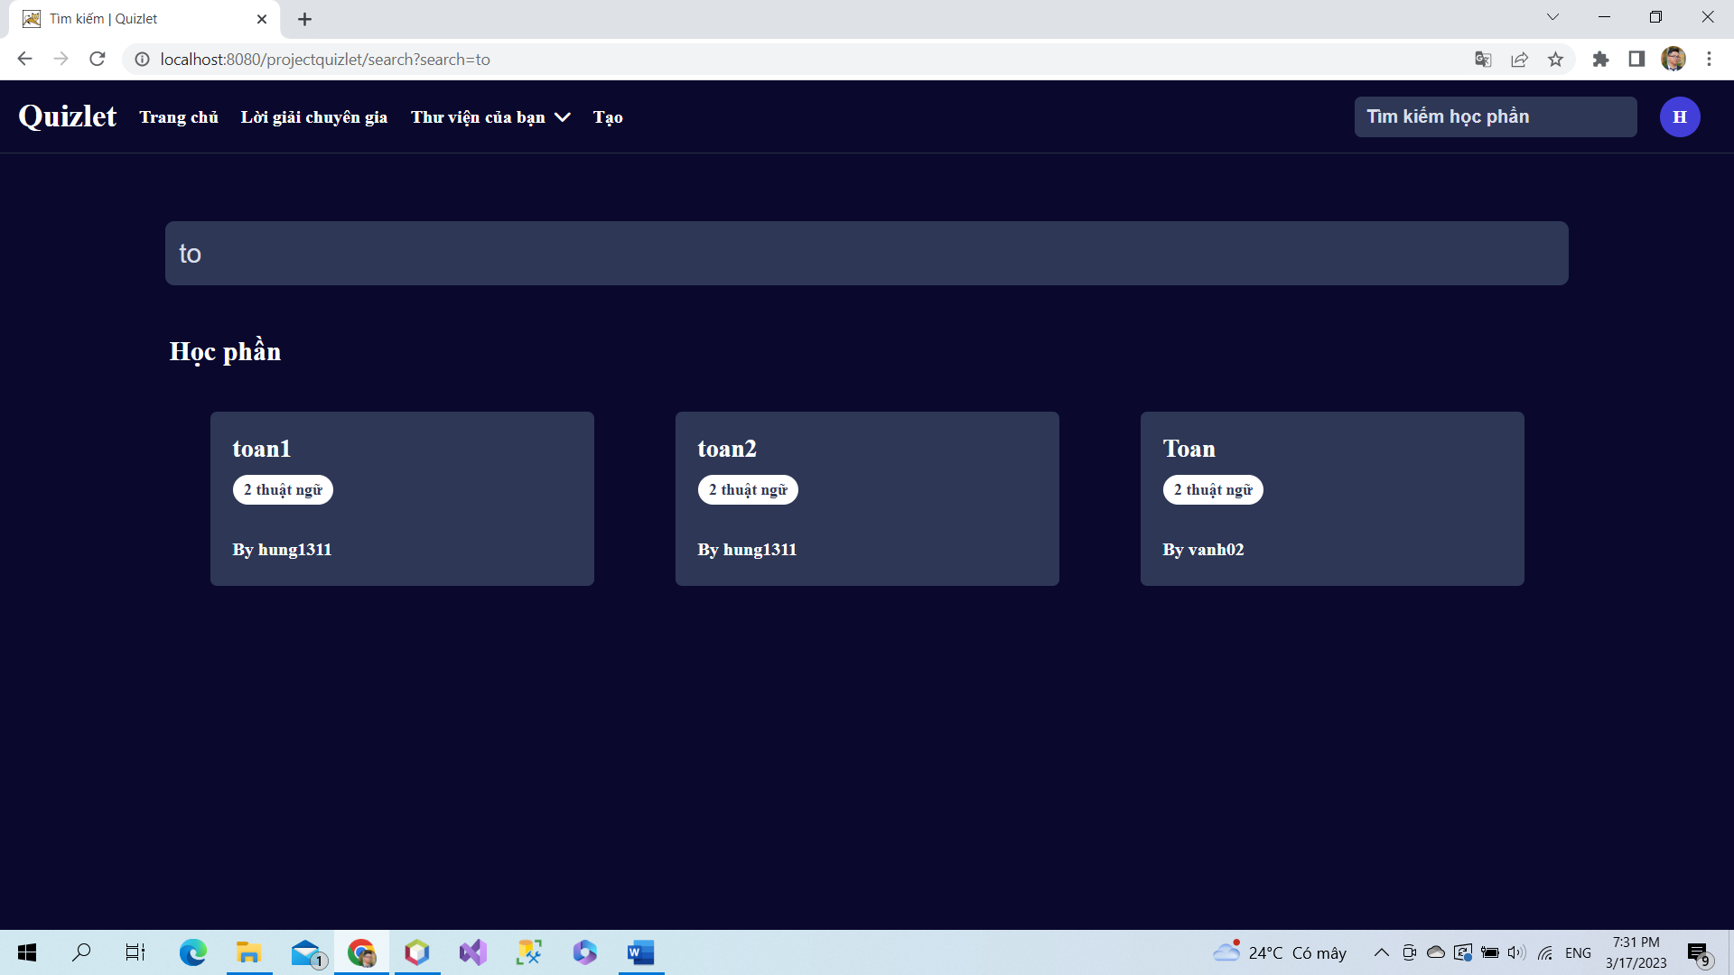

If users want search study sets by name, users can input or characters of them to search input.

### a. Class Diagram

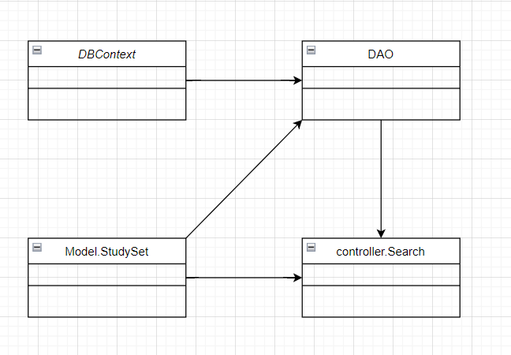

### b. Class Specifications

#### Study sets Class

|  |  |  |
| --- | --- | --- |
| **No** | **Method** | **Description** |
| *01* | *StudySet(){}* | *Default constructor* |
| *02* | *StudySet(….){}* | *Parameterized constructor* |
| *03* | *getId(){}* | *Getter of id* |
| *04* | *setId(int id){}* | *Setter of id* |
| *05* | *getTitle(){}* | *Getter of title* |
| *06* | *setTitle(string title){]* | *Setter of title* |
| *07* | *getDescription(){}* | *Getter of description* |
| *08* | *setDescription(string des){}* | *Setter of description* |
| *09* | *isIsShare(){}* | *Getter of isShare* |
| *10* | *setIsShare(Boolean isShare){]* | *Setter of isShare* |
| *11* | *getuserId(){}* | *Getter of user id* |
| *12* | *setUserid(int id){]* | *Setter of user id* |
| *13* | *getnumberCard(){}* | *Count number of cards in a study set* |
| *14* | *getAuthor(){}* | *Get name of user create study sets* |

#### Search controller Class

|  |  |  |
| --- | --- | --- |
| **No** | **Method** | **Description** |
| *01* | *doGet(){}* | *Search by name in list study sets* |
|  |  |  |

#### DAO Class

|  |  |  |
| --- | --- | --- |
| **No** | **Method** | **Description** |
| *01* | *getAllStudySet(){}* | *Get all study sets in database* |
|  |  |  |

#### DBContext Class

|  |  |  |
| --- | --- | --- |
| **No** | **Method** | **Description** |
| *01* | *DBContext(){}* | *Connect to database* |

### c. Sequence Diagram(s)

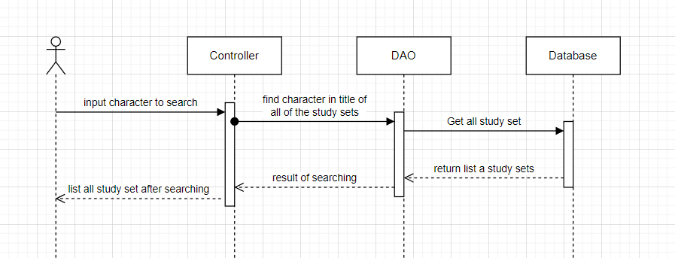

### d. Database Queries

# *Select * from StudySet*

## 5. Verify code

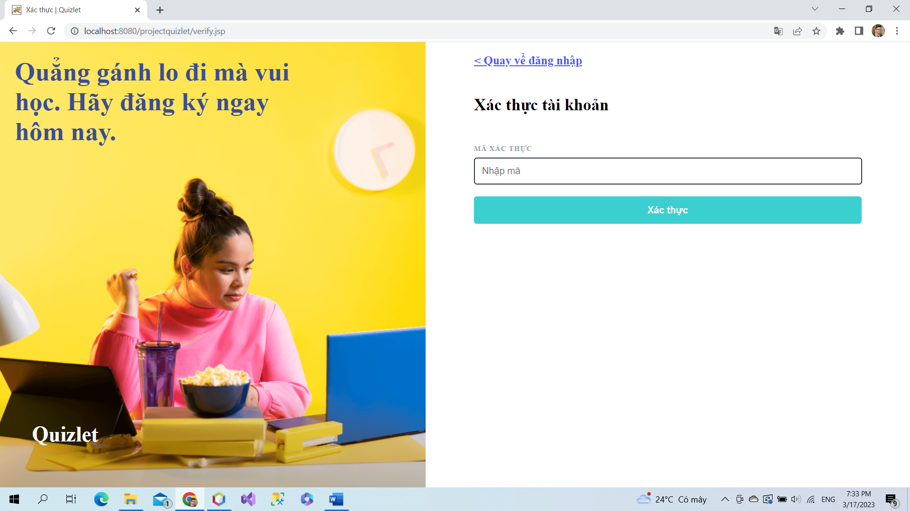

After users register a new account, to login, users must check email to get code and input it to verify page. After verify, account of users will be active to login.

### a. Class Diagram

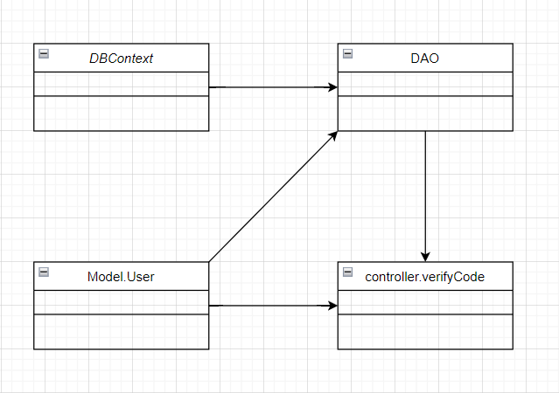

### b. Class Specifications

### User Class

|  |  |  |
| --- | --- | --- |
| **No** | **Method** | **Description** |
| *01* | *User(){}* | Default constructor |
| *02* | *User(….){}* | *Parameterized constructor* |
| *03* | *getName(){}* | *Getter of Name* |
| *04* | *setName(string name){}* | *Setter of Name* |
| *05* | *getPass(){}* | *Getter of Pass* |
| *06* | *setPass(string pass){}* | *Setter of Pass* |
| *07* | *getEmail(){}* | *Getter email* |
| *08* | *setEmail(string email){}* | *Setter of email* |
| *09* | *isIsActive(){}* | *Getter of isActive* |
| *10* | *setIsActive(Boolean isActive){}* | *Setter of isActive* |
| *11* | *getAvatar(){}* | *Getter of avatar* |
| *12* | *setAvatar(string avatar)* | *Setter of avatar* |
| *13* | *getLanguage(){}* | *Getter of language* |
| *14* | *setLanguage(string language){}* | *Setter of language* |

#### DBContext Class

|  |  |  |
| --- | --- | --- |
| **No** | **Method** | **Description** |
| *01* | *DBContext(){}* | *Connect to database* |

#### Verify controller Class

|  |  |  |
| --- | --- | --- |
| **No** | **Method** | **Description** |
| *01* | *doGet(){}* | *Send redirect to verify.jsp* |
| *02* | *doPost(){}* | *Active account by verify code* |

#### DAO Class

|  |  |  |
| --- | --- | --- |
| **No** | **Method** | **Description** |
| *01* | *Active account(string email){}* | *Update is active in database* |

### c. Sequence Diagram(s)

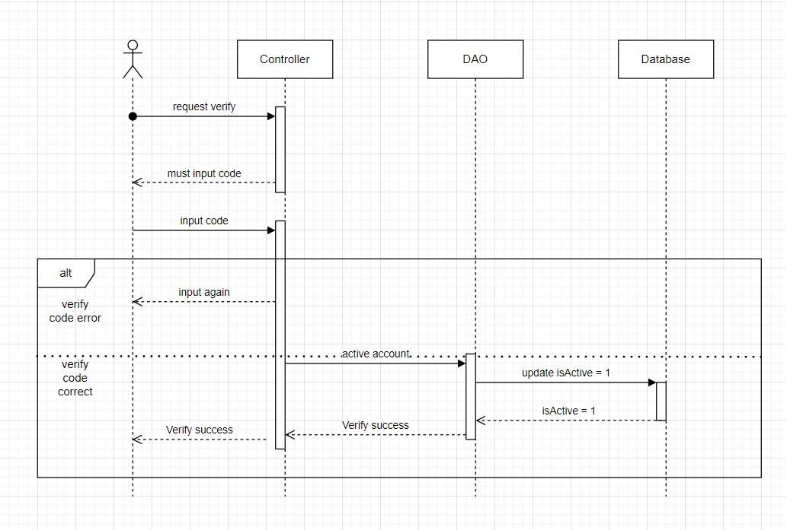

### d. Database Queries

*String sql = "update [User] set isActive = 1 where gmail like ?";*

## 6. FlashCard

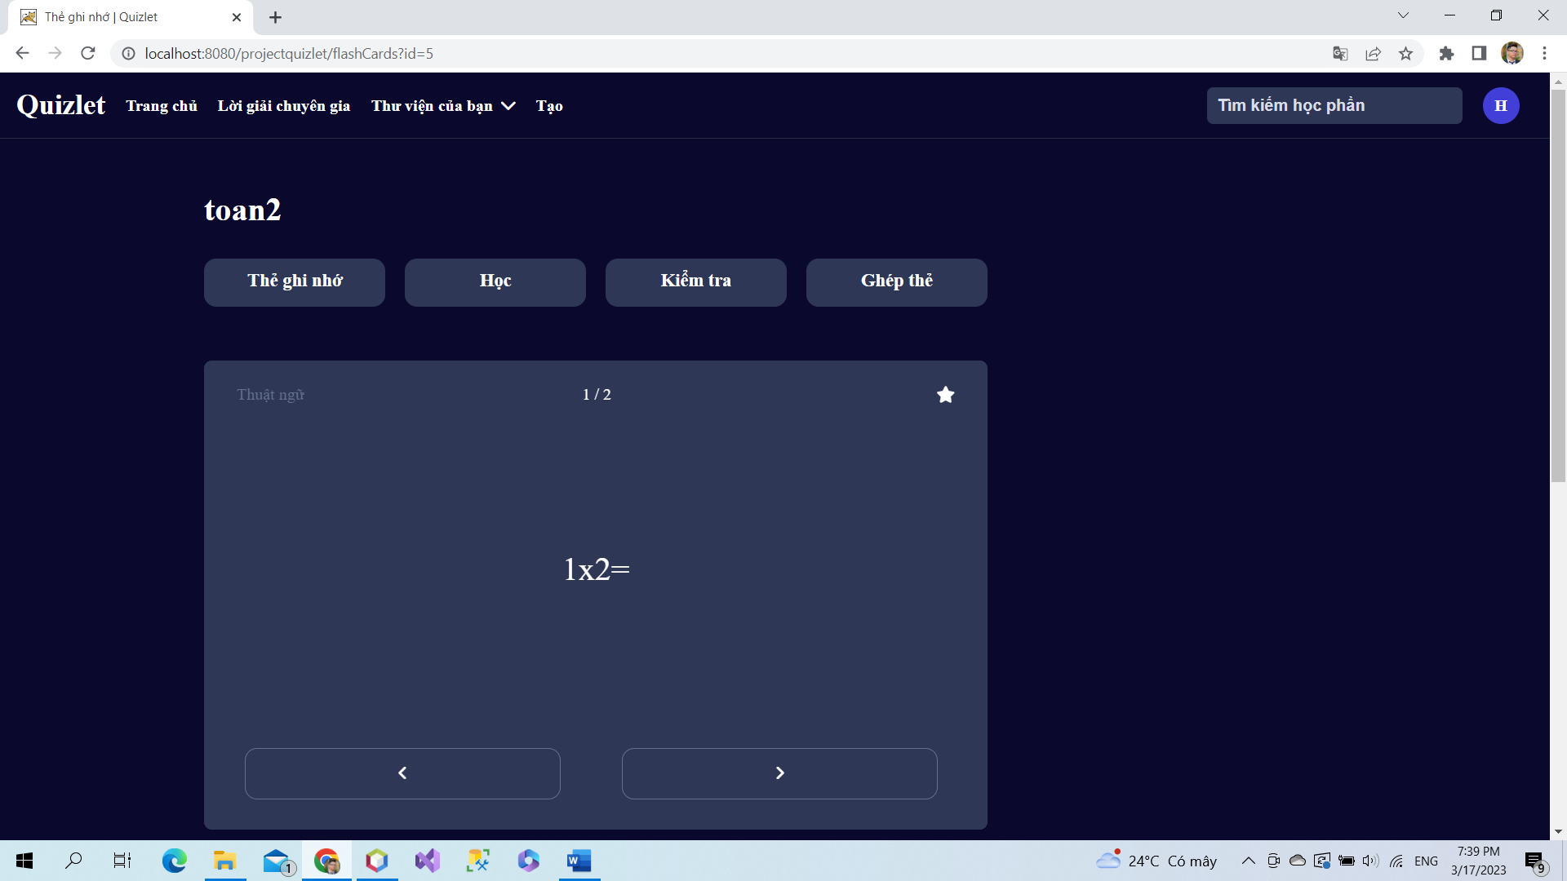

Click a study set to view information.

### a. Class Diagram

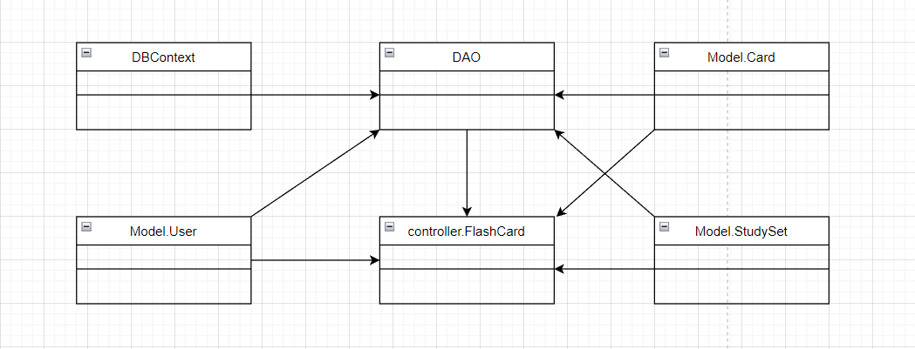

### b. Class Specifications

### User Class

|  |  |  |
| --- | --- | --- |
| **No** | **Method** | **Description** |
| *01* | *User(){}* | Default constructor |
| *02* | *User(….){}* | *Parameterized constructor* |
| *03* | *getName(){}* | *Getter of Name* |
| *04* | *setName(string name){}* | *Setter of Name* |
| *05* | *getPass(){}* | *Getter of Pass* |
| *06* | *setPass(string pass){}* | *Setter of Pass* |
| *07* | *getEmail(){}* | *Getter email* |
| *08* | *setEmail(string email){}* | *Setter of email* |
| *09* | *isIsActive(){}* | *Getter of isActive* |
| *10* | *setIsActive(Boolean isActive){}* | *Setter of isActive* |
| *11* | *getAvatar(){}* | *Getter of avatar* |
| *12* | *setAvatar(string avatar)* | *Setter of avatar* |
| *13* | *getLanguage(){}* | *Getter of language* |
| *14* | *setLanguage(string language){}* | *Setter of language* |

#### DBContext Class

|  |  |  |
| --- | --- | --- |
| **No** | **Method** | **Description** |
| *01* | *DBContext(){}* | *Connect to database* |

#### FlashCrard controller Class

|  |  |  |
| --- | --- | --- |
| **No** | **Method** | **Description** |
| *01* | *doGet(){}* | *Call function get all card in study sets* |

#### DAO Class

|  |  |  |
| --- | --- | --- |
| **No** | **Method** | **Description** |
| *01* | *getStudySetById(int id){}* | *Get study sets by its id* |
| *02* | *getUserByUserId(int id){}* | *Get user by id* |
| *03* | *getAllCardInSet(int id){}* | *Get all card in study set* |
| *04* | *getStudiedCard(int setId, int uId)* | *Get all studied cards* |

#### StudySet Class

|  |  |  |
| --- | --- | --- |
| **No** | **Method** | **Description** |
| *01* | *StudySet() {)* | *Default Constructor* |
| *02* | *StudySet(){.....}* | *Parameterized constructor* |
| *03* | *getId(){}* | *getter of StudySetId* |
| *04* | *setId(int id){}* | *setter of StudySetId* |
| *05* | *getTitle(){}* | *getter of Title* |
| *06* | *setTitle(string title){}* | *setter of Title* |
| *07* | *getDescription(){}* | *getter of Description* |
| *08* | *setDescription(string Description){}* | *setter of Description* |
| *09* | *isIsShare() {}* | *getter of isShare* |
| *10* | *setIsShare(boolean isShare) { }* | *setter of isShare* |
| *11* | *getUserId() { }* | *getter of UserId* |
| *12* | *setUserId(int userId) { }* | *setter of UserId* |
| *13* | *getNumberCard() {}* | *get number flashcard in studyset* |
| *14* | *String getAuthor() {}* | *get name of User created studyset* |

### Card Class

|  |  |  |
| --- | --- | --- |
| **No** | **Method** | **Description** |
| *01* | *Card() {)* | *Default Constructor* |
| *02* | *Card(){.....}* | *Parameterized constructor* |
| *03* | *getId(){}* | *getter of CardId* |
| *04* | *setId(int id){}* | *setter of CardId* |
| *05* | *getTerm(){}* | *getter of Term* |
| *06* | *setTerm(string term){}* | *setter of Term* |
| *07* | *getDefinition(){}* | *getter of Definition* |
| *08* | *setDefinition(string Definition){}* | *setter of Definition* |
| *09* | *getStudySetId() { }* | *getter of StudySetId* |
| *10* | *setStudySetId(int studySetId) { }* | *setter of StudySetId* |

### 

### c. Sequence Diagram(s)

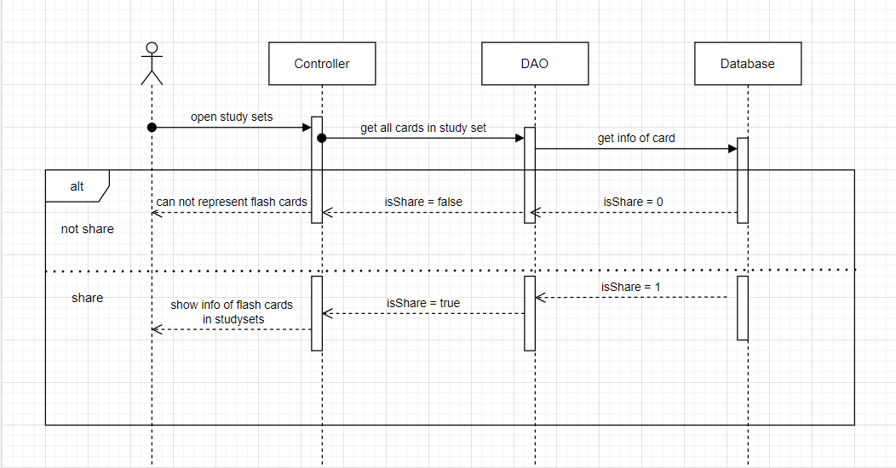

### d. Database Queries

*String sql = "SELECT [studySetId]\n"*

*+ " ,[title]\n"*

*+ " ,[description]\n"*

*+ " ,[isShare]\n"*

*+ " ,[userId]\n"*

*+ " FROM [dbo].[StudySet]\n"*

*+ " WHERE studySetId=?";*

*String sql = "SELECT [cardId]\n"*

*+ " ,[term]\n"*

*+ " ,[definition]\n"*

*+ " ,[studySetId]\n"*

*+ " FROM [dbo].[Card]\n"*

*+ " WHERE studySetID=?";*

*String sql = "SELECT [userId]\n"*

*+ " ,[cardId]\n"*

*+ " FROM [dbo].[FlashCards]"*

*+ " WHERE studySetId = ? and userId = ?";*

## 7.Create StudySet

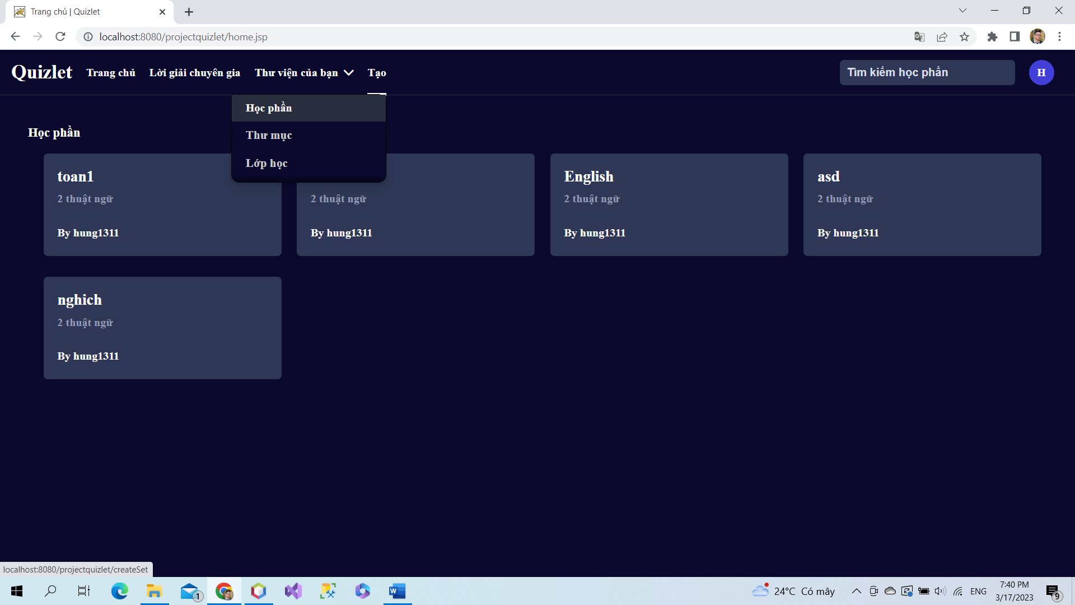

In header, click to “Tạo” then click to “Học phần” to create new study set.

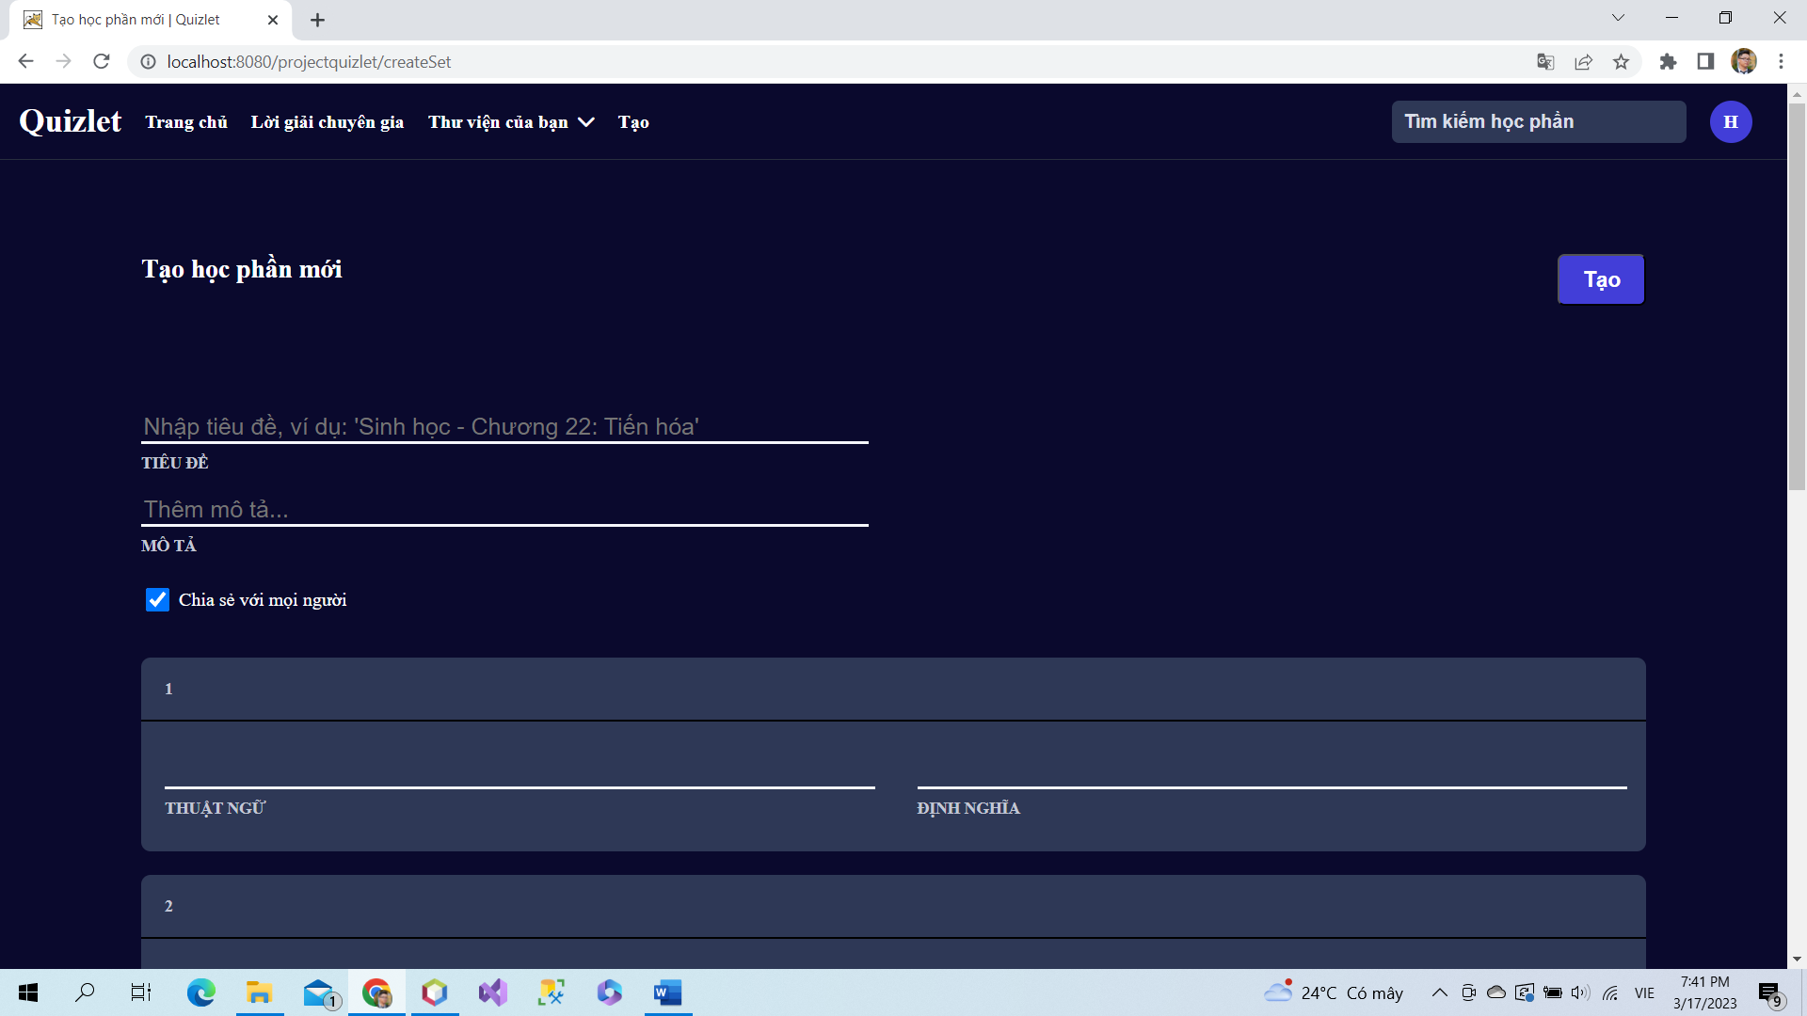

Users can create new study set and flash cards in study set.

### a. Class Diagram

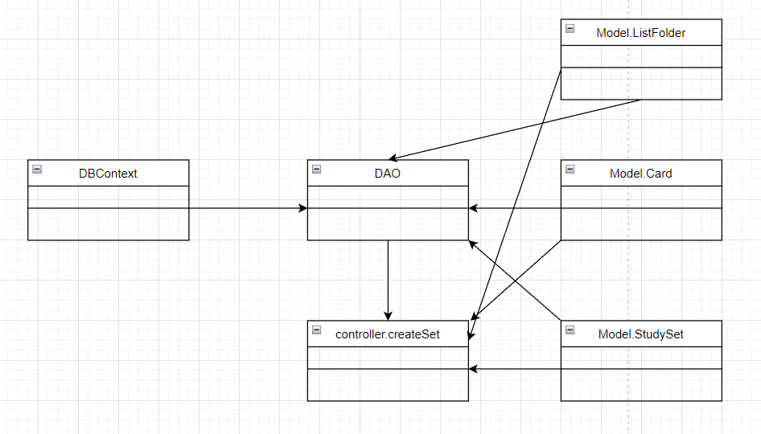

### b. Class Specifications

### User Class

|  |  |  |
| --- | --- | --- |
| **No** | **Method** | **Description** |
| *01* | *User(){}* | Default constructor |
| *02* | *User(….){}* | *Parameterized constructor* |
| *03* | *getName(){}* | *Getter of Name* |
| *04* | *setName(string name){}* | *Setter of Name* |
| *05* | *getPass(){}* | *Getter of Pass* |
| *06* | *setPass(string pass){}* | *Setter of Pass* |
| *07* | *getEmail(){}* | *Getter email* |
| *08* | *setEmail(string email){}* | *Setter of email* |
| *09* | *isIsActive(){}* | *Getter of isActive* |
| *10* | *setIsActive(Boolean isActive){}* | *Setter of isActive* |
| *11* | *getAvatar(){}* | *Getter of avatar* |
| *12* | *setAvatar(string avatar)* | *Setter of avatar* |
| *13* | *getLanguage(){}* | *Getter of language* |
| *14* | *setLanguage(string language){}* | *Setter of language* |

#### DBContext Class

|  |  |  |
| --- | --- | --- |
| **No** | **Method** | **Description** |
| *01* | *DBContext(){}* | *Connect to database* |

#### CreateSet controller Class

|  |  |  |
| --- | --- | --- |
| **No** | **Method** | **Description** |
| *01* | *doGet(){}* | *Fill info to card* |
| *02* | *doPost(){}* | *Add study set and card in set* |

#### DAO Class

|  |  |  |
| --- | --- | --- |
| **No** | **Method** | **Description** |
| *01* | *addStuySet(StudySet set){}* | *Add new study set* |
| *02* | *addCard(Card c){]* | *Add card to study set* |
| *03* | *createListFolder(listF){}* | *Add study set to a folder* |

#### StudySet Class

|  |  |  |
| --- | --- | --- |
| **No** | **Method** | **Description** |
| *01* | *StudySet() {)* | *Default Constructor* |
| *02* | *StudySet(){.....}* | *Parameterized constructor* |
| *03* | *getId(){}* | *getter of StudySetId* |
| *04* | *setId(int id){}* | *setter of StudySetId* |
| *05* | *getTitle(){}* | *getter of Title* |
| *06* | *setTitle(string title){}* | *setter of Title* |
| *07* | *getDescription(){}* | *getter of Description* |
| *08* | *setDescription(string Description){}* | *setter of Description* |
| *09* | *isIsShare() {}* | *getter of isShare* |
| *10* | *setIsShare(boolean isShare) { }* | *setter of isShare* |
| *11* | *getUserId() { }* | *getter of UserId* |
| *12* | *setUserId(int userId) { }* | *setter of UserId* |
| *13* | *getNumberCard() {}* | *get number flashcard in studyset* |
| *14* | *String getAuthor() {}* | *get name of User created studyset* |

### 

### Card Class

|  |  |  |
| --- | --- | --- |
| **No** | **Method** | **Description** |
| *01* | *Card() {)* | *Default Constructor* |
| *02* | *Card(){.....}* | *Parameterized constructor* |
| *03* | *getId(){}* | *getter of CardId* |
| *04* | *setId(int id){}* | *setter of CardId* |
| *05* | *getTerm(){}* | *getter of Term* |
| *06* | *setTerm(string term){}* | *setter of Term* |
| *07* | *getDefinition(){}* | *getter of Definition* |
| *08* | *setDefinition(string Definition){}* | *setter of Definition* |
| *09* | *getStudySetId() { }* | *getter of StudySetId* |
| *10* | *setStudySetId(int studySetId) { }* | *setter of StudySetId* |

### 

### c. Sequence Diagram(s)

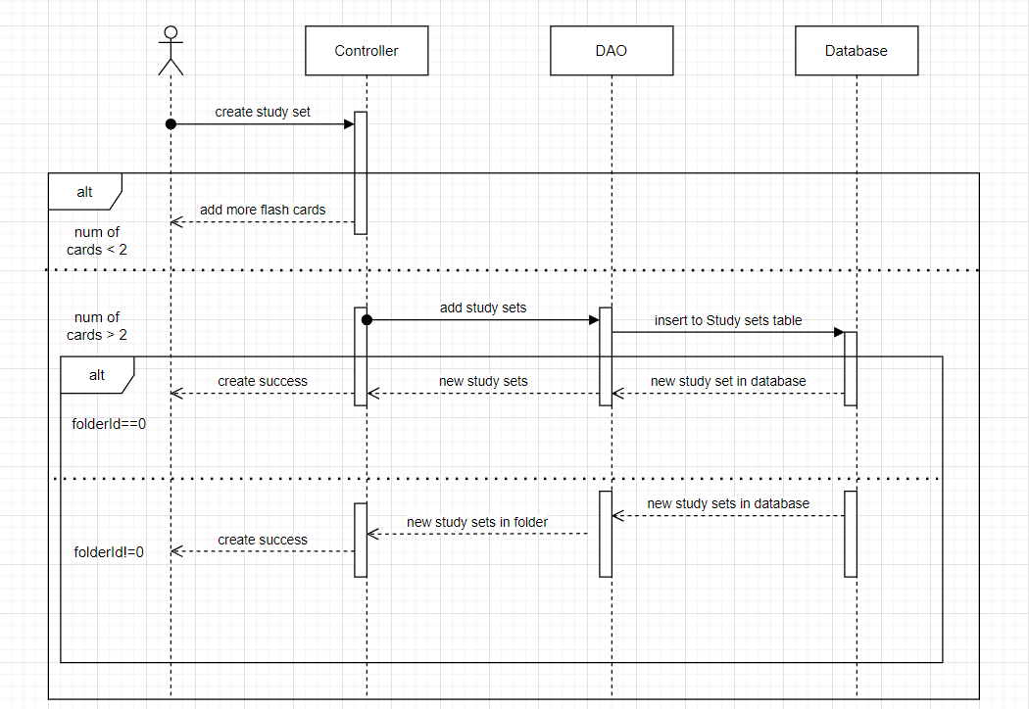

### d. Database Queries

*String sql = "INSERT INTO [dbo].[StudySet]\n"*

*+ " ([title]\n"*

*+ " ,[description]\n"*

*+ " ,[isShare]\n"*

*+ " ,[userId])\n"*

*+ " VALUES\n"*

*+ " (?\n"*

*+ " ,?\n"*

*+ " ,?\n"*

*+ " ,?)";*

*String sql = "INSERT INTO [dbo].[ListFolder]\n"*

*+ " ([studySetId]\n"*

*+ " ,[folderId])\n"*

*+ " VALUES(?,?)";*

## 8.Delete StudySet

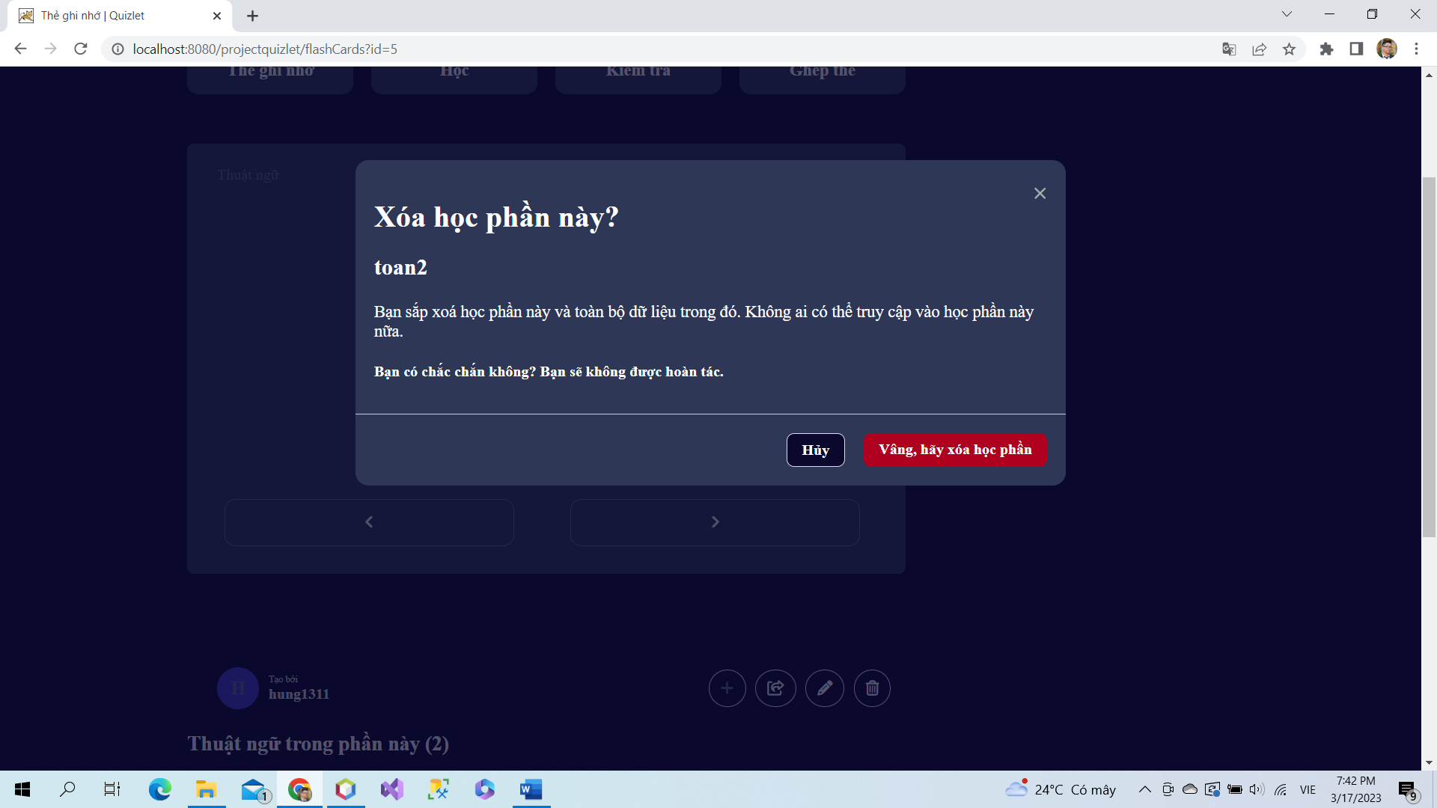

If users want to delete study set, users click to icon delete, then screen will present a message box to ask again to delete study set. Users click to “ Vâng hãy xóa học phần” to confirm to delete and click to “Hủy” to cancel to delete study set.

### a. Class Diagram

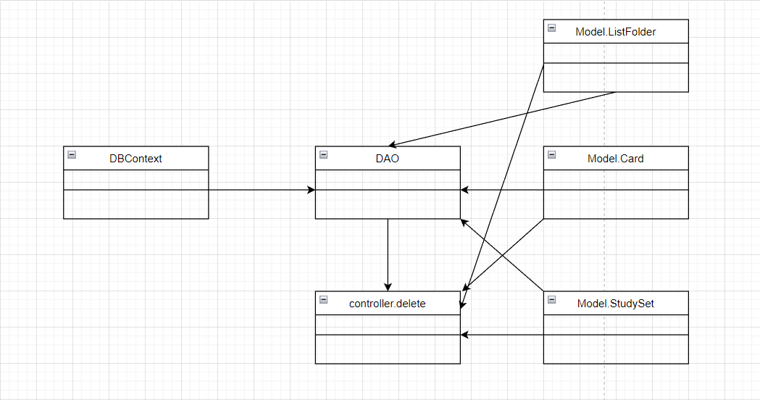

### b. Class Specifications

### User Class

|  |  |  |
| --- | --- | --- |
| **No** | **Method** | **Description** |
| *01* | *User(){}* | Default constructor |
| *02* | *User(….){}* | *Parameterized constructor* |
| *03* | *getName(){}* | *Getter of Name* |
| *04* | *setName(string name){}* | *Setter of Name* |
| *05* | *getPass(){}* | *Getter of Pass* |
| *06* | *setPass(string pass){}* | *Setter of Pass* |
| *07* | *getEmail(){}* | *Getter email* |
| *08* | *setEmail(string email){}* | *Setter of email* |
| *09* | *isIsActive(){}* | *Getter of isActive* |
| *10* | *setIsActive(Boolean isActive){}* | *Setter of isActive* |
| *11* | *getAvatar(){}* | *Getter of avatar* |
| *12* | *setAvatar(string avatar)* | *Setter of avatar* |
| *13* | *getLanguage(){}* | *Getter of language* |
| *14* | *setLanguage(string language){}* | *Setter of language* |

#### DBContext Class

|  |  |  |
| --- | --- | --- |
| **No** | **Method** | **Description** |
| *01* | *DBContext(){}* | *Connect to database* |

#### Delete controller Class

|  |  |  |
| --- | --- | --- |
| **No** | **Method** | **Description** |
| *01* | *doGet(){}* | *Delete card in study set, study set, and delete study set in folder* |

#### DAO Class

|  |  |  |
| --- | --- | --- |
| **No** | **Method** | **Description** |
| *01* | *deleteAllCards(int id){}* | *Delete all cards in study sets* |
| *02* | *deleteStudySet(int id){}* | *Delete study set* |
| *03* | *deleteInListFolder(int id){]* | *Delete study set in folders* |

#### StudySet Class

|  |  |  |
| --- | --- | --- |
| **No** | **Method** | **Description** |
| *01* | *StudySet() {)* | *Default Constructor* |
| *02* | *StudySet(){.....}* | *Parameterized constructor* |
| *03* | *getId(){}* | *getter of StudySetId* |
| *04* | *setId(int id){}* | *setter of StudySetId* |
| *05* | *getTitle(){}* | *getter of Title* |
| *06* | *setTitle(string title){}* | *setter of Title* |
| *07* | *getDescription(){}* | *getter of Description* |
| *08* | *setDescription(string Description){}* | *setter of Description* |
| *09* | *isIsShare() {}* | *getter of isShare* |
| *10* | *setIsShare(boolean isShare) { }* | *setter of isShare* |
| *11* | *getUserId() { }* | *getter of UserId* |
| *12* | *setUserId(int userId) { }* | *setter of UserId* |
| *13* | *getNumberCard() {}* | *get number flashcard in studyset* |
| *14* | *String getAuthor() {}* | *get name of User created studyset* |

### 

### Card Class

|  |  |  |
| --- | --- | --- |
| **No** | **Method** | **Description** |
| *01* | *Card() {)* | *Default Constructor* |
| *02* | *Card(){.....}* | *Parameterized constructor* |
| *03* | *getId(){}* | *getter of CardId* |
| *04* | *setId(int id){}* | *setter of CardId* |
| *05* | *getTerm(){}* | *getter of Term* |
| *06* | *setTerm(string term){}* | *setter of Term* |
| *07* | *getDefinition(){}* | *getter of Definition* |
| *08* | *setDefinition(string Definition){}* | *setter of Definition* |
| *09* | *getStudySetId() { }* | *getter of StudySetId* |
| *10* | *setStudySetId(int studySetId) { }* | *setter of StudySetId* |

### 

### c. Sequence Diagram(s)

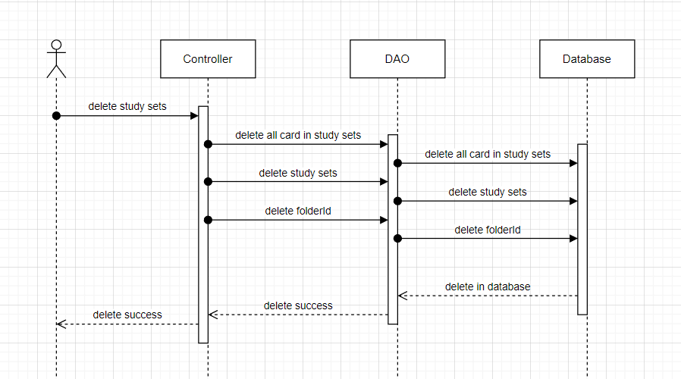

### d. Database Queries

*String sql = "DELETE FROM [dbo].[ListFolder]\n"*

*+ " WHERE studySetId = ?";*

*String sql = "DELETE FROM [dbo].[Card]\n"*

*+ " WHERE studySetId=?";*

*String sql = "DELETE FROM [dbo].[StudySet]\n"*

*+ " WHERE studySetId=?";*

## 9.Add Studied Cards

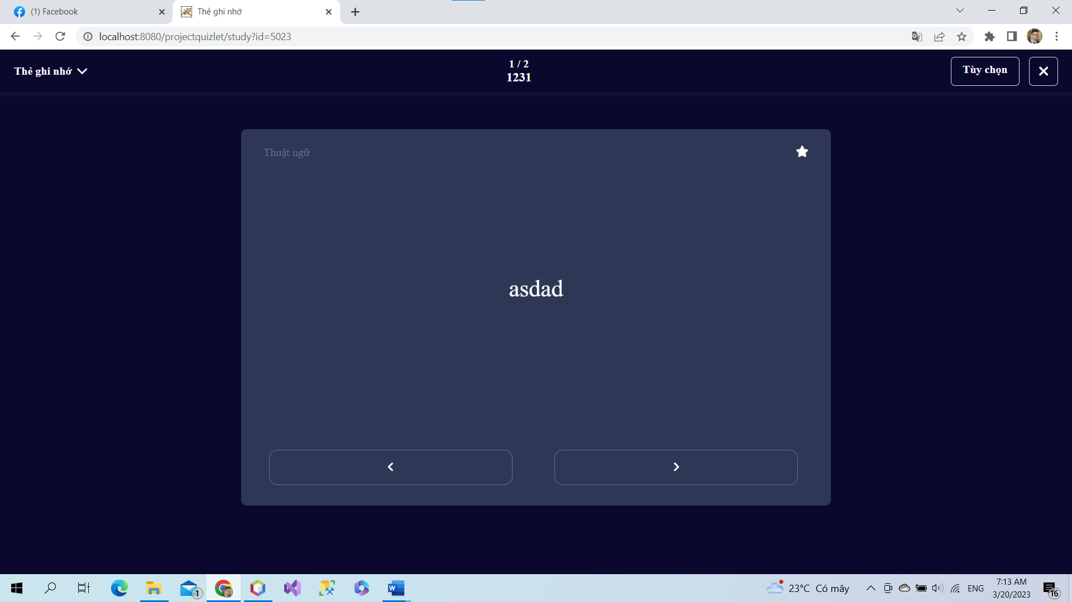

When user study by flash cards, system will save studied cards and number of studied cards.

### a. Class Diagram

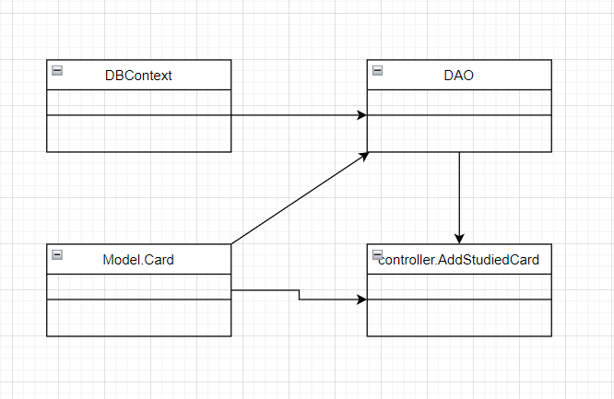

### b. Class Specifications

### User Class

|  |  |  |
| --- | --- | --- |
| **No** | **Method** | **Description** |
| *01* | *User(){}* | Default constructor |
| *02* | *User(….){}* | *Parameterized constructor* |
| *03* | *getName(){}* | *Getter of Name* |
| *04* | *setName(string name){}* | *Setter of Name* |
| *05* | *getPass(){}* | *Getter of Pass* |
| *06* | *setPass(string pass){}* | *Setter of Pass* |
| *07* | *getEmail(){}* | *Getter email* |
| *08* | *setEmail(string email){}* | *Setter of email* |
| *09* | *isIsActive(){}* | *Getter of isActive* |
| *10* | *setIsActive(Boolean isActive){}* | *Setter of isActive* |
| *11* | *getAvatar(){}* | *Getter of avatar* |
| *12* | *setAvatar(string avatar)* | *Setter of avatar* |
| *13* | *getLanguage(){}* | *Getter of language* |
| *14* | *setLanguage(string language){}* | *Setter of language* |

#### DBContext Class

|  |  |  |
| --- | --- | --- |
| **No** | **Method** | **Description** |
| *01* | *DBContext(){}* | *Connect to database* |

#### AddStudiedCard controller Class

|  |  |  |
| --- | --- | --- |
| **No** | **Method** | **Description** |
| *01* | *doGet(){}* | *Add all studied card to a list* |

#### DAO Class

|  |  |  |
| --- | --- | --- |
| **No** | **Method** | **Description** |
| *01* | *getAllCardinSet(int id){}* | *Get all card in study set* |
| *02* | *getListStudiedCardId(int sid, int uid){}* | *Get list all studied card id* |
| *03* | *addStudiedCard(int uid, int id, studySetId){}* | *Add all studied card to a list* |

#### StudySet Class

|  |  |  |
| --- | --- | --- |
| **No** | **Method** | **Description** |
| *01* | *StudySet() {)* | *Default Constructor* |
| *02* | *StudySet(){.....}* | *Parameterized constructor* |
| *03* | *getId(){}* | *getter of StudySetId* |
| *04* | *setId(int id){}* | *setter of StudySetId* |
| *05* | *getTitle(){}* | *getter of Title* |
| *06* | *setTitle(string title){}* | *setter of Title* |
| *07* | *getDescription(){}* | *getter of Description* |
| *08* | *setDescription(string Description){}* | *setter of Description* |
| *09* | *isIsShare() {}* | *getter of isShare* |
| *10* | *setIsShare(boolean isShare) { }* | *setter of isShare* |
| *11* | *getUserId() { }* | *getter of UserId* |
| *12* | *setUserId(int userId) { }* | *setter of UserId* |
| *13* | *getNumberCard() {}* | *get number flashcard in studyset* |
| *14* | *String getAuthor() {}* | *get name of User created studyset* |

### 

### Card Class

|  |  |  |
| --- | --- | --- |
| **No** | **Method** | **Description** |
| *01* | *Card() {)* | *Default Constructor* |
| *02* | *Card(){.....}* | *Parameterized constructor* |
| *03* | *getId(){}* | *getter of CardId* |
| *04* | *setId(int id){}* | *setter of CardId* |
| *05* | *getTerm(){}* | *getter of Term* |
| *06* | *setTerm(string term){}* | *setter of Term* |
| *07* | *getDefinition(){}* | *getter of Definition* |
| *08* | *setDefinition(string Definition){}* | *setter of Definition* |
| *09* | *getStudySetId() { }* | *getter of StudySetId* |
| *10* | *setStudySetId(int studySetId) { }* | *setter of StudySetId* |

### 

### c. Sequence Diagram(s)

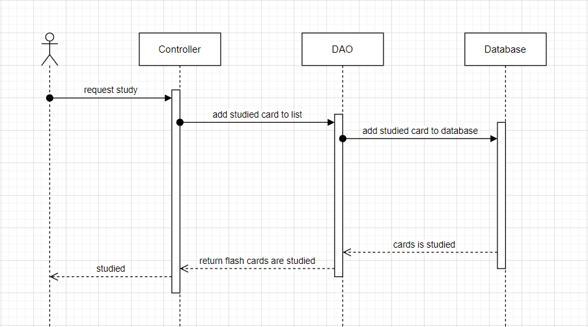

### d. Database Queries

*String sql = "SELECT [cardId]\n"*

*+ " ,[term]\n"*

*+ " ,[definition]\n"*

*+ " ,[studySetId]\n"*

*+ " FROM [dbo].[Card]\n"*

*+ " WHERE studySetID=?";*

*String sql = "SELECT [userId]\n"*

*+ " ,[cardId]\n"*

*+ " FROM [dbo].[FlashCards]"*

*+ " WHERE studySetId = ? and userId = ?";*

*String sql = "INSERT INTO [dbo].[FlashCards]\n"*

*+ " ([userId]\n"*

*+ " ,[cardId]\n"*

*+ " ,[studySetId])\n"*

*+ " VALUES(?,?,?)";*

## 10.Forget password

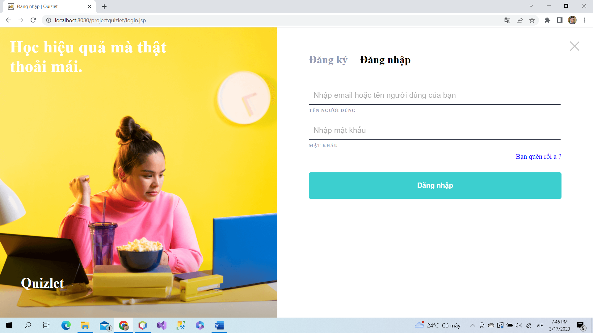

If users forget their password, they can click to “Bạn quên rồi à?” to use email to reset password.

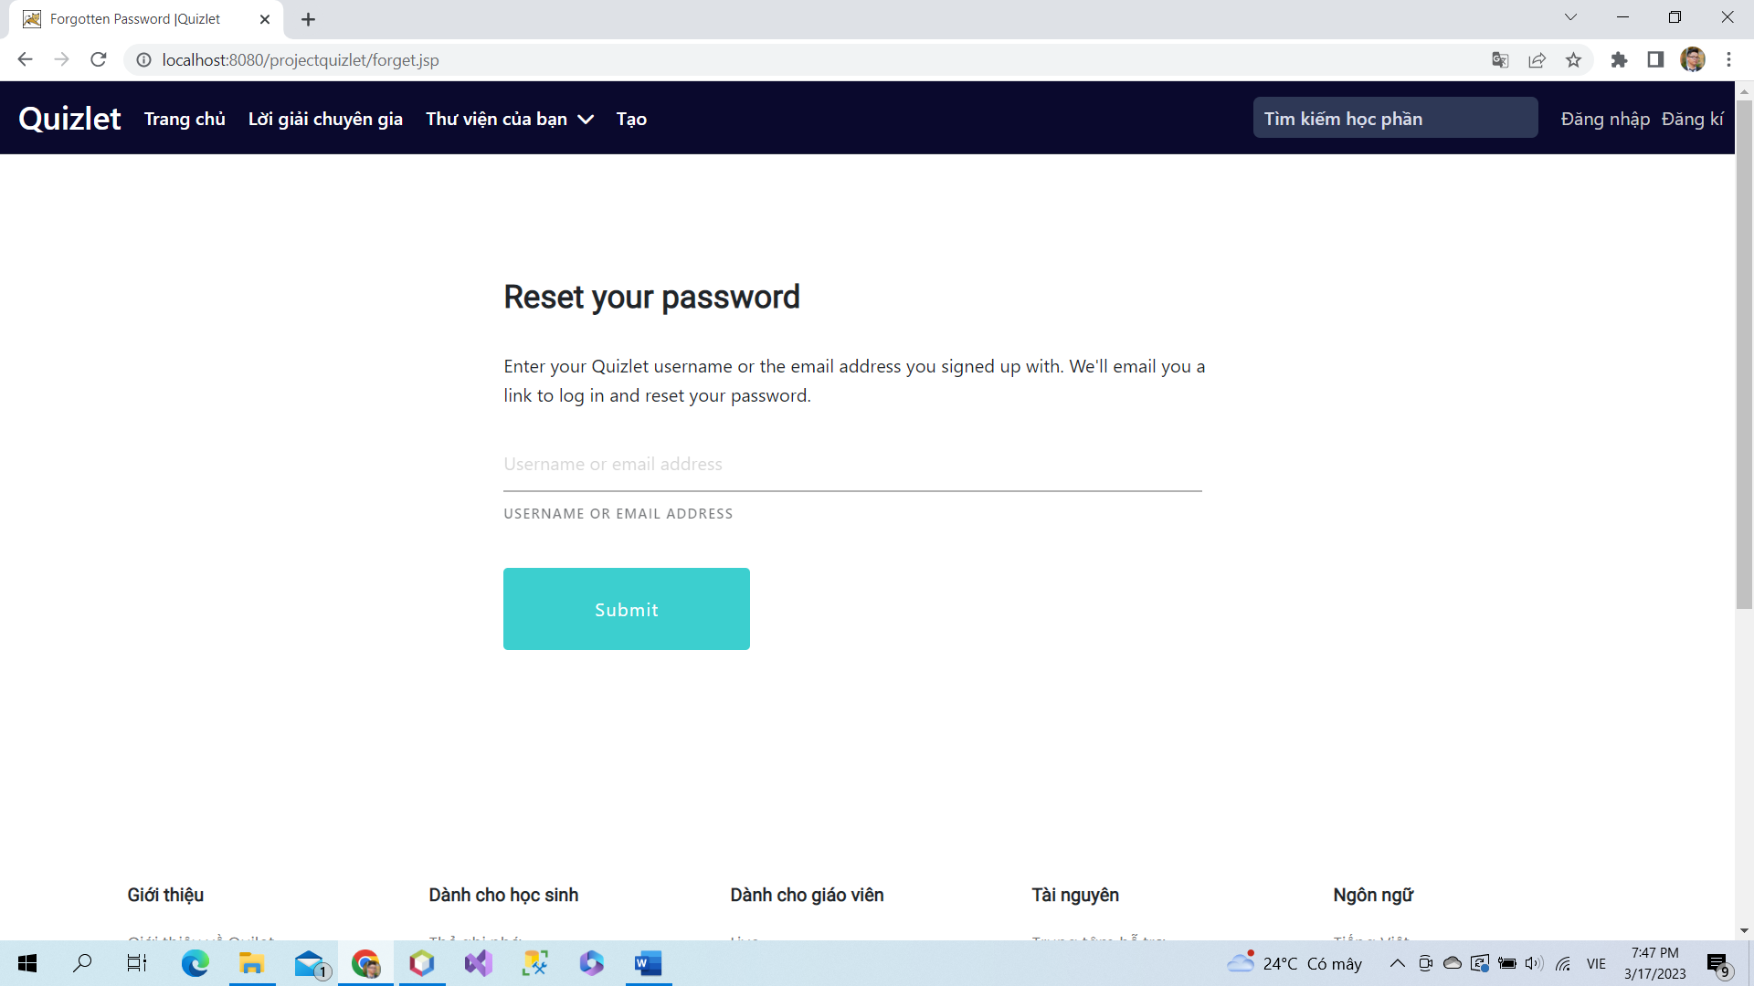

Input email of users

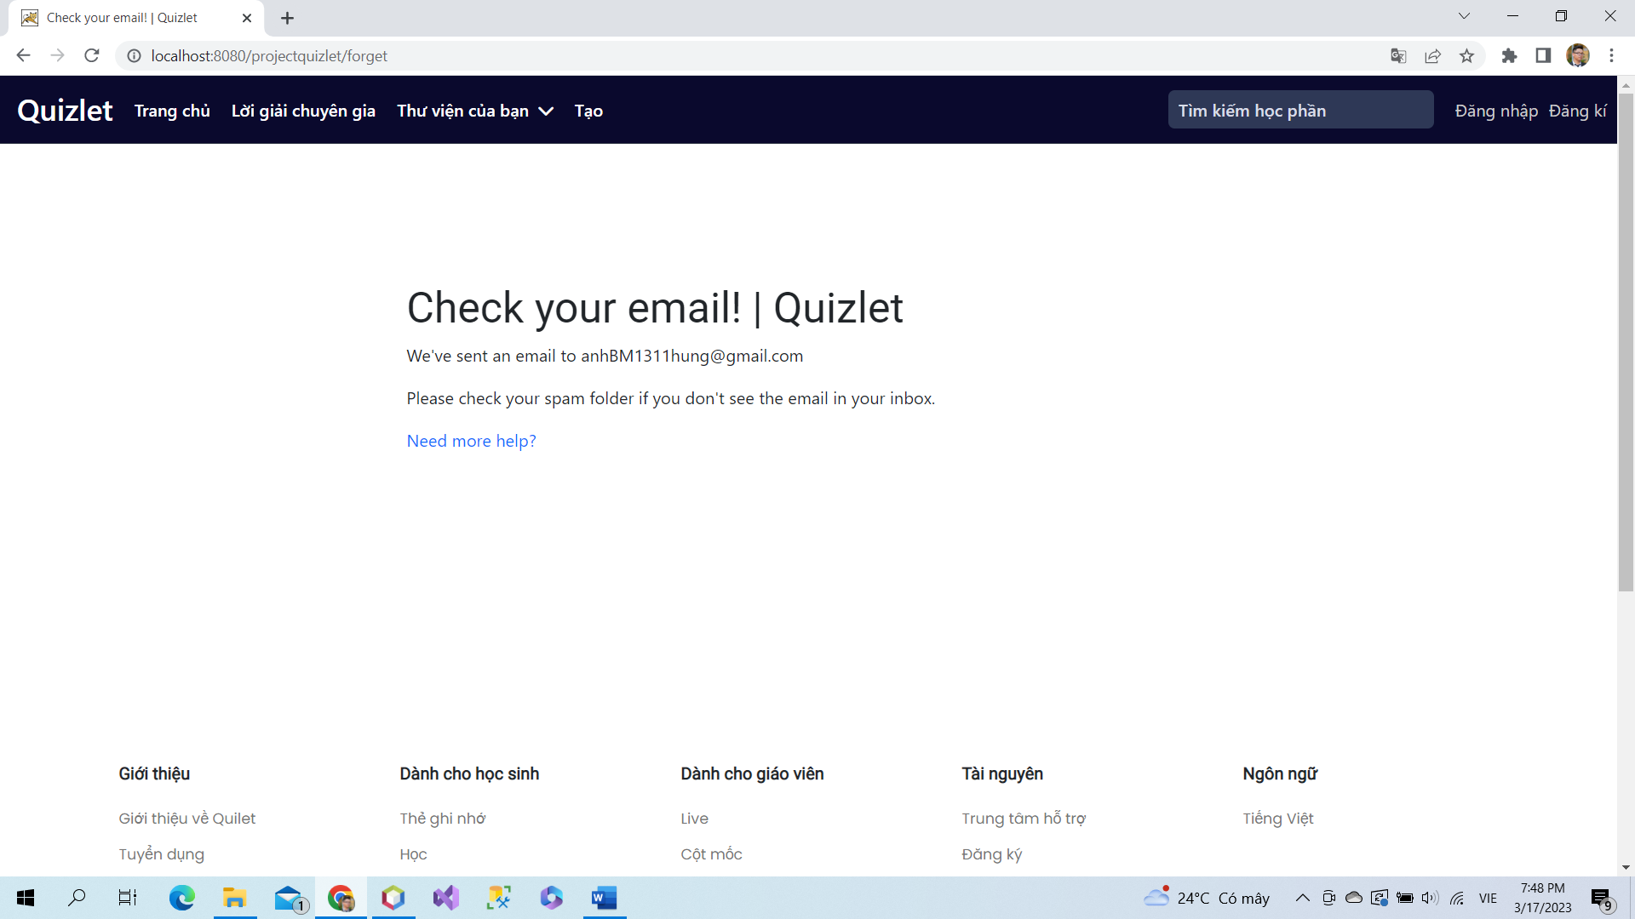

Check mail to skip next step.

### a. Class Diagram

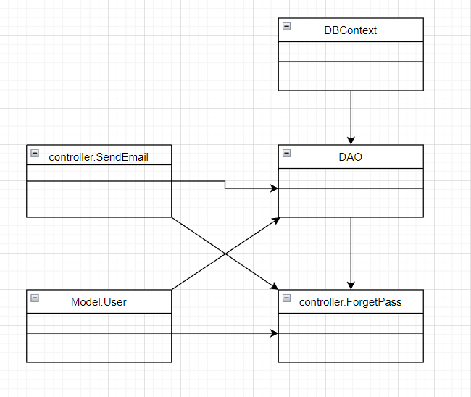

### b. Class Specifications

### User Class

|  |  |  |
| --- | --- | --- |
| **No** | **Method** | **Description** |
| *01* | *User(){}* | Default constructor |
| *02* | *User(….){}* | *Parameterized constructor* |
| *03* | *getName(){}* | *Getter of Name* |
| *04* | *setName(string name){}* | *Setter of Name* |
| *05* | *getPass(){}* | *Getter of Pass* |
| *06* | *setPass(string pass){}* | *Setter of Pass* |
| *07* | *getEmail(){}* | *Getter email* |
| *08* | *setEmail(string email){}* | *Setter of email* |
| *09* | *isIsActive(){}* | *Getter of isActive* |
| *10* | *setIsActive(Boolean isActive){}* | *Setter of isActive* |
| *11* | *getAvatar(){}* | *Getter of avatar* |
| *12* | *setAvatar(string avatar)* | *Setter of avatar* |
| *13* | *getLanguage(){}* | *Getter of language* |
| *14* | *setLanguage(string language){}* | *Setter of language* |

#### DBContext Class

|  |  |  |
| --- | --- | --- |
| **No** | **Method** | **Description** |
| *01* | *DBContext(){}* | *Connect to database* |

#### FogetPass controller Class

|  |  |  |
| --- | --- | --- |
| **No** | **Method** | **Description** |
| *01* | *doPost(){}* | *Send link change password to email of user* |

#### DAO Class

|  |  |  |
| --- | --- | --- |
| **No** | **Method** | **Description** |
| *01* | *checkUser(string email){}* | *Check email in database* |

#### SendEmail Class

|  |  |  |
| --- | --- | --- |
| **No** | **Method** | **Description** |
| *01* | *SendEmailPass(){}* | *Send link to change password to user* |

### 

### c. Sequence Diagram(s)

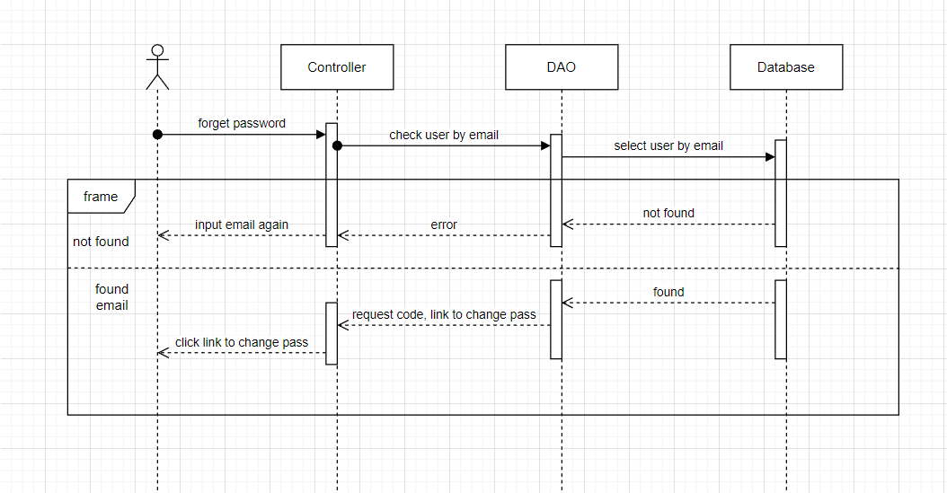

### d. Database Queries

*String sql = "select * from [User] where gmail =? ";*

## 11.Change password

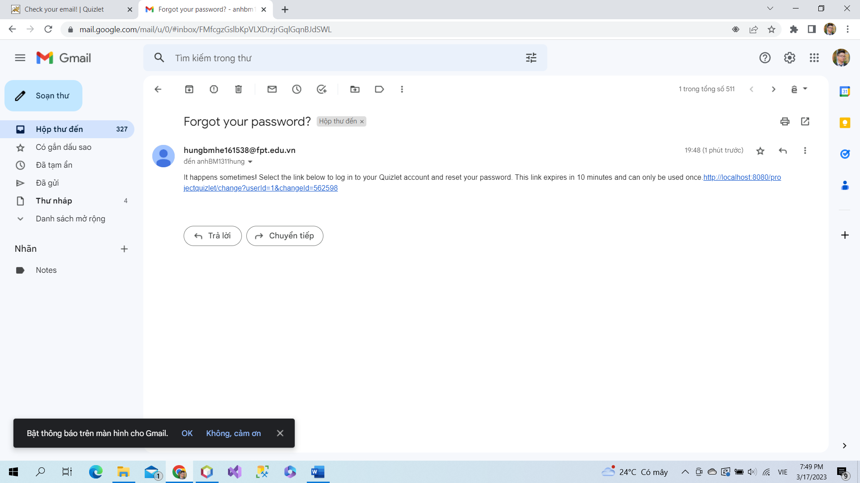

Check email to get link to change password.

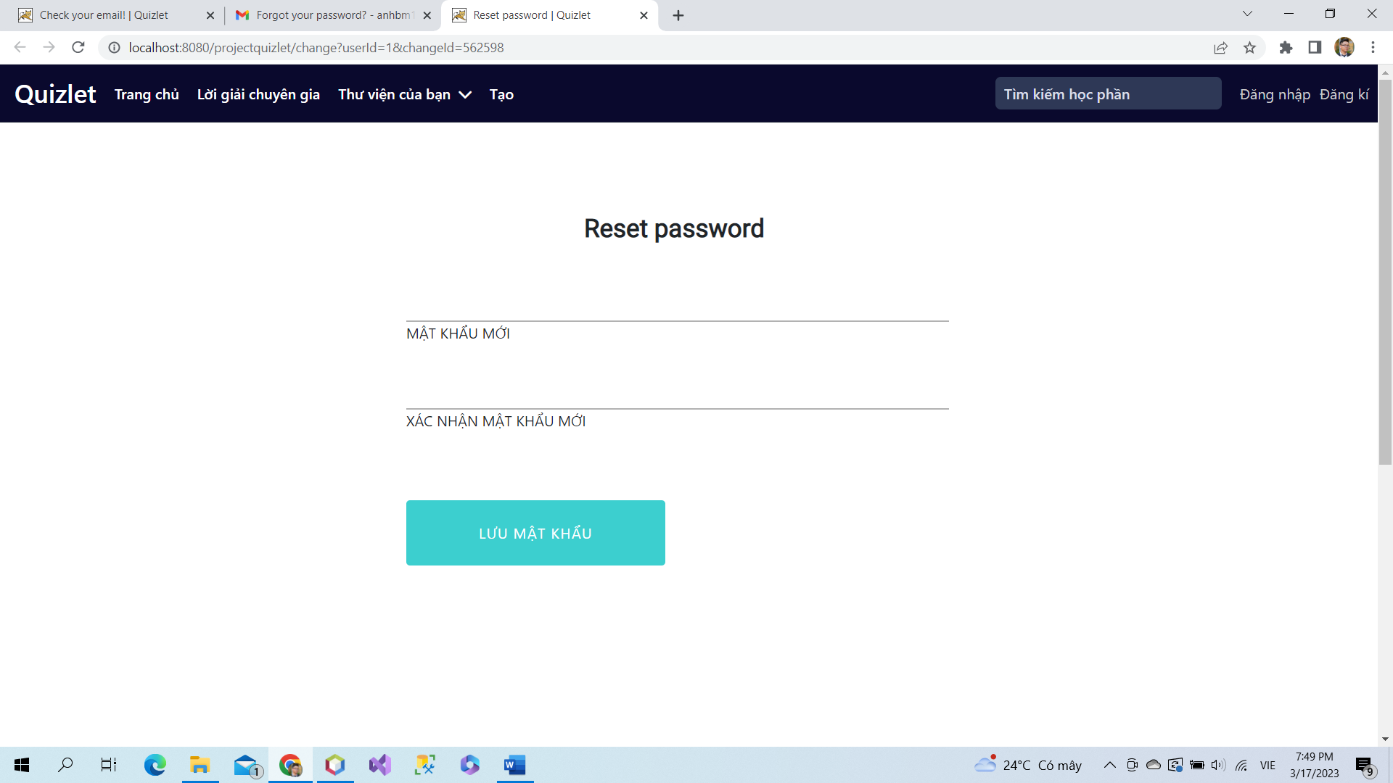

Input new password and confrim it to change password. After save new password, users can login to acccount by new password.

### a. Class Diagram

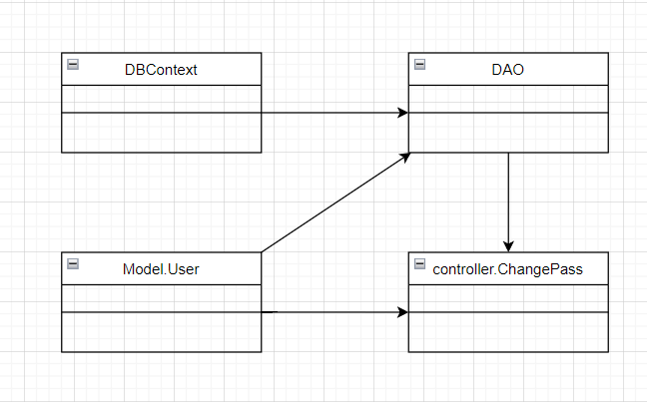

### b. Class Specifications

### User Class

|  |  |  |
| --- | --- | --- |
| **No** | **Method** | **Description** |
| *01* | *User(){}* | Default constructor |
| *02* | *User(….){}* | *Parameterized constructor* |
| *03* | *getName(){}* | *Getter of Name* |
| *04* | *setName(string name){}* | *Setter of Name* |
| *05* | *getPass(){}* | *Getter of Pass* |
| *06* | *setPass(string pass){}* | *Setter of Pass* |
| *07* | *getEmail(){}* | *Getter email* |
| *08* | *setEmail(string email){}* | *Setter of email* |
| *09* | *isIsActive(){}* | *Getter of isActive* |
| *10* | *setIsActive(Boolean isActive){}* | *Setter of isActive* |
| *11* | *getAvatar(){}* | *Getter of avatar* |
| *12* | *setAvatar(string avatar)* | *Setter of avatar* |
| *13* | *getLanguage(){}* | *Getter of language* |
| *14* | *setLanguage(string language){}* | *Setter of language* |

#### DBContext Class

|  |  |  |
| --- | --- | --- |
| **No** | **Method** | **Description** |
| *01* | *DBContext(){}* | *Connect to database* |

#### ChangePass controller Class

|  |  |  |
| --- | --- | --- |
| **No** | **Method** | **Description** |
| *01* | *doGet(){}* | *Check code verify when send email* |
| *02* | *doPost(){}* | *Change password* |

#### DAO Class

|  |  |  |
| --- | --- | --- |
| **No** | **Method** | **Description** |
| *01* | *getIdByEmail(string email){}* | *Get id of user by email* |
| *02* | *updatePass(string pass, int uId){}* | *Update new password* |

### 

### 

### c. Sequence Diagram(s)

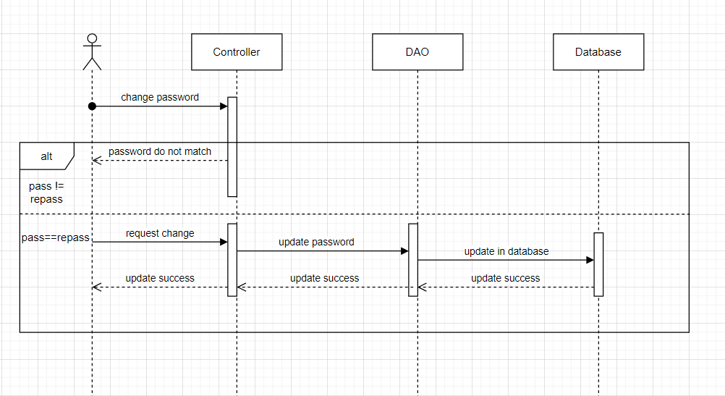

### d. Database Queries

*String sql = "UPDATE [User]\n"*

*+ "SET\n"*

*+ "\n"*

*+ "password = ?\n"*

*+ "\n"*

*+ "WHERE userId = ?";*

## 12.Update studyset

### a. Class Diagram

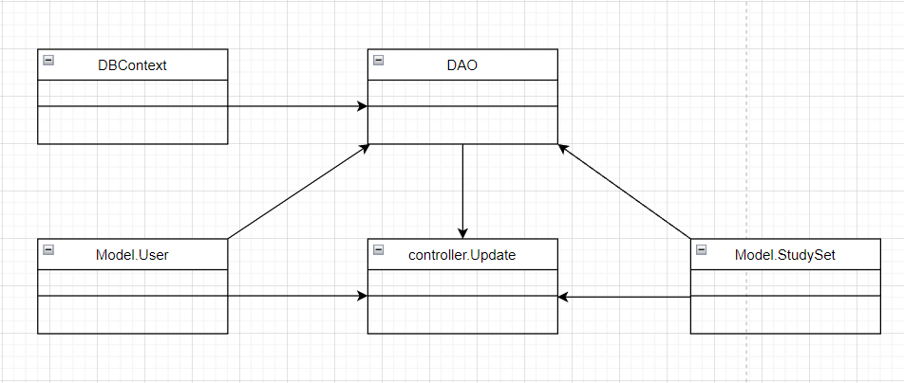

### b. Class Specifications

### User Class

|  |  |  |
| --- | --- | --- |
| **No** | **Method** | **Description** |
| *01* | *User(){}* | Default constructor |
| *02* | *User(….){}* | *Parameterized constructor* |
| *03* | *getName(){}* | *Getter of Name* |
| *04* | *setName(string name){}* | *Setter of Name* |
| *05* | *getPass(){}* | *Getter of Pass* |
| *06* | *setPass(string pass){}* | *Setter of Pass* |
| *07* | *getEmail(){}* | *Getter email* |
| *08* | *setEmail(string email){}* | *Setter of email* |
| *09* | *isIsActive(){}* | *Getter of isActive* |
| *10* | *setIsActive(Boolean isActive){}* | *Setter of isActive* |
| *11* | *getAvatar(){}* | *Getter of avatar* |
| *12* | *setAvatar(string avatar)* | *Setter of avatar* |
| *13* | *getLanguage(){}* | *Getter of language* |
| *14* | *setLanguage(string language){}* | *Setter of language* |

#### DBContext Class

|  |  |  |
| --- | --- | --- |
| **No** | **Method** | **Description** |
| *01* | *DBContext(){}* | *Connect to database* |

#### Update controller Class

|  |  |  |
| --- | --- | --- |
| **No** | **Method** | **Description** |
| *01* | *doGet(){}* | *Get information of all card in study set to update* |
| *02* | *doPost(){}* | *Update or add new cards in study set* |

#### DAO Class

|  |  |  |
| --- | --- | --- |
| **No** | **Method** | **Description** |
| *01* | *getStudySetByID(int id){}* | *Get study set by study set id* |
| *02* | *getAllCardInSet(int id){}* | *Get all cards in study set* |
| *03* | *updateStudySet(studyset s){}* | *Update study set* |
| *04* | *updateCard(Card c){}* | *Update cards in study set* |
| *05* | *addCard(Card c){}* | *Add more cards in study sets* |
|  |  |  |

#### StudySet Class

|  |  |  |
| --- | --- | --- |
| **No** | **Method** | **Description** |
| *01* | *StudySet() {)* | *Default Constructor* |
| *02* | *StudySet(){.....}* | *Parameterized constructor* |
| *03* | *getId(){}* | *getter of StudySetId* |
| *04* | *setId(int id){}* | *setter of StudySetId* |
| *05* | *getTitle(){}* | *getter of Title* |
| *06* | *setTitle(string title){}* | *setter of Title* |
| *07* | *getDescription(){}* | *getter of Description* |
| *08* | *setDescription(string Description){}* | *setter of Description* |
| *09* | *isIsShare() {}* | *getter of isShare* |
| *10* | *setIsShare(boolean isShare) { }* | *setter of isShare* |
| *11* | *getUserId() { }* | *getter of UserId* |
| *12* | *setUserId(int userId) { }* | *setter of UserId* |
| *13* | *getNumberCard() {}* | *get number flashcard in studyset* |
| *14* | *String getAuthor() {}* | *get name of User created studyset* |

### 

### 

### Card Class

|  |  |  |
| --- | --- | --- |
| **No** | **Method** | **Description** |
| *01* | *Card() {)* | *Default Constructor* |
| *02* | *Card(){.....}* | *Parameterized constructor* |
| *03* | *getId(){}* | *getter of CardId* |
| *04* | *setId(int id){}* | *setter of CardId* |
| *05* | *getTerm(){}* | *getter of Term* |
| *06* | *setTerm(string term){}* | *setter of Term* |
| *07* | *getDefinition(){}* | *getter of Definition* |
| *08* | *setDefinition(string Definition){}* | *setter of Definition* |
| *09* | *getStudySetId() { }* | *getter of StudySetId* |
| *10* | *setStudySetId(int studySetId) { }* | *setter of StudySetId* |

### 

### 

### 

### c. Sequence Diagram(s)

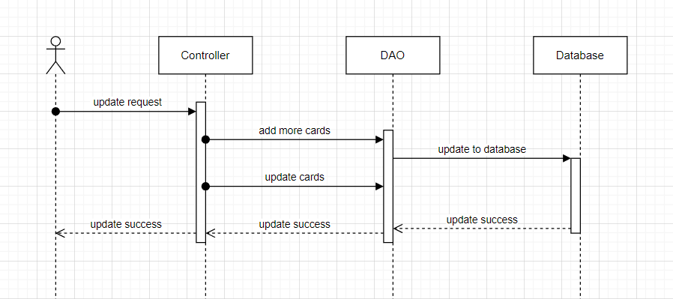

### d. Database Queries

*String sql = "UPDATE [dbo].[StudySet]\n"*

*+ " SET [title] = ?\n"*

*+ " ,[description] = ?\n"*

*+ " ,[isShare] = ?\n"*

*+ " WHERE studySetId=?";*

## 13.Home

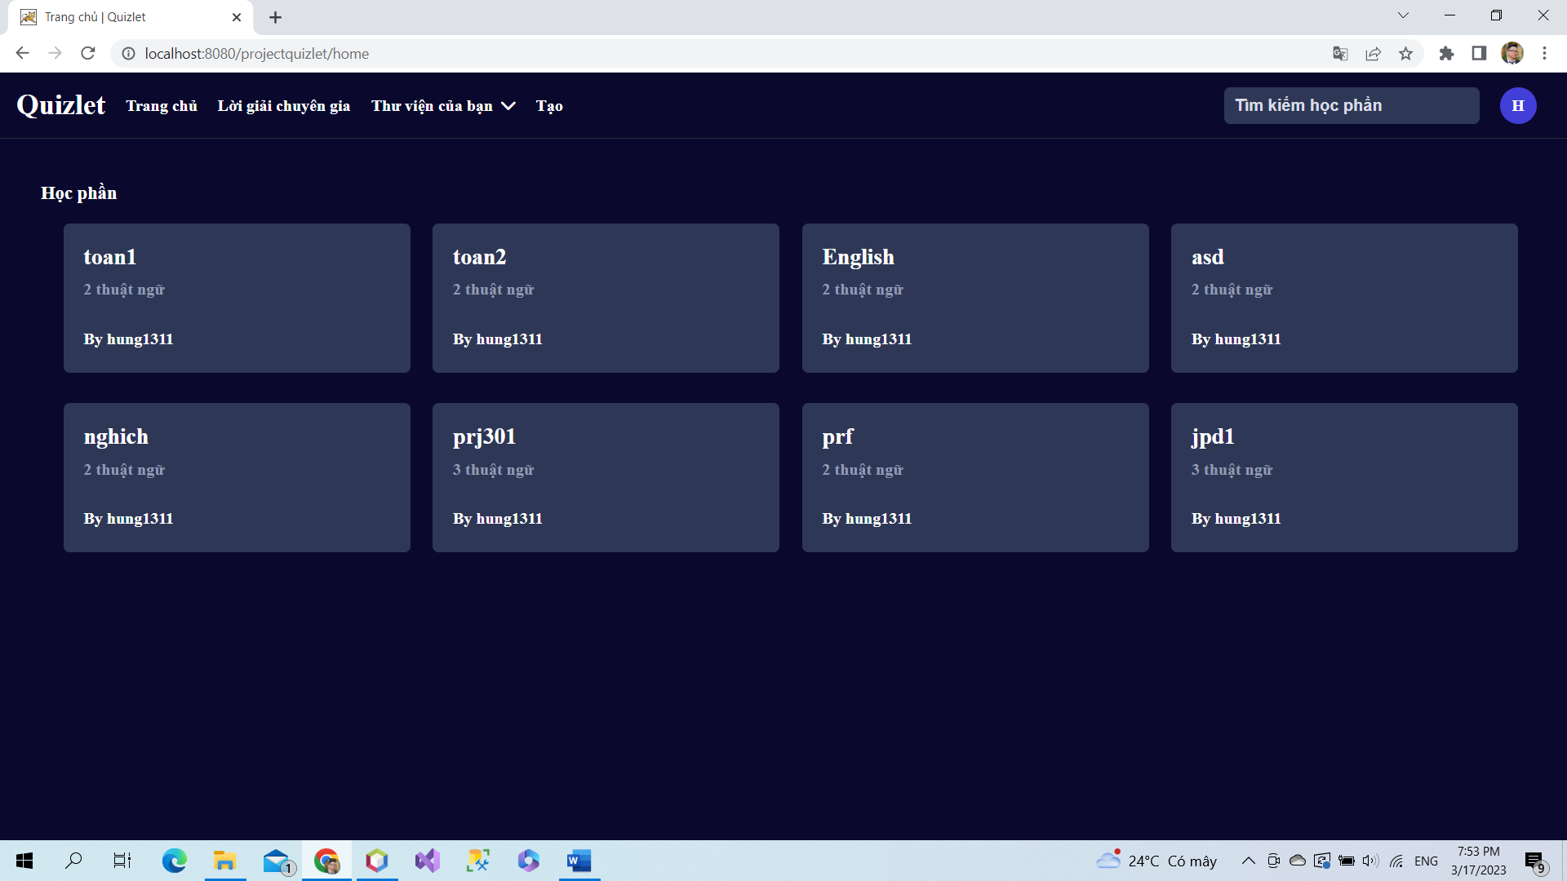

After login users will access to home page and user can use all feature of page.

### a. Class Diagram

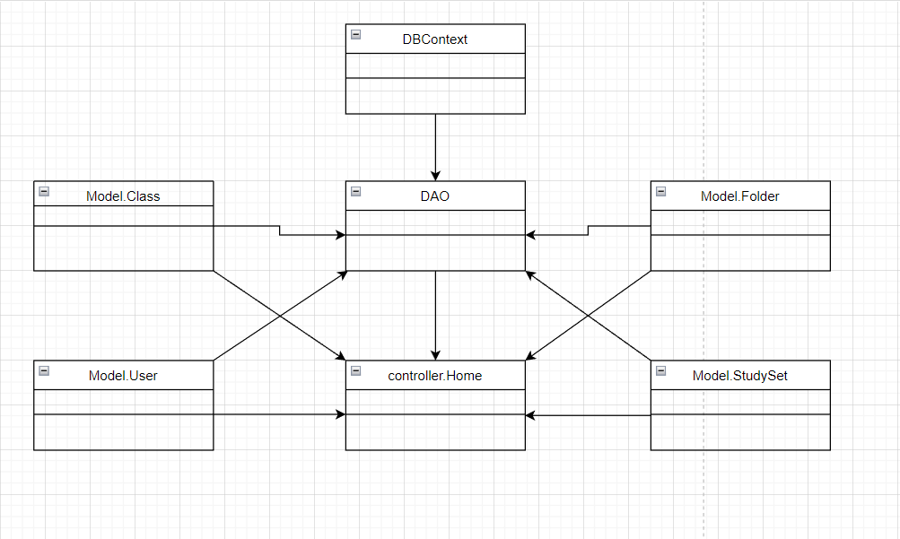

### b. Class Specifications

### User Class

|  |  |  |
| --- | --- | --- |
| **No** | **Method** | **Description** |
| *01* | *User(){}* | Default constructor |
| *02* | *User(….){}* | *Parameterized constructor* |
| *03* | *getName(){}* | *Getter of Name* |
| *04* | *setName(string name){}* | *Setter of Name* |
| *05* | *getPass(){}* | *Getter of Pass* |
| *06* | *setPass(string pass){}* | *Setter of Pass* |
| *07* | *getEmail(){}* | *Getter email* |
| *08* | *setEmail(string email){}* | *Setter of email* |
| *09* | *isIsActive(){}* | *Getter of isActive* |
| *10* | *setIsActive(Boolean isActive){}* | *Setter of isActive* |
| *11* | *getAvatar(){}* | *Getter of avatar* |
| *12* | *setAvatar(string avatar)* | *Setter of avatar* |
| *13* | *getLanguage(){}* | *Getter of language* |
| *14* | *setLanguage(string language){}* | *Setter of language* |

#### DBContext Class

|  |  |  |
| --- | --- | --- |
| **No** | **Method** | **Description** |
| *01* | *DBContext(){}* | *Connect to database* |

#### Home controller Class

|  |  |  |
| --- | --- | --- |
| **No** | **Method** | **Description** |
| *01* | *doGet(){}* | *List all studySet and your library* |

#### DAO Class

|  |  |  |
| --- | --- | --- |
| **No** | **Method** | **Description** |
| *01* | *getAllStudySet(string email){}* | *Get all study set* |
| *02* | *getFiveStudySet(int id){}* | *Get top 5 study set order by id* |
| *03* | *getUserByUserID(int id){}* | *Get user by user id* |
| *04* | *getTopFiveFolder(int id){}* | *Get top 5 folder order by id* |

#### StudySet Class

|  |  |  |
| --- | --- | --- |
| **No** | **Method** | **Description** |
| *01* | *StudySet() {)* | *Default Constructor* |
| *02* | *StudySet(){.....}* | *Parameterized constructor* |
| *03* | *getId(){}* | *getter of StudySetId* |
| *04* | *setId(int id){}* | *setter of StudySetId* |
| *05* | *getTitle(){}* | *getter of Title* |
| *06* | *setTitle(string title){}* | *setter of Title* |
| *07* | *getDescription(){}* | *getter of Description* |
| *08* | *setDescription(string Description){}* | *setter of Description* |
| *09* | *isIsShare() {}* | *getter of isShare* |
| *10* | *setIsShare(boolean isShare) { }* | *setter of isShare* |
| *11* | *getUserId() { }* | *getter of UserId* |
| *12* | *setUserId(int userId) { }* | *setter of UserId* |
| *13* | *getNumberCard() {}* | *get number flashcard in studyset* |
| *14* | *String getAuthor() {}* | *get name of User created studyset* |

### 

### 

### Folder Class

|  |  |  |
| --- | --- | --- |
| **No** | **Method** | **Description** |
| *01* | *Folder() {)* | *Default Constructor* |
| *02* | *Folder(){.....}* | *Parameterized constructor* |
| *03* | *getId(){}* | *getter of CardId* |
| *04* | *setId(int id){}* | *setter of CardId* |
| *05* | *getTitle(){}* | *getter of Title* |
| *06* | *setTitle(string term){}* | *setter of Title* |
| *07* | *getDescription(){}* | *getter of Description* |
| *08* | *setDescription(string Definition){}* | *setter of Description* |
| *09* | *getUserId() { }* | *getter of UserId* |
| *10* | *setUserId(int UserId) { }* | *setter of UserId* |

### 

### Class Class

|  |  |  |
| --- | --- | --- |
| **No** | **Method** | **Description** |
| *01* | *Class() {)* | *Default Constructor* |
| *02* | *Class(){.....}* | *Parameterized constructor* |
| *03* | *getId(){}* | *getter of Class Id* |
| *04* | *setId(int id){}* | *setter of Class Id* |
| *05* | *getName(){}* | *getter of Class Name* |
| *06* | *setName(string name){}* | *setter of Class Name* |
| *07* | *getDesc(){}* | *getter of Desc* |
| *08* | *setDesc(string Desc){}* | *setter of Desc* |
| *09* | *getUserId() { }* | *getter of UserId* |
| *10* | *setUserId(int UserId) { }* | *setter of UserId* |
| *11* | *isIsInvite() {}* | *getter of isInvite* |
| *12* | *setIsInvite(boolean isInvite) { }* | *setter of isInvite* |
| *13* | *isIsEdit() {}* | *getter of isEdit* |
| *14* | *setIsEdit(boolean isEdit) { }* | *setter of isEdit* |
| *15* | *getInviteCode() {}* | *getter of inviteCode* |
| *16* | *setInviteCode(string inviteCode) { }* | *setter of inviteCode* |
| *17* | *getSchoolName() {}* | *getter of schoolName* |
| *18* | *setSchoolName(string inviteCode) { }* | *setter of schoolName* |

### 

### c. Sequence Diagram(s)

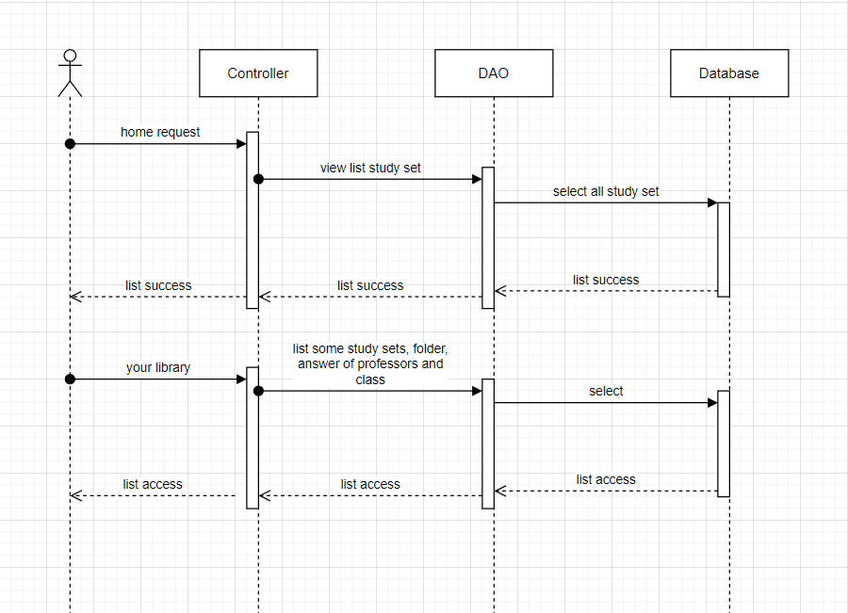

### d. Database Queries

*String sql = "Select * from StudySet";*

*String sql = "select top 5 * from StudySet where userId = ? order by studySetId desc";*

*String sql = "select top 5 * from Folder where userId = ? order by folderId desc ";*

## 14.Class set

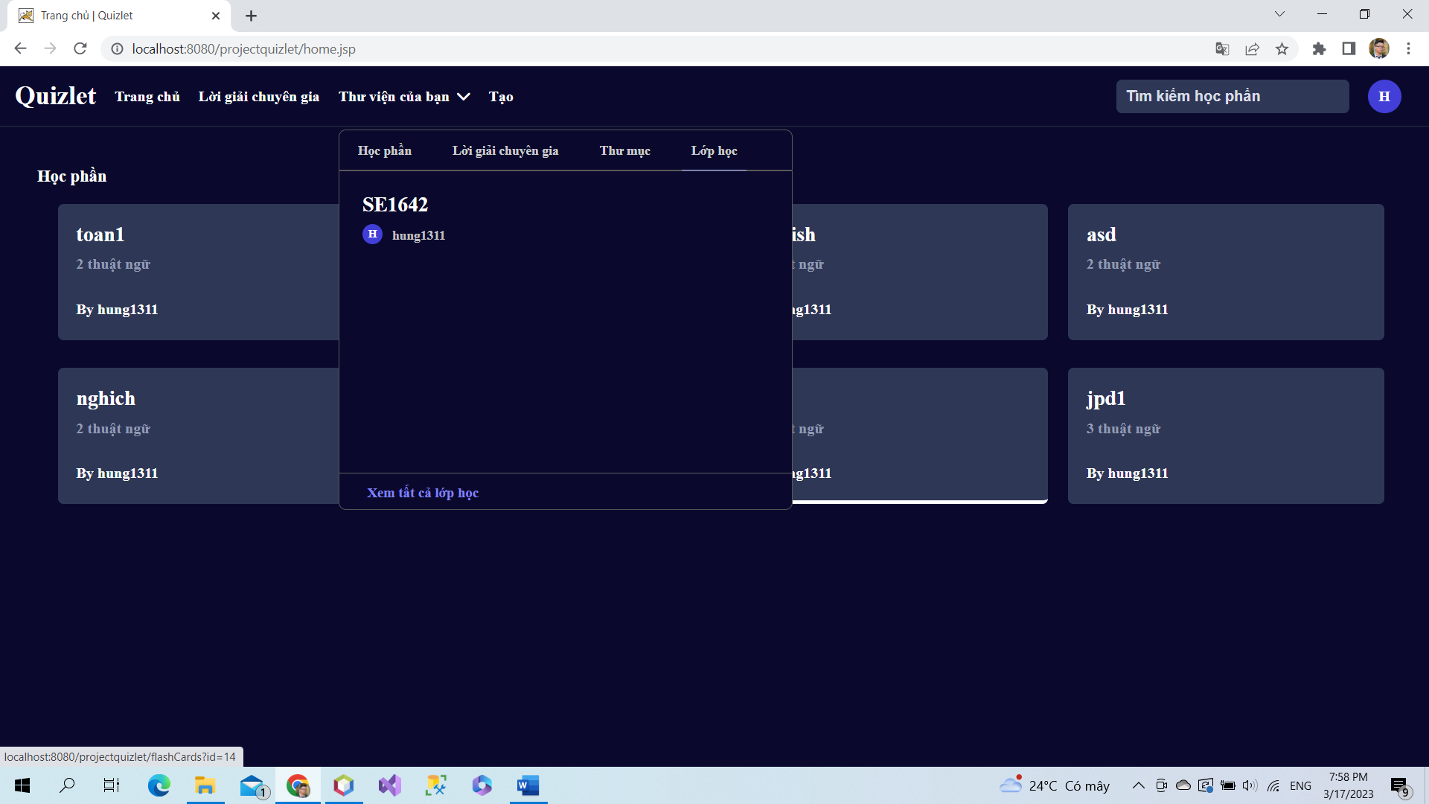

Click to view all class

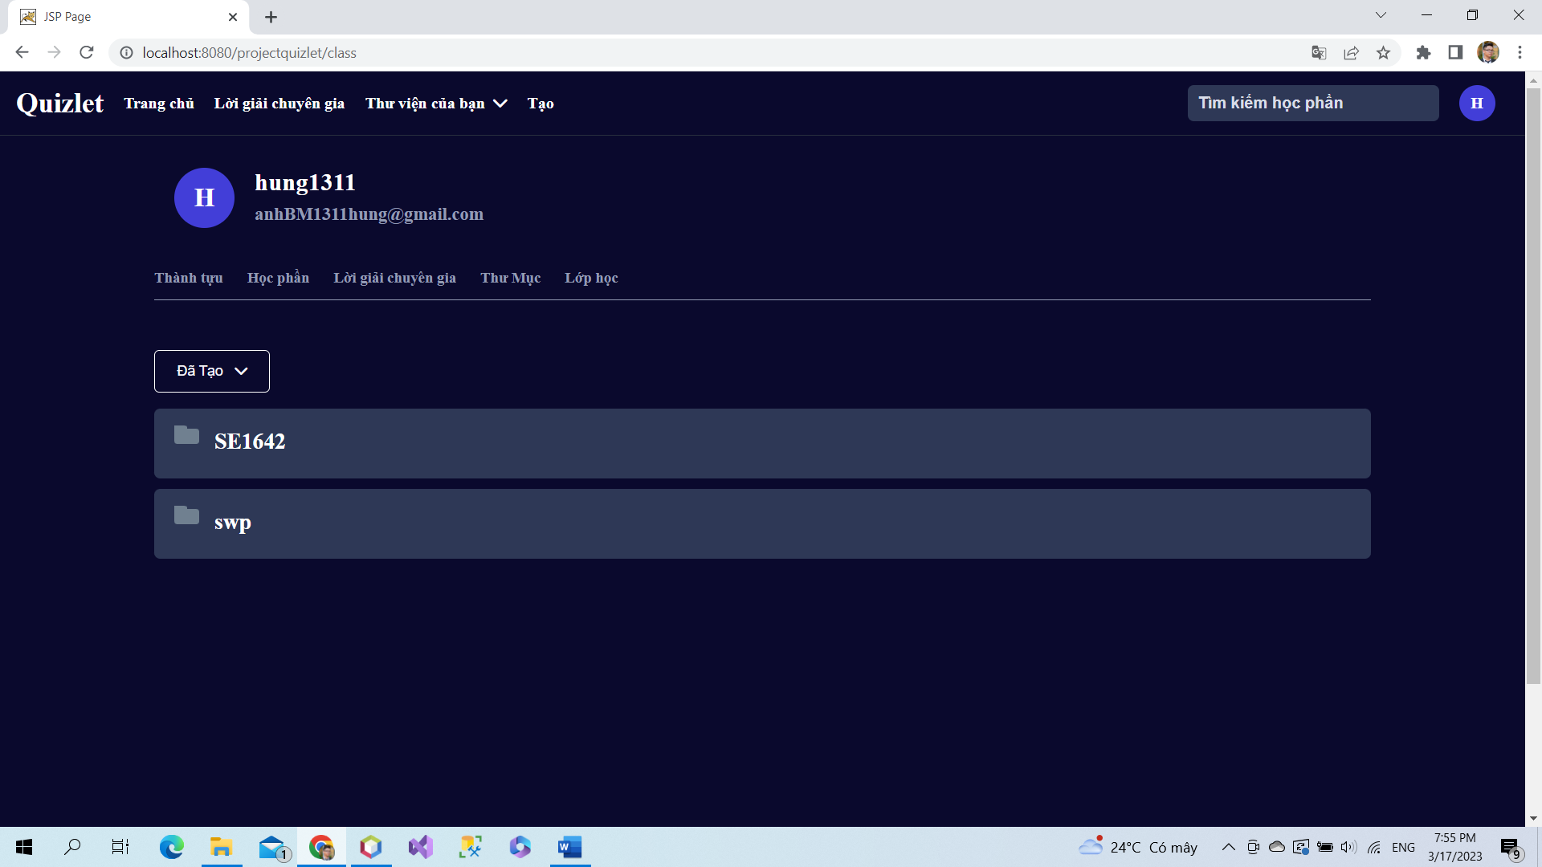

User can view list all class sets created by them.

### a. Class Diagram

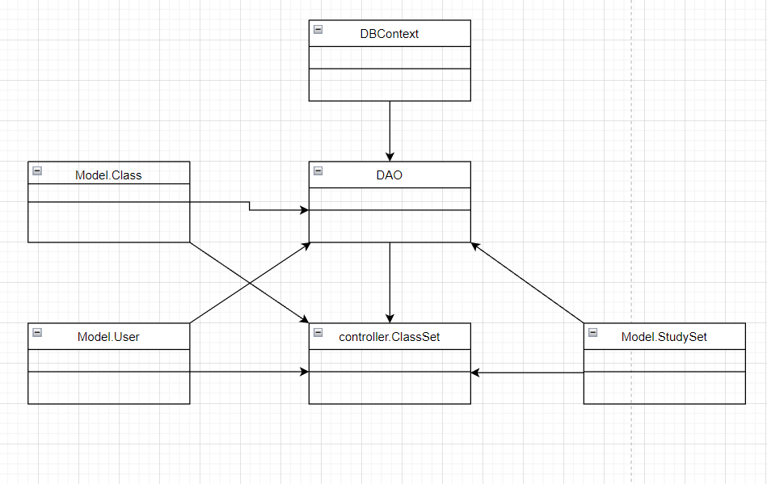

### b. Class Specifications

### User Class

|  |  |  |
| --- | --- | --- |
| **No** | **Method** | **Description** |
| *01* | *User(){}* | Default constructor |
| *02* | *User(….){}* | *Parameterized constructor* |
| *03* | *getName(){}* | *Getter of Name* |
| *04* | *setName(string name){}* | *Setter of Name* |
| *05* | *getPass(){}* | *Getter of Pass* |
| *06* | *setPass(string pass){}* | *Setter of Pass* |
| *07* | *getEmail(){}* | *Getter email* |
| *08* | *setEmail(string email){}* | *Setter of email* |
| *09* | *isIsActive(){}* | *Getter of isActive* |
| *10* | *setIsActive(Boolean isActive){}* | *Setter of isActive* |
| *11* | *getAvatar(){}* | *Getter of avatar* |
| *12* | *setAvatar(string avatar)* | *Setter of avatar* |
| *13* | *getLanguage(){}* | *Getter of language* |
| *14* | *setLanguage(string language){}* | *Setter of language* |

#### DBContext Class

|  |  |  |
| --- | --- | --- |
| **No** | **Method** | **Description** |
| *01* | *DBContext(){}* | *Connect to database* |

#### ClassSet controller Class

|  |  |  |
| --- | --- | --- |
| **No** | **Method** | **Description** |
| *01* | *doGet(){}* | *List information of class and information of study sets in class* |

#### DAO Class

|  |  |  |
| --- | --- | --- |
| **No** | **Method** | **Description** |
| *01* | *getListStudySetbyClassId(int id){}* | *Get all study set in a class* |
| *02* | *getClassByClassID(int id){}* | *Get class by class id* |
| *03* | *getAllStudySet(){}* | *Get all study set* |

#### StudySet Class

|  |  |  |
| --- | --- | --- |
| **No** | **Method** | **Description** |
| *01* | *StudySet() {)* | *Default Constructor* |
| *02* | *StudySet(){.....}* | *Parameterized constructor* |
| *03* | *getId(){}* | *getter of StudySetId* |
| *04* | *setId(int id){}* | *setter of StudySetId* |
| *05* | *getTitle(){}* | *getter of Title* |
| *06* | *setTitle(string title){}* | *setter of Title* |
| *07* | *getDescription(){}* | *getter of Description* |
| *08* | *setDescription(string Description){}* | *setter of Description* |
| *09* | *isIsShare() {}* | *getter of isShare* |
| *10* | *setIsShare(boolean isShare) { }* | *setter of isShare* |
| *11* | *getUserId() { }* | *getter of UserId* |
| *12* | *setUserId(int userId) { }* | *setter of UserId* |
| *13* | *getNumberCard() {}* | *get number flashcard in studyset* |
| *14* | *String getAuthor() {}* | *get name of User created studyset* |

### Class Class

|  |  |  |
| --- | --- | --- |
| **No** | **Method** | **Description** |
| *01* | *Class() {)* | *Default Constructor* |
| *02* | *Class(){.....}* | *Parameterized constructor* |
| *03* | *getId(){}* | *getter of Class Id* |
| *04* | *setId(int id){}* | *setter of Class Id* |
| *05* | *getName(){}* | *getter of Class Name* |
| *06* | *setName(string name){}* | *setter of Class Name* |
| *07* | *getDesc(){}* | *getter of Desc* |
| *08* | *setDesc(string Desc){}* | *setter of Desc* |
| *09* | *getUserId() { }* | *getter of UserId* |
| *10* | *setUserId(int UserId) { }* | *setter of UserId* |
| *11* | *isIsInvite() {}* | *getter of isInvite* |
| *12* | *setIsInvite(boolean isInvite) { }* | *setter of isInvite* |
| *13* | *isIsEdit() {}* | *getter of isEdit* |
| *14* | *setIsEdit(boolean isEdit) { }* | *setter of isEdit* |
| *15* | *getInviteCode() {}* | *getter of inviteCode* |
| *16* | *setInviteCode(string inviteCode) { }* | *setter of inviteCode* |
| *17* | *getSchoolName() {}* | *getter of schoolName* |
| *18* | *setSchoolName(string inviteCode) { }* | *setter of schoolName* |

### 

### c. Sequence Diagram(s)

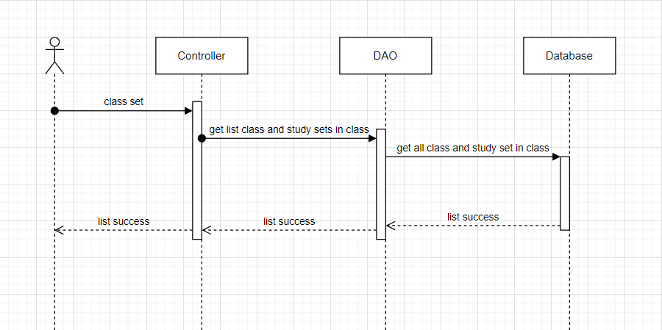

### d. Database Queries

*String sql = "select*from [Class] where classId=?";*

*String sql = "Select * from StudySet";*

## 15.Folder set

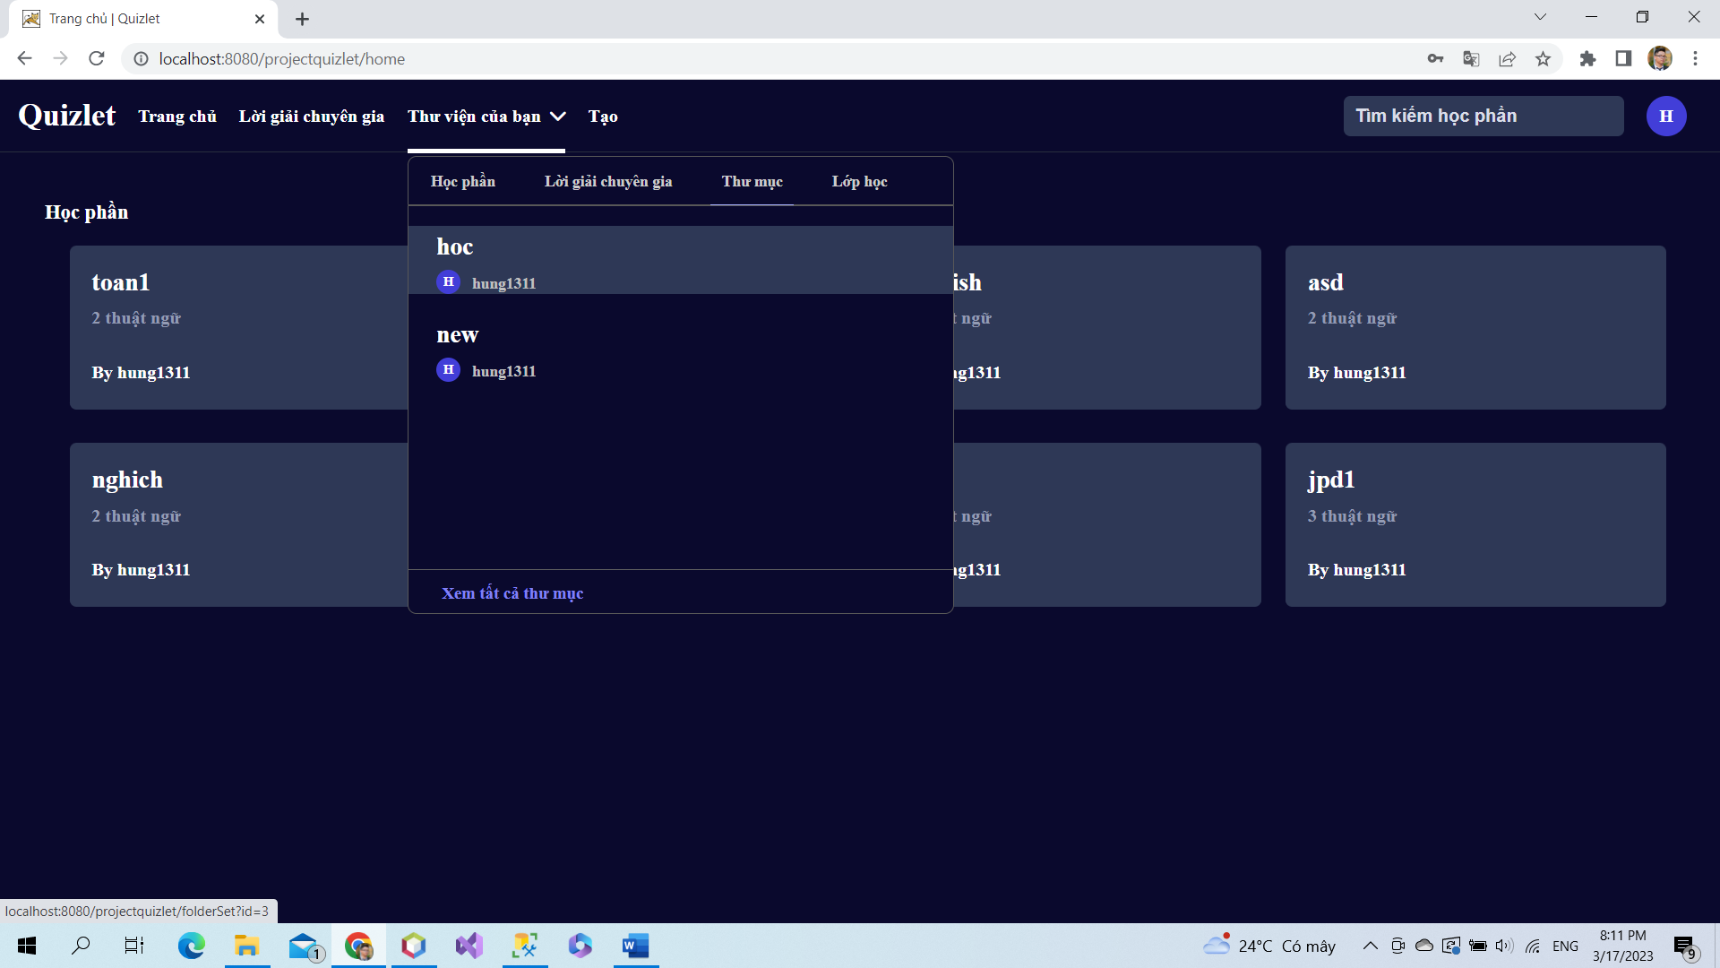

Click to view all folder to view list folder created

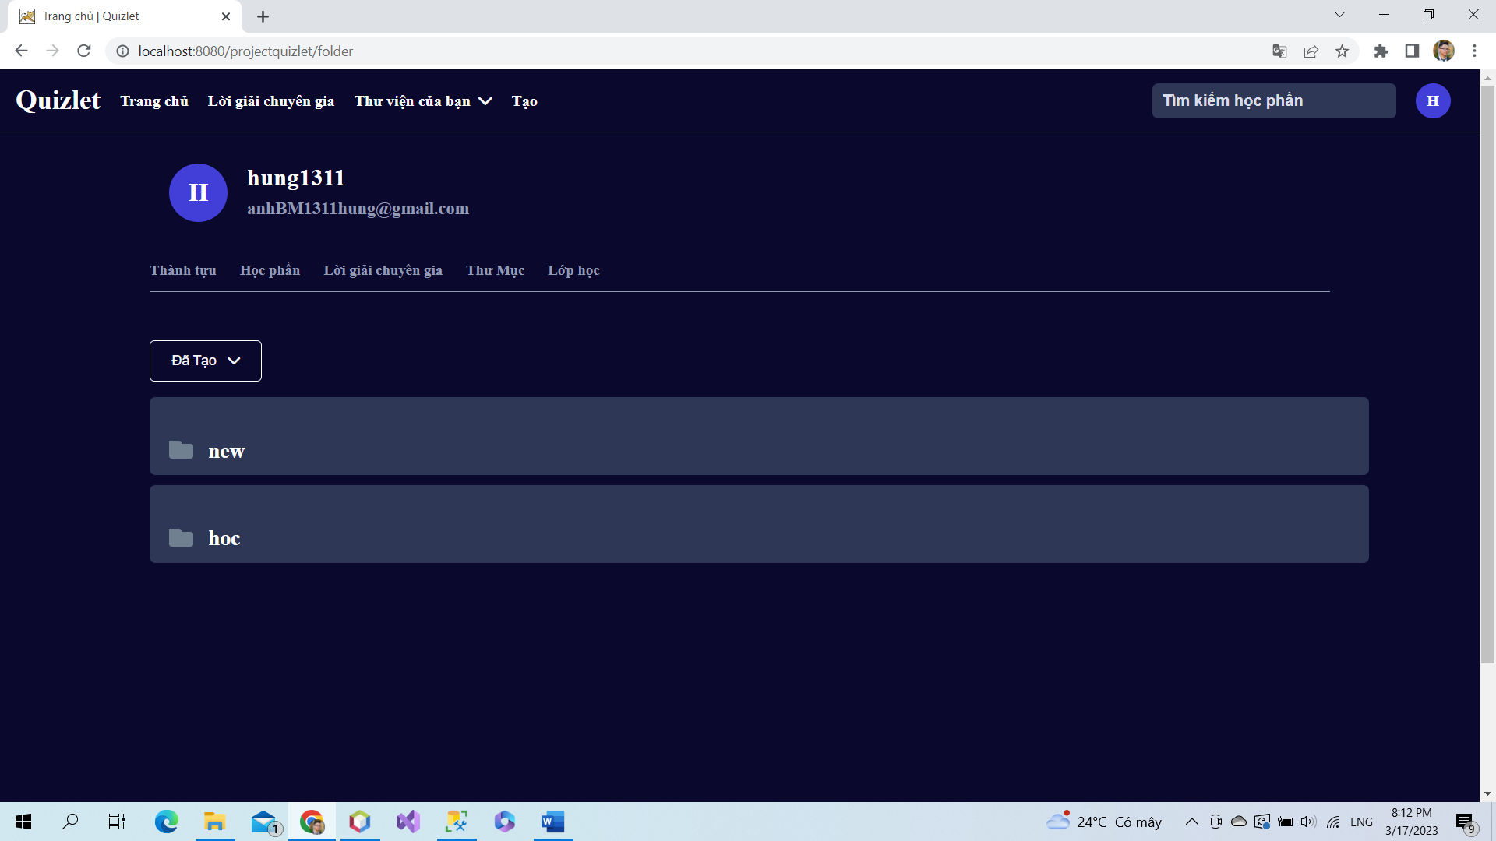

User can view list folder set of them.

### a. Class Diagram

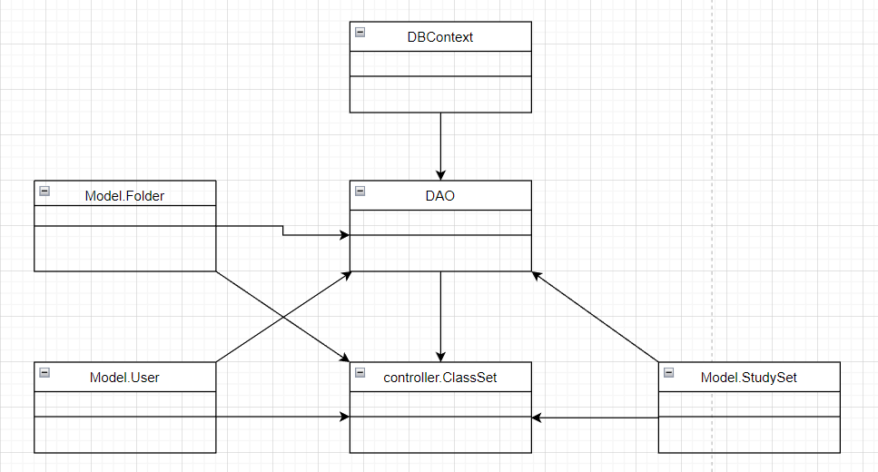

### b. Class Specifications

### User Class

|  |  |  |
| --- | --- | --- |
| **No** | **Method** | **Description** |
| *01* | *User(){}* | Default constructor |
| *02* | *User(….){}* | *Parameterized constructor* |
| *03* | *getName(){}* | *Getter of Name* |
| *04* | *setName(string name){}* | *Setter of Name* |
| *05* | *getPass(){}* | *Getter of Pass* |
| *06* | *setPass(string pass){}* | *Setter of Pass* |
| *07* | *getEmail(){}* | *Getter email* |
| *08* | *setEmail(string email){}* | *Setter of email* |
| *09* | *isIsActive(){}* | *Getter of isActive* |
| *10* | *setIsActive(Boolean isActive){}* | *Setter of isActive* |
| *11* | *getAvatar(){}* | *Getter of avatar* |
| *12* | *setAvatar(string avatar)* | *Setter of avatar* |
| *13* | *getLanguage(){}* | *Getter of language* |
| *14* | *setLanguage(string language){}* | *Setter of language* |

#### DBContext Class

|  |  |  |
| --- | --- | --- |
| **No** | **Method** | **Description** |
| *01* | *DBContext(){}* | *Connect to database* |

#### FolderSet controller Class

|  |  |  |
| --- | --- | --- |
| **No** | **Method** | **Description** |
| *01* | *doGet(){}* | *Get List study set* |
| *02* | *doPost(){}* | *Delete folder and study set in folder* |

#### DAO Class

|  |  |  |
| --- | --- | --- |
| **No** | **Method** | **Description** |
| *01* | *getListStudySet(int id){}* | *Get list study set and card in study set* |
| *02* | *getFolderByFolderId(int id){}* | *Get folder by folder id* |
| *03* | *getAllStudySet()* | *Get info of study set* |
| *04* | *removeListFolder(int id){}* | *Get remove list folder* |
| *05* | *deleteFolderByFolderId(int id){}* | *Delete folder by folder id* |

#### StudySet Class

|  |  |  |
| --- | --- | --- |
| **No** | **Method** | **Description** |
| *01* | *StudySet() {)* | *Default Constructor* |
| *02* | *StudySet(){.....}* | *Parameterized constructor* |
| *03* | *getId(){}* | *getter of StudySetId* |
| *04* | *setId(int id){}* | *setter of StudySetId* |
| *05* | *getTitle(){}* | *getter of Title* |
| *06* | *setTitle(string title){}* | *setter of Title* |
| *07* | *getDescription(){}* | *getter of Description* |
| *08* | *setDescription(string Description){}* | *setter of Description* |
| *09* | *isIsShare() {}* | *getter of isShare* |
| *10* | *setIsShare(boolean isShare) { }* | *setter of isShare* |
| *11* | *getUserId() { }* | *getter of UserId* |
| *12* | *setUserId(int userId) { }* | *setter of UserId* |
| *13* | *getNumberCard() {}* | *get number flashcard in studyset* |
| *14* | *String getAuthor() {}* | *get name of User created studyset* |

### 

### Folder Class

|  |  |  |
| --- | --- | --- |
| **No** | **Method** | **Description** |
| *01* | *Folder() {)* | *Default Constructor* |
| *02* | *Folder(){.....}* | *Parameterized constructor* |
| *03* | *getId(){}* | *getter of CardId* |
| *04* | *setId(int id){}* | *setter of CardId* |
| *05* | *getTitle(){}* | *getter of Title* |
| *06* | *setTitle(string term){}* | *setter of Title* |
| *07* | *getDescription(){}* | *getter of Description* |
| *08* | *setDescription(string Definition){}* | *setter of Description* |
| *09* | *getUserId() { }* | *getter of UserId* |
| *10* | *setUserId(int UserId) { }* | *setter of UserId* |

### 

### c. Sequence Diagram(s)

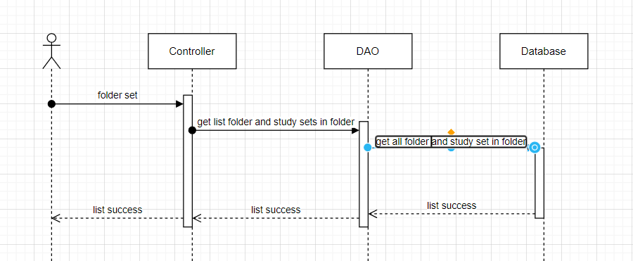

### d. Database Queries

*String sql = "select * from [Folder] where folderId =? ";*

*String sql = "Select * from StudySet";*

## 16.Study set list

### a. Class Diagram

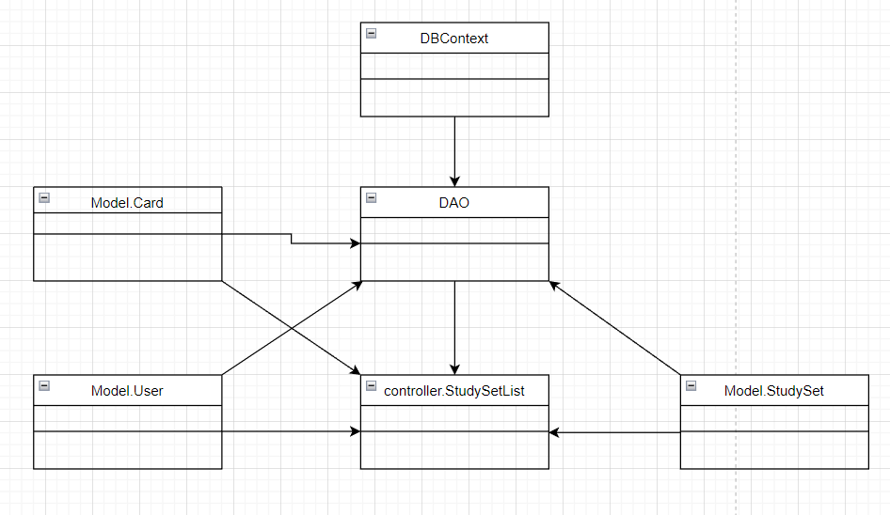

### b. Class Specifications

### User Class

|  |  |  |
| --- | --- | --- |
| **No** | **Method** | **Description** |
| *01* | *User(){}* | Default constructor |
| *02* | *User(….){}* | *Parameterized constructor* |
| *03* | *getName(){}* | *Getter of Name* |
| *04* | *setName(string name){}* | *Setter of Name* |
| *05* | *getPass(){}* | *Getter of Pass* |
| *06* | *setPass(string pass){}* | *Setter of Pass* |
| *07* | *getEmail(){}* | *Getter email* |
| *08* | *setEmail(string email){}* | *Setter of email* |
| *09* | *isIsActive(){}* | *Getter of isActive* |
| *10* | *setIsActive(Boolean isActive){}* | *Setter of isActive* |
| *11* | *getAvatar(){}* | *Getter of avatar* |
| *12* | *setAvatar(string avatar)* | *Setter of avatar* |
| *13* | *getLanguage(){}* | *Getter of language* |
| *14* | *setLanguage(string language){}* | *Setter of language* |

#### DBContext Class

|  |  |  |
| --- | --- | --- |
| **No** | **Method** | **Description** |
| *01* | *DBContext(){}* | *Connect to database* |

#### Verify controller Class

|  |  |  |
| --- | --- | --- |
| **No** | **Method** | **Description** |
| *01* | *doGet(){}* | *Send redirect to verify.jsp* |
| *02* | *doPost(){}* | *Active account by verify code* |

#### DAO Class

|  |  |  |
| --- | --- | --- |
| **No** | **Method** | **Description** |
| *01* | *Active account(string email){}* | *Update is active in database* |

#### StudySet Class

|  |  |  |
| --- | --- | --- |
| **No** | **Method** | **Description** |
| *01* | *StudySet() {)* | *Default Constructor* |
| *02* | *StudySet(){.....}* | *Parameterized constructor* |
| *03* | *getId(){}* | *getter of StudySetId* |
| *04* | *setId(int id){}* | *setter of StudySetId* |
| *05* | *getTitle(){}* | *getter of Title* |
| *06* | *setTitle(string title){}* | *setter of Title* |
| *07* | *getDescription(){}* | *getter of Description* |
| *08* | *setDescription(string Description){}* | *setter of Description* |
| *09* | *isIsShare() {}* | *getter of isShare* |
| *10* | *setIsShare(boolean isShare) { }* | *setter of isShare* |
| *11* | *getUserId() { }* | *getter of UserId* |
| *12* | *setUserId(int userId) { }* | *setter of UserId* |
| *13* | *getNumberCard() {}* | *get number flashcard in studyset* |
| *14* | *String getAuthor() {}* | *get name of User created studyset* |

### 

### 

### Folder Class

|  |  |  |
| --- | --- | --- |
| **No** | **Method** | **Description** |
| *01* | *Folder() {)* | *Default Constructor* |
| *02* | *Folder(){.....}* | *Parameterized constructor* |
| *03* | *getId(){}* | *getter of CardId* |
| *04* | *setId(int id){}* | *setter of CardId* |
| *05* | *getTitle(){}* | *getter of Title* |
| *06* | *setTitle(string term){}* | *setter of Title* |
| *07* | *getDescription(){}* | *getter of Description* |
| *08* | *setDescription(string Definition){}* | *setter of Description* |
| *09* | *getUserId() { }* | *getter of UserId* |
| *10* | *setUserId(int UserId) { }* | *setter of UserId* |

### 

### 

### 

### Class Class

|  |  |  |
| --- | --- | --- |
| **No** | **Method** | **Description** |
| *01* | *Class() {)* | *Default Constructor* |
| *02* | *Class(){.....}* | *Parameterized constructor* |
| *03* | *getId(){}* | *getter of Class Id* |
| *04* | *setId(int id){}* | *setter of Class Id* |
| *05* | *getName(){}* | *getter of Class Name* |
| *06* | *setName(string name){}* | *setter of Class Name* |
| *07* | *getDesc(){}* | *getter of Desc* |
| *08* | *setDesc(string Desc){}* | *setter of Desc* |
| *09* | *getUserId() { }* | *getter of UserId* |
| *10* | *setUserId(int UserId) { }* | *setter of UserId* |
| *11* | *isIsInvite() {}* | *getter of isInvite* |
| *12* | *setIsInvite(boolean isInvite) { }* | *setter of isInvite* |
| *13* | *isIsEdit() {}* | *getter of isEdit* |
| *14* | *setIsEdit(boolean isEdit) { }* | *setter of isEdit* |
| *15* | *getInviteCode() {}* | *getter of inviteCode* |
| *16* | *setInviteCode(string inviteCode) { }* | *setter of inviteCode* |
| *17* | *getSchoolName() {}* | *getter of schoolName* |
| *18* | *setSchoolName(string inviteCode) { }* | *setter of schoolName* |

### 

### Card Class

|  |  |  |
| --- | --- | --- |
| **No** | **Method** | **Description** |
| *01* | *Card() {)* | *Default Constructor* |
| *02* | *Card(){.....}* | *Parameterized constructor* |
| *03* | *getId(){}* | *getter of CardId* |
| *04* | *setId(int id){}* | *setter of CardId* |
| *05* | *getTerm(){}* | *getter of Term* |
| *06* | *setTerm(string term){}* | *setter of Term* |
| *07* | *getDefinition(){}* | *getter of Definition* |
| *08* | *setDefinition(string Definition){}* | *setter of Definition* |
| *09* | *getStudySetId() { }* | *getter of StudySetId* |
| *10* | *setStudySetId(int studySetId) { }* | *setter of StudySetId* |

### 

### c. Sequence Diagram(s)

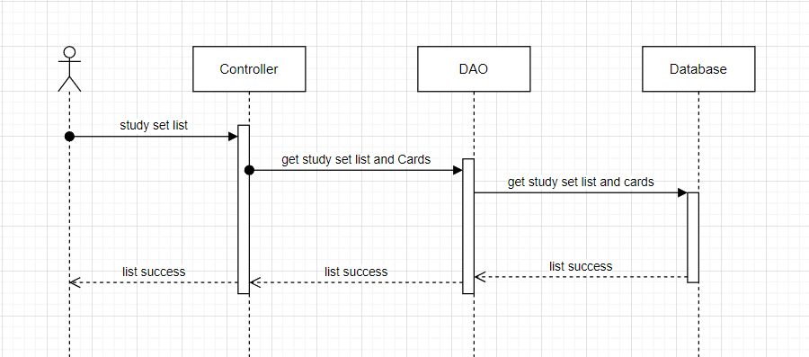

### d. Database Queries

*String sql = "UPDATE [User]\n"*

*+ "SET\n"*

*+ "\n"*

*+ "password = ?\n"*

*+ "\n"*

*+ "WHERE userId = ?";*

## 17.Controller folder set

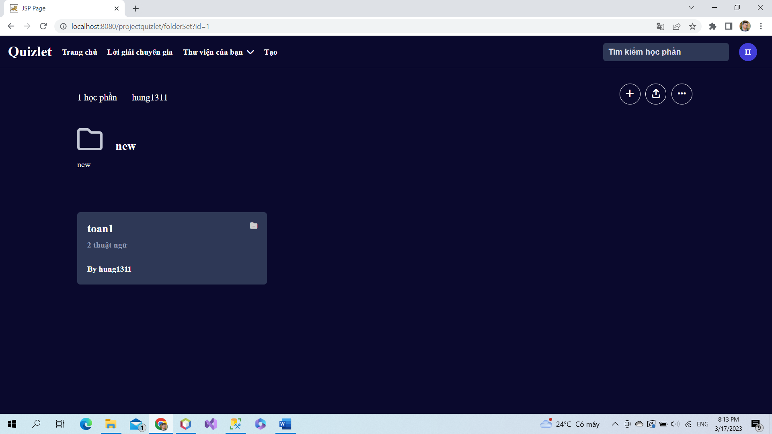

If users want to view folder, they can click to folder. Then, user can add or delete study set to other users.

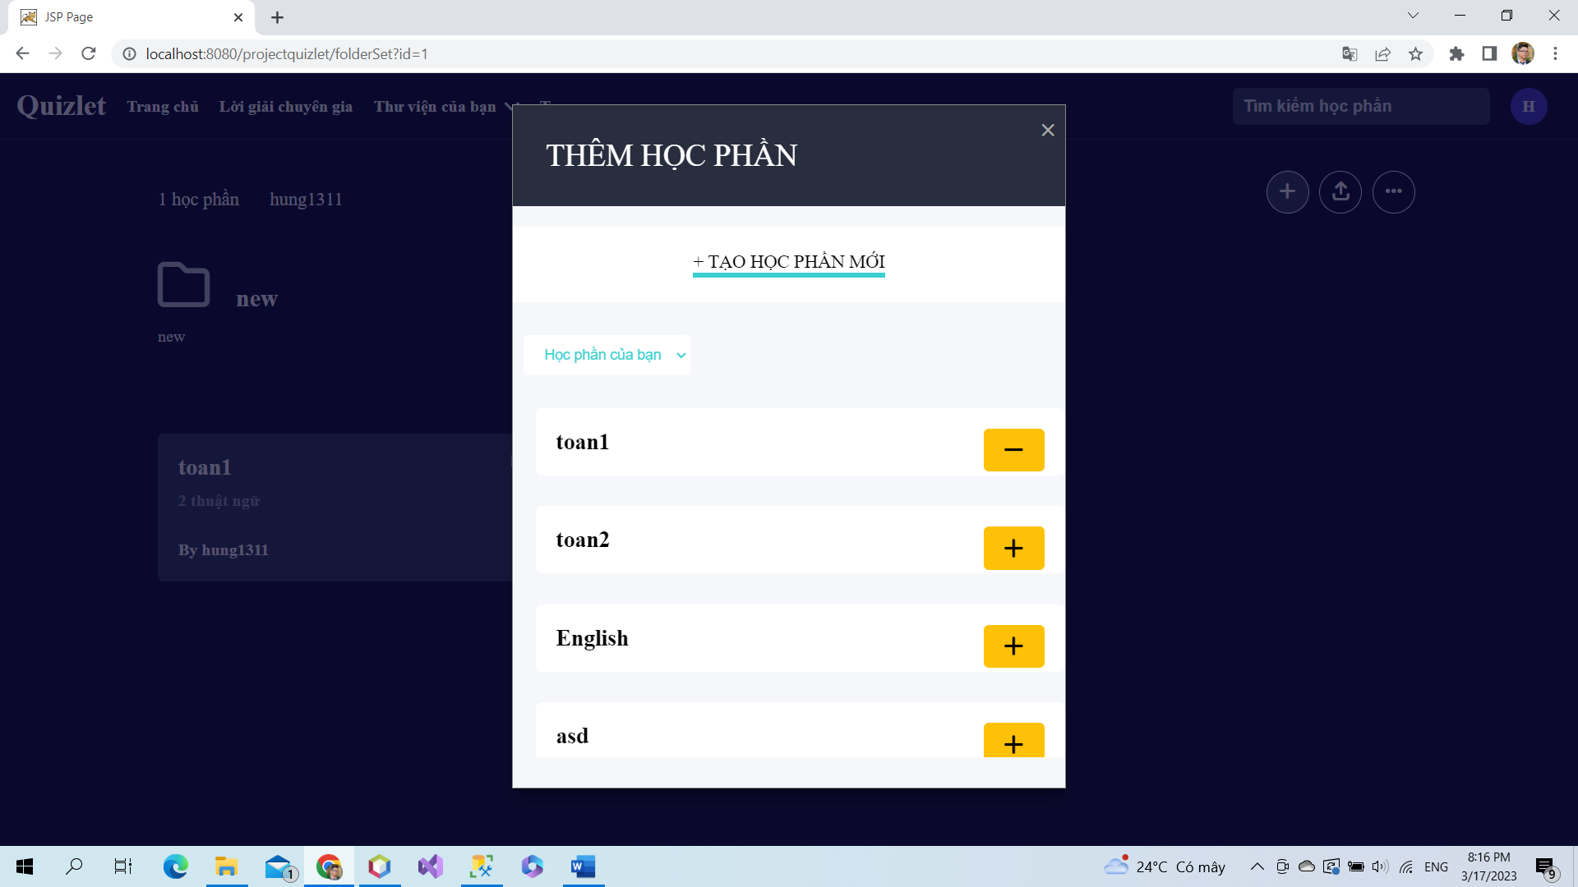

Click + to add study set to folder.

Click - to delete study set from folder

Click “ Tạo học phần mới ” to create a new study set in folder.

### a. Class Diagram

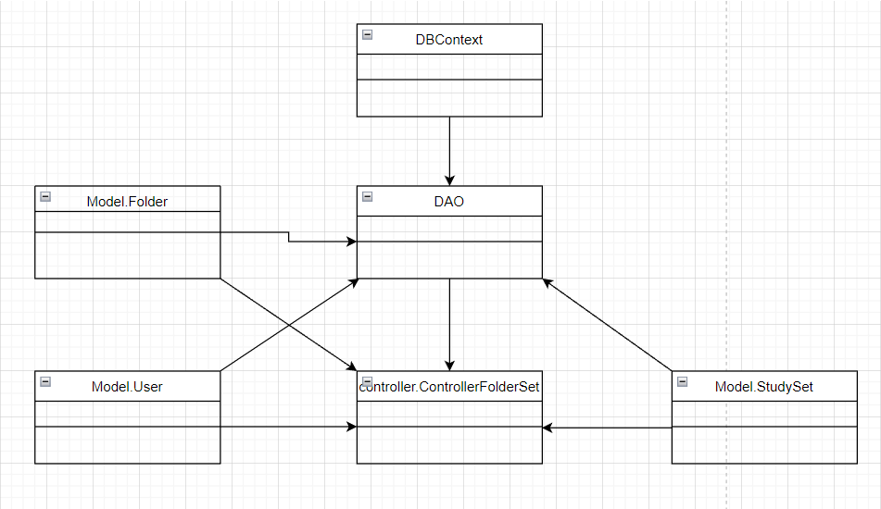

### b. Class Specifications

### User Class

|  |  |  |
| --- | --- | --- |
| **No** | **Method** | **Description** |
| *01* | *User(){}* | Default constructor |
| *02* | *User(….){}* | *Parameterized constructor* |
| *03* | *getName(){}* | *Getter of Name* |
| *04* | *setName(string name){}* | *Setter of Name* |
| *05* | *getPass(){}* | *Getter of Pass* |
| *06* | *setPass(string pass){}* | *Setter of Pass* |
| *07* | *getEmail(){}* | *Getter email* |
| *08* | *setEmail(string email){}* | *Setter of email* |
| *09* | *isIsActive(){}* | *Getter of isActive* |
| *10* | *setIsActive(Boolean isActive){}* | *Setter of isActive* |
| *11* | *getAvatar(){}* | *Getter of avatar* |
| *12* | *setAvatar(string avatar)* | *Setter of avatar* |
| *13* | *getLanguage(){}* | *Getter of language* |
| *14* | *setLanguage(string language){}* | *Setter of language* |

#### DBContext Class

|  |  |  |
| --- | --- | --- |
| **No** | **Method** | **Description** |
| *01* | *DBContext(){}* | *Connect to database* |

#### ControllerFolderSet controller Class

|  |  |  |
| --- | --- | --- |
| **No** | **Method** | **Description** |
| *01* | *doGet(){}* | *Delete or add new study set to folder set* |

#### DAO Class

|  |  |  |
| --- | --- | --- |
| **No** | **Method** | **Description** |
| *01* | *deleteStudySetInFolder(int fid, int sid){}* | *Delete study set from folder* |
| *02* | *addStudySetInFolder(int fid, int sid){}* | *Add new study set to folder* |

#### StudySet Class

|  |  |  |
| --- | --- | --- |
| **No** | **Method** | **Description** |
| *01* | *StudySet() {)* | *Default Constructor* |
| *02* | *StudySet(){.....}* | *Parameterized constructor* |
| *03* | *getId(){}* | *getter of StudySetId* |
| *04* | *setId(int id){}* | *setter of StudySetId* |
| *05* | *getTitle(){}* | *getter of Title* |
| *06* | *setTitle(string title){}* | *setter of Title* |
| *07* | *getDescription(){}* | *getter of Description* |
| *08* | *setDescription(string Description){}* | *setter of Description* |
| *09* | *isIsShare() {}* | *getter of isShare* |
| *10* | *setIsShare(boolean isShare) { }* | *setter of isShare* |
| *11* | *getUserId() { }* | *getter of UserId* |
| *12* | *setUserId(int userId) { }* | *setter of UserId* |
| *13* | *getNumberCard() {}* | *get number flashcard in studyset* |
| *14* | *String getAuthor() {}* | *get name of User created studyset* |

### 

### 

### Folder Class

|  |  |  |
| --- | --- | --- |
| **No** | **Method** | **Description** |
| *01* | *Folder() {)* | *Default Constructor* |
| *02* | *Folder(){.....}* | *Parameterized constructor* |
| *03* | *getId(){}* | *getter of CardId* |
| *04* | *setId(int id){}* | *setter of CardId* |
| *05* | *getTitle(){}* | *getter of Title* |
| *06* | *setTitle(string term){}* | *setter of Title* |
| *07* | *getDescription(){}* | *getter of Description* |
| *08* | *setDescription(string Definition){}* | *setter of Description* |
| *09* | *getUserId() { }* | *getter of UserId* |
| *10* | *setUserId(int UserId) { }* | *setter of UserId* |

### 

### 

### 

### 

### 

### c. Sequence Diagram(s)

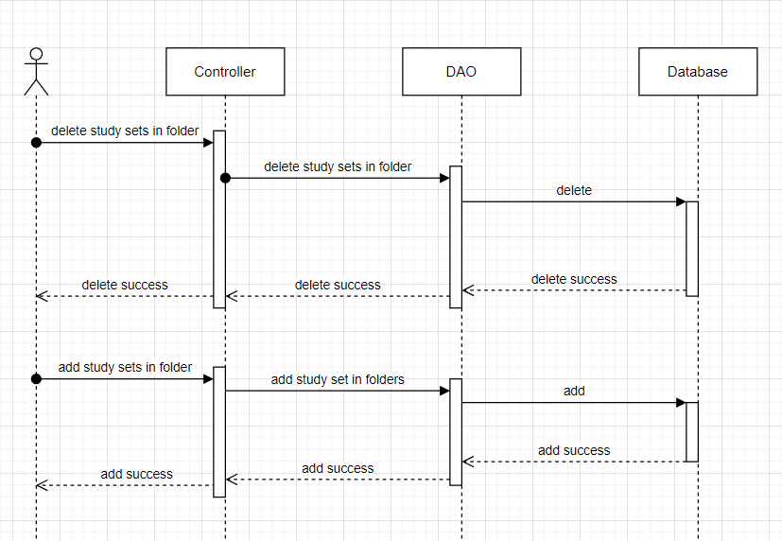

### d. Database Queries

*String sql = "DELETE FROM [dbo].[ListFolder]\n"*

*+ " WHERE studySetId=? and folderId=?";*

*String sql = "INSERT INTO [dbo].[ListFolder]\n"*

*+ " ([studySetId]\n"*

*+ " ,[folderId])\n"*

*+ " VALUES (?, ?)";*

## 18.Controller class set

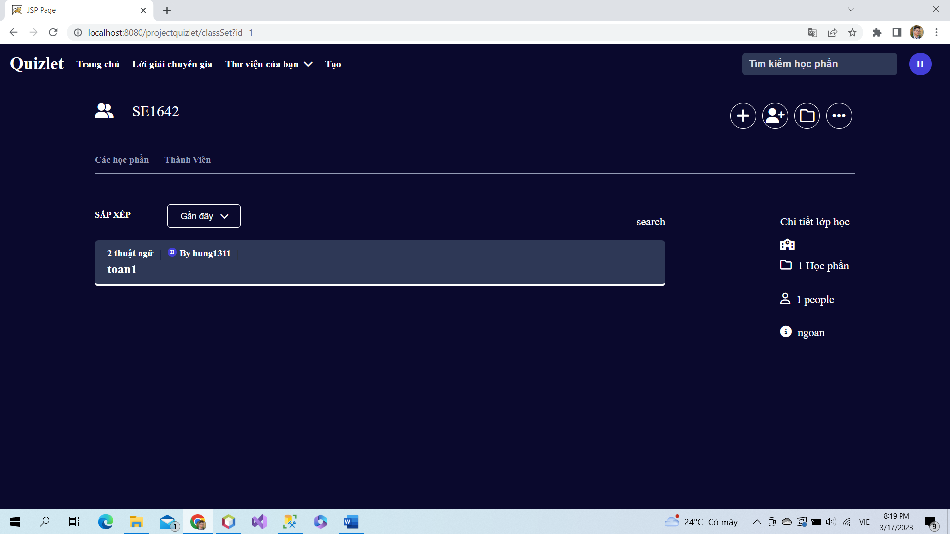

Choose a class. In here, users can add or delete new study sets and member in class or folder in class.

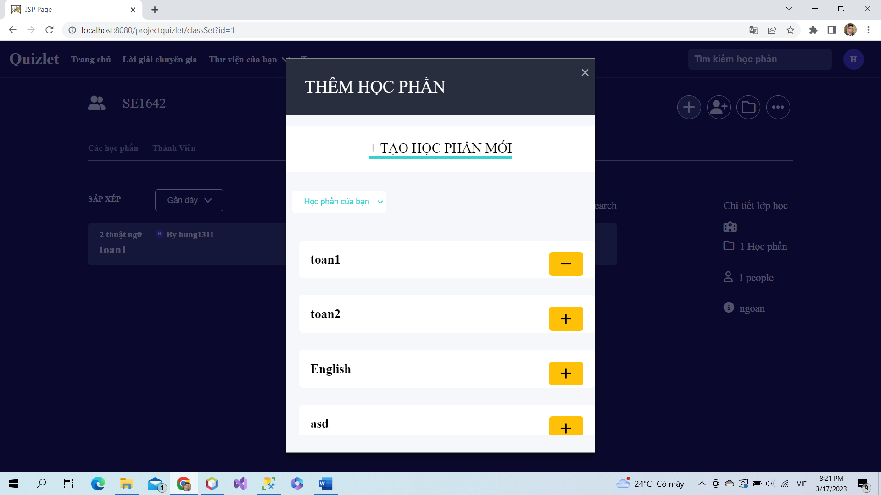

Click + to add study set to class.

Click - to delete study set from class

Click “ Tạo học phần mới ” to create a new study set in class.

### a. Class Diagram

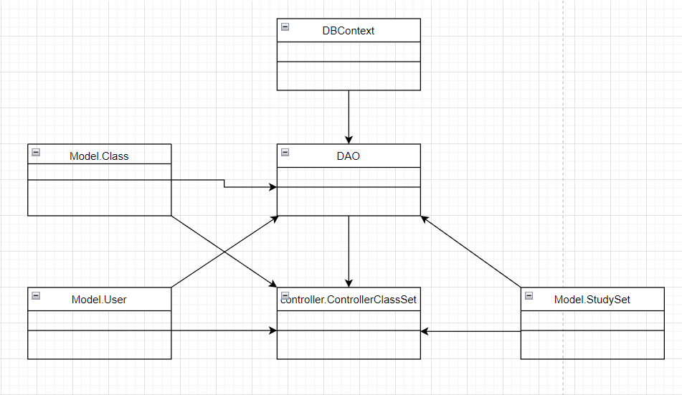

### b. Class Specifications

### User Class

|  |  |  |
| --- | --- | --- |
| **No** | **Method** | **Description** |
| *01* | *User(){}* | Default constructor |
| *02* | *User(….){}* | *Parameterized constructor* |
| *03* | *getName(){}* | *Getter of Name* |
| *04* | *setName(string name){}* | *Setter of Name* |
| *05* | *getPass(){}* | *Getter of Pass* |
| *06* | *setPass(string pass){}* | *Setter of Pass* |
| *07* | *getEmail(){}* | *Getter email* |
| *08* | *setEmail(string email){}* | *Setter of email* |
| *09* | *isIsActive(){}* | *Getter of isActive* |
| *10* | *setIsActive(Boolean isActive){}* | *Setter of isActive* |
| *11* | *getAvatar(){}* | *Getter of avatar* |
| *12* | *setAvatar(string avatar)* | *Setter of avatar* |
| *13* | *getLanguage(){}* | *Getter of language* |
| *14* | *setLanguage(string language){}* | *Setter of language* |

#### DBContext Class

|  |  |  |
| --- | --- | --- |
| **No** | **Method** | **Description** |
| *01* | *DBContext(){}* | *Connect to database* |

#### Controller Class Set Class

|  |  |  |
| --- | --- | --- |
| **No** | **Method** | **Description** |
| *01* | *doGet(){}* | *Delete or add study set in class* |

|  |  |  |
| --- | --- | --- |
| **No** | **Method** | **Description** |
| *01* | *deleteStudySetInClass(int cid, int sid){}* | *Delete study set from class* |
| *02* | *addStudySetInClass(int cid, int sid){}* | *Add new study set to class* |

#### StudySet Class

|  |  |  |
| --- | --- | --- |
| **No** | **Method** | **Description** |
| *01* | *StudySet() {)* | *Default Constructor* |
| *02* | *StudySet(){.....}* | *Parameterized constructor* |
| *03* | *getId(){}* | *getter of StudySetId* |
| *04* | *setId(int id){}* | *setter of StudySetId* |
| *05* | *getTitle(){}* | *getter of Title* |
| *06* | *setTitle(string title){}* | *setter of Title* |
| *07* | *getDescription(){}* | *getter of Description* |
| *08* | *setDescription(string Description){}* | *setter of Description* |
| *09* | *isIsShare() {}* | *getter of isShare* |
| *10* | *setIsShare(boolean isShare) { }* | *setter of isShare* |
| *11* | *getUserId() { }* | *getter of UserId* |
| *12* | *setUserId(int userId) { }* | *setter of UserId* |
| *13* | *getNumberCard() {}* | *get number flashcard in studyset* |
| *14* | *String getAuthor() {}* | *get name of User created studyset* |

### 

### Class Class

|  |  |  |
| --- | --- | --- |
| **No** | **Method** | **Description** |
| *01* | *Class() {)* | *Default Constructor* |
| *02* | *Class(){.....}* | *Parameterized constructor* |
| *03* | *getId(){}* | *getter of Class Id* |
| *04* | *setId(int id){}* | *setter of Class Id* |
| *05* | *getName(){}* | *getter of Class Name* |
| *06* | *setName(string name){}* | *setter of Class Name* |
| *07* | *getDesc(){}* | *getter of Desc* |
| *08* | *setDesc(string Desc){}* | *setter of Desc* |
| *09* | *getUserId() { }* | *getter of UserId* |
| *10* | *setUserId(int UserId) { }* | *setter of UserId* |
| *11* | *isIsInvite() {}* | *getter of isInvite* |
| *12* | *setIsInvite(boolean isInvite) { }* | *setter of isInvite* |
| *13* | *isIsEdit() {}* | *getter of isEdit* |
| *14* | *setIsEdit(boolean isEdit) { }* | *setter of isEdit* |
| *15* | *getInviteCode() {}* | *getter of inviteCode* |
| *16* | *setInviteCode(string inviteCode) { }* | *setter of inviteCode* |
| *17* | *getSchoolName() {}* | *getter of schoolName* |
| *18* | *setSchoolName(string inviteCode) { }* | *setter of schoolName* |

### 

### c. Sequence Diagram(s)

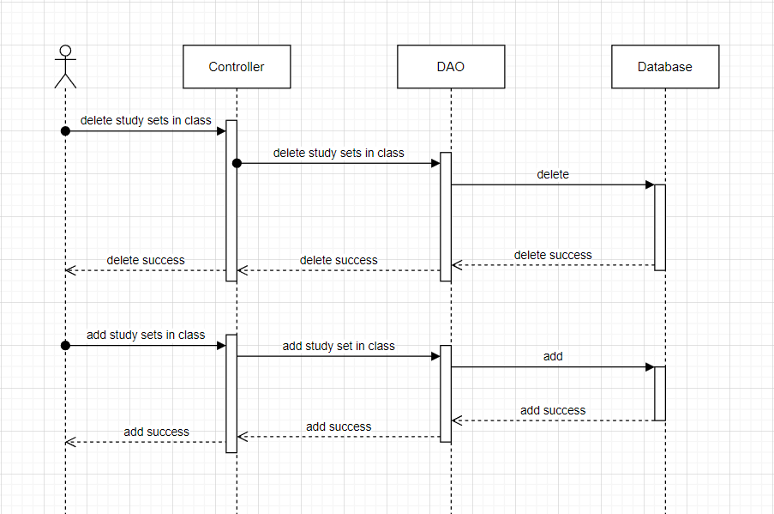

### d. Database Queries

*String sql = "DELETE FROM [dbo].[ListStudySet]\n"*

*+ " WHERE studySetId=? and classId=?";*

*String sql = "INSERT INTO [dbo].[ListStudySet]\n"*

*+ " ([studySetId]\n"*

*+ " ,[classId])\n"*

*+ " VALUES (?, ?)";*

## 19. Create class

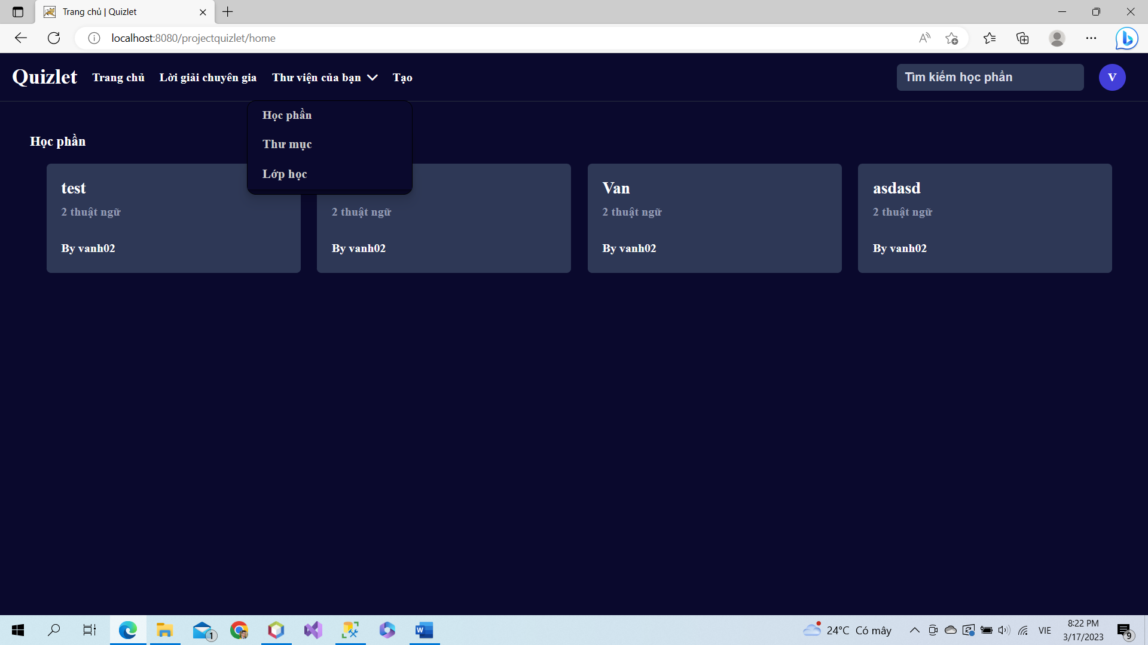

Click button “Tạo” and choose “Lớp học” to create a new class

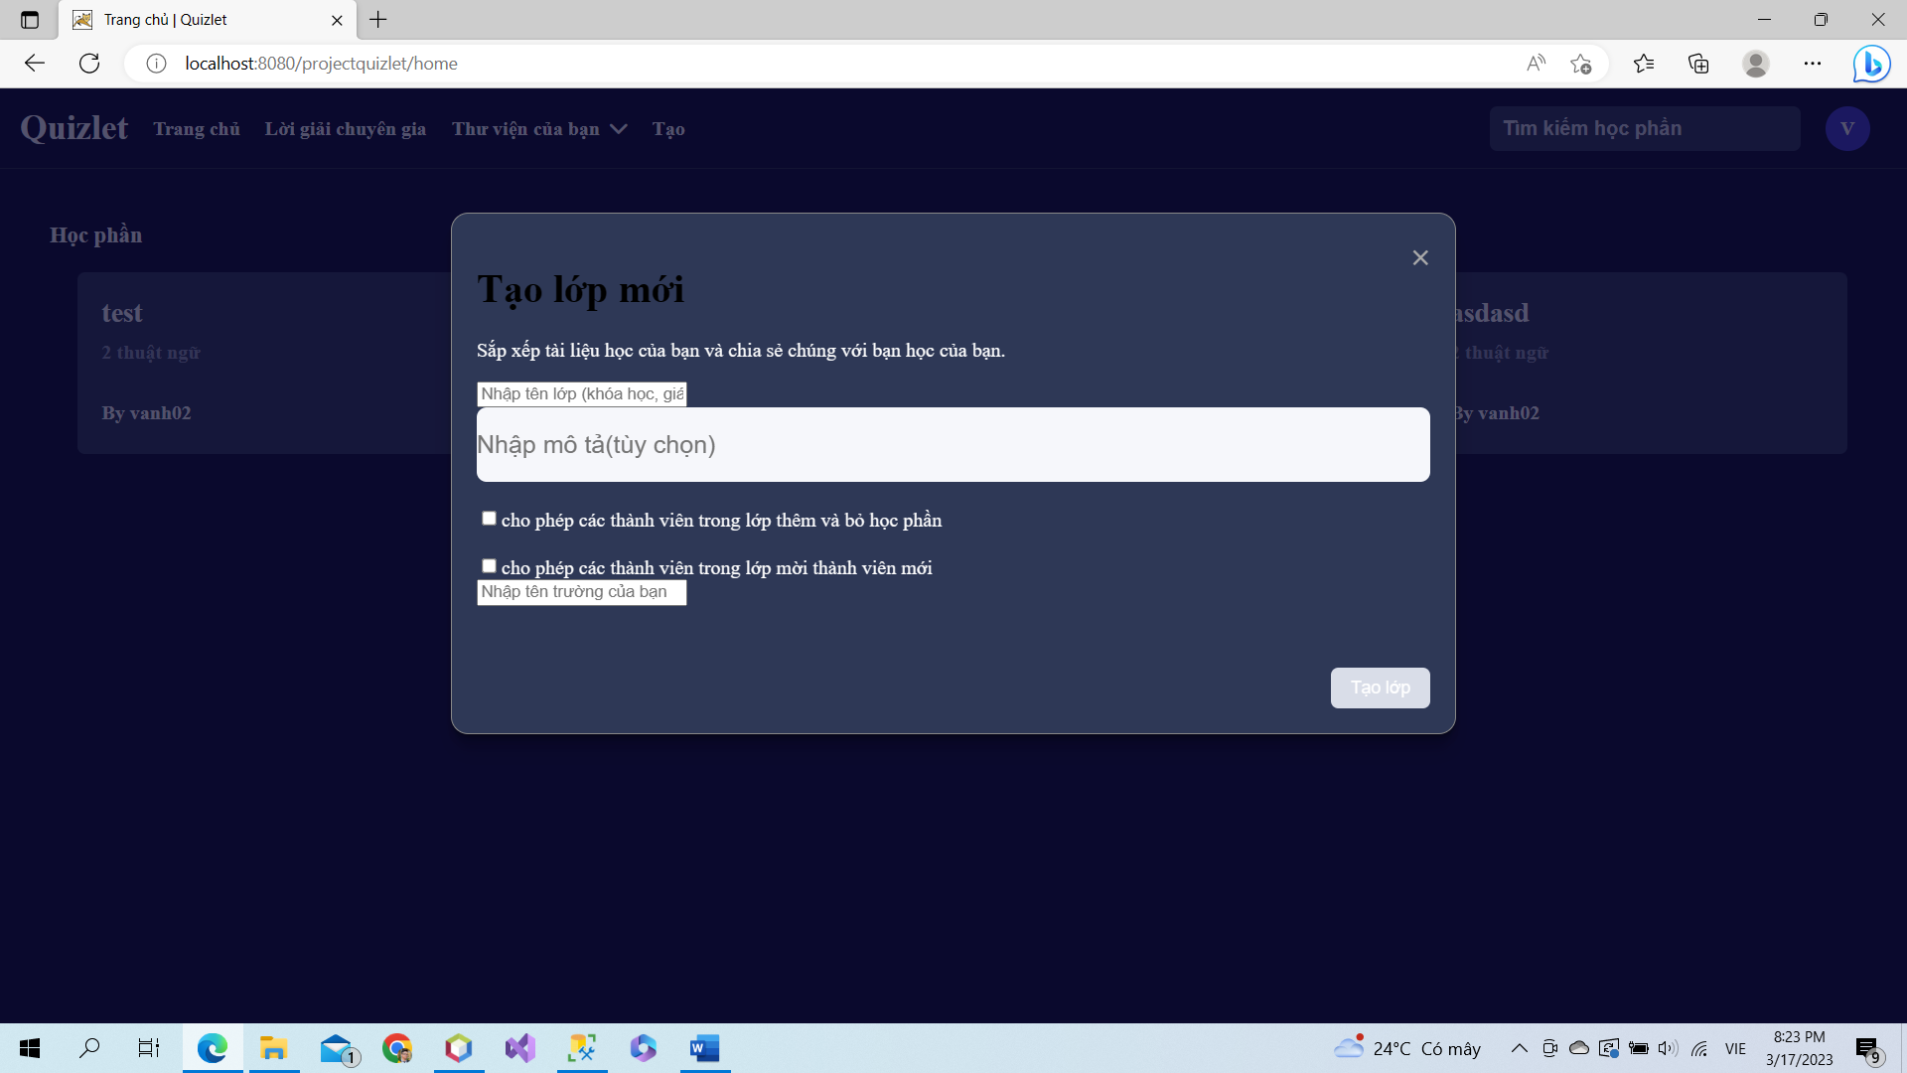

Input info of new class then click to “tạo lớp”.

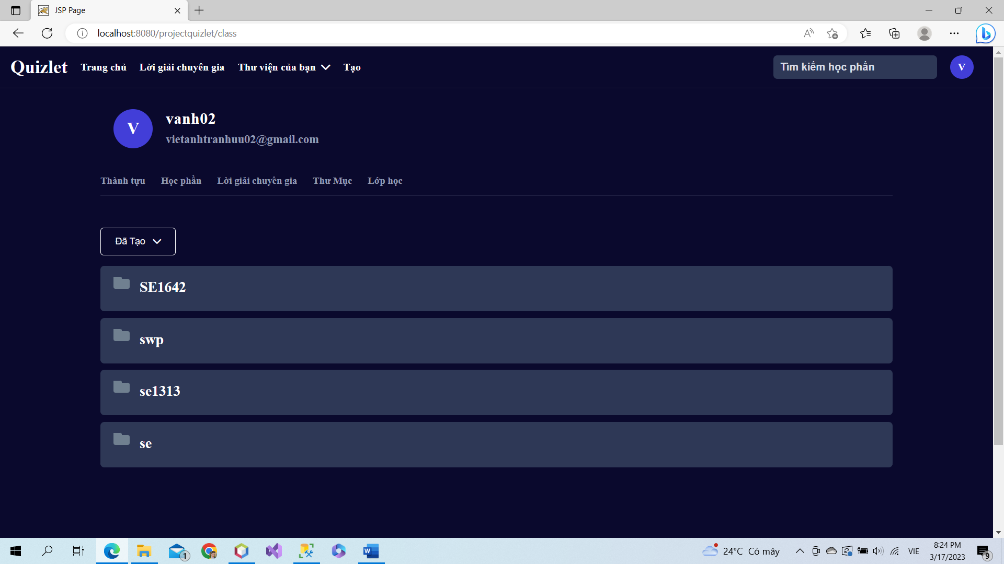

After create a new class, it will be added to class set.

### a. Class Diagram

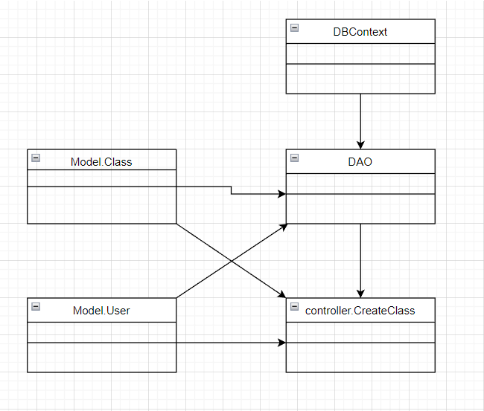

### b. Class Specifications

### User Class

|  |  |  |
| --- | --- | --- |
| **No** | **Method** | **Description** |
| *01* | *User(){}* | Default constructor |
| *02* | *User(….){}* | *Parameterized constructor* |
| *03* | *getName(){}* | *Getter of Name* |
| *04* | *setName(string name){}* | *Setter of Name* |
| *05* | *getPass(){}* | *Getter of Pass* |
| *06* | *setPass(string pass){}* | *Setter of Pass* |
| *07* | *getEmail(){}* | *Getter email* |
| *08* | *setEmail(string email){}* | *Setter of email* |
| *09* | *isIsActive(){}* | *Getter of isActive* |
| *10* | *setIsActive(Boolean isActive){}* | *Setter of isActive* |
| *11* | *getAvatar(){}* | *Getter of avatar* |
| *12* | *setAvatar(string avatar)* | *Setter of avatar* |
| *13* | *getLanguage(){}* | *Getter of language* |
| *14* | *setLanguage(string language){}* | *Setter of language* |

#### DBContext Class

|  |  |  |
| --- | --- | --- |
| **No** | **Method** | **Description** |
| *01* | *DBContext(){}* | *Connect to database* |

#### CreateClass controller Class

|  |  |  |
| --- | --- | --- |
| **No** | **Method** | **Description** |
| *01* | *doGet(){}* | *List some class* |
| *02* | *doPost(){}* | *Create new class* |

#### DAO Class

|  |  |  |
| --- | --- | --- |
| **No** | **Method** | **Description** |
| *01* | *getAllClass(){}* | *Get all class in database* |
| *02* | *createClass(class c)* | *Create a new class* |

### 

### 

### 

### 

### 

### Class Class

|  |  |  |
| --- | --- | --- |
| **No** | **Method** | **Description** |
| *01* | *Class() {)* | *Default Constructor* |
| *02* | *Class(){.....}* | *Parameterized constructor* |
| *03* | *getId(){}* | *getter of Class Id* |
| *04* | *setId(int id){}* | *setter of Class Id* |
| *05* | *getName(){}* | *getter of Class Name* |
| *06* | *setName(string name){}* | *setter of Class Name* |
| *07* | *getDesc(){}* | *getter of Desc* |
| *08* | *setDesc(string Desc){}* | *setter of Desc* |
| *09* | *getUserId() { }* | *getter of UserId* |
| *10* | *setUserId(int UserId) { }* | *setter of UserId* |
| *11* | *isIsInvite() {}* | *getter of isInvite* |
| *12* | *setIsInvite(boolean isInvite) { }* | *setter of isInvite* |
| *13* | *isIsEdit() {}* | *getter of isEdit* |
| *14* | *setIsEdit(boolean isEdit) { }* | *setter of isEdit* |
| *15* | *getInviteCode() {}* | *getter of inviteCode* |
| *16* | *setInviteCode(string inviteCode) { }* | *setter of inviteCode* |
| *17* | *getSchoolName() {}* | *getter of schoolName* |
| *18* | *setSchoolName(string inviteCode) { }* | *setter of schoolName* |

### 

### 

### c. Sequence Diagram(s)

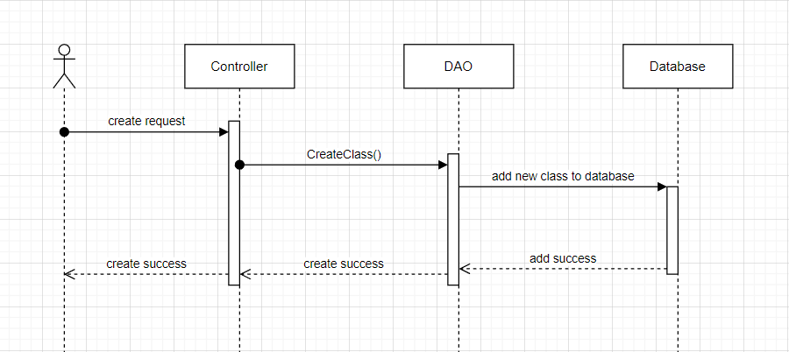

### d. Database Queries

*String sql = "INSERT INTO [dbo].[Class]\n"*

*+ " ([className]\n"*

*+ " ,[description]\n"*

*+ " ,[isInvite]\n"*

*+ " ,[inviteCode]\n"*

*+ " ,[isEdit]\n"*

*+ " ,[schoolName]\n"*

*+ " ,[userId])\n"*

*+ " VALUES\n"*

*+ " (?\n"*

*+ " ,? \n"*

*+ " ,? \n"*

*+ " ,?\n"*

*+ " ,?\n"*

*+ " ,?\n"*

*+ " ,?)";*

## 20. Create folder

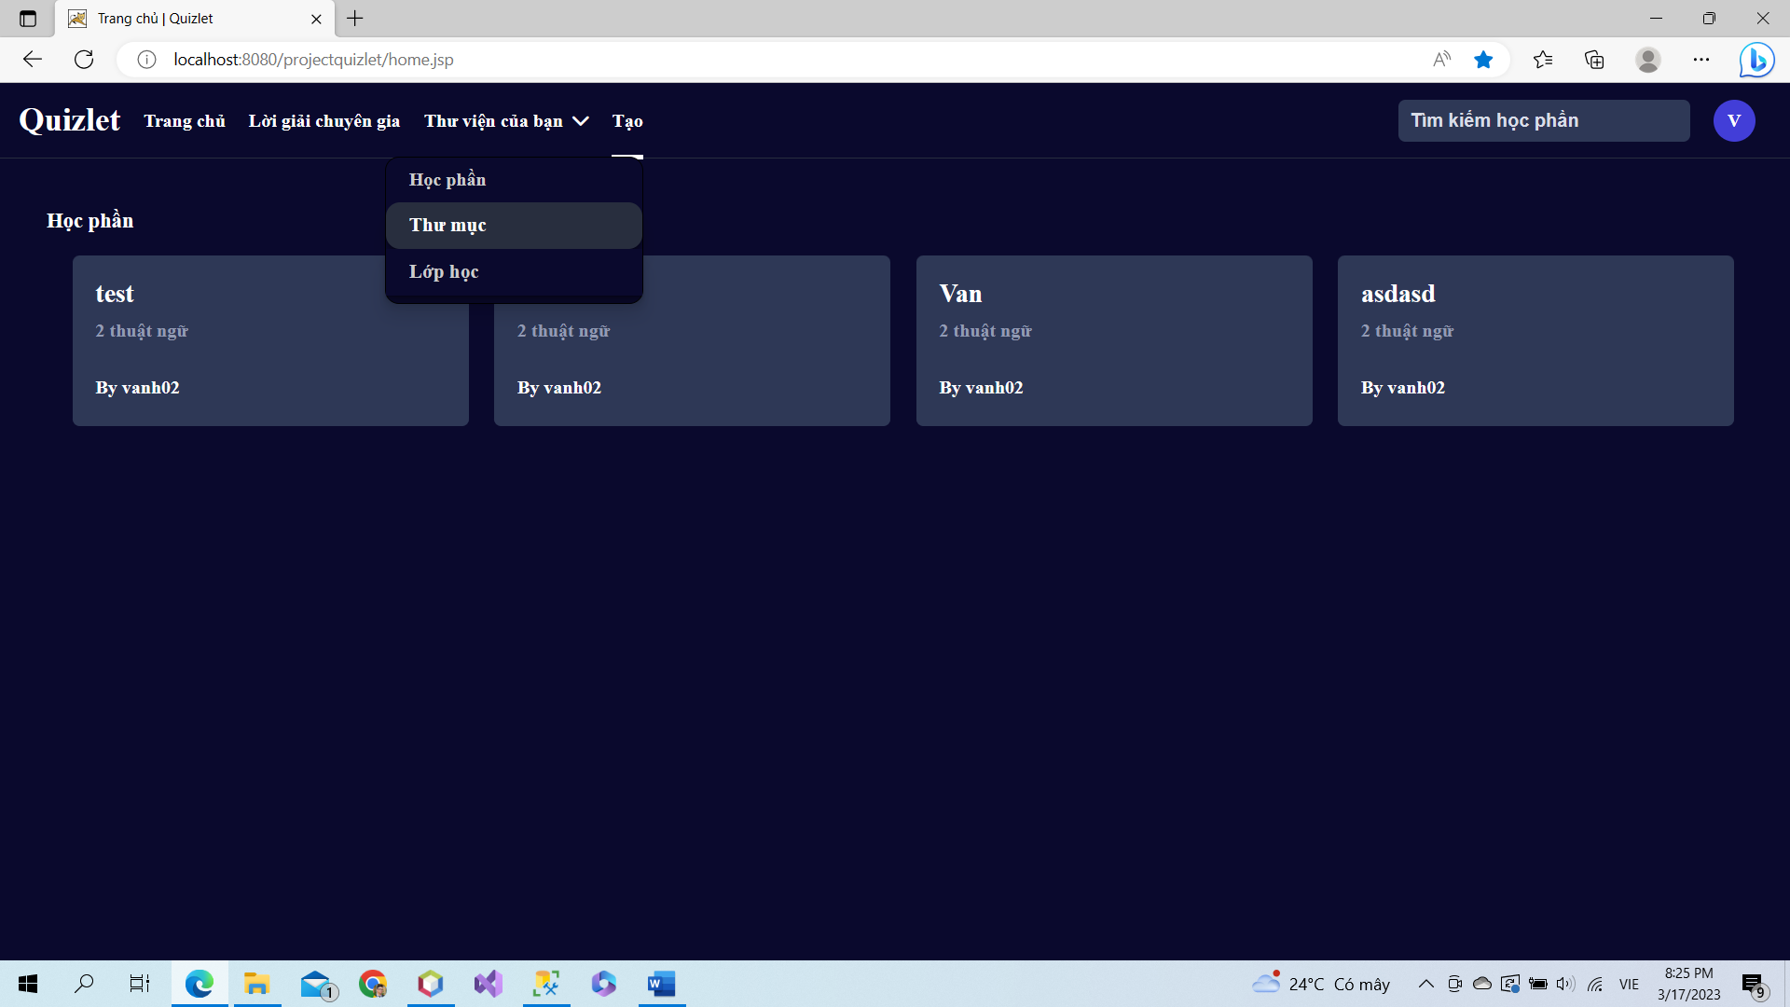

Click button “Tạo” and choose “thư mục” to create a new folder

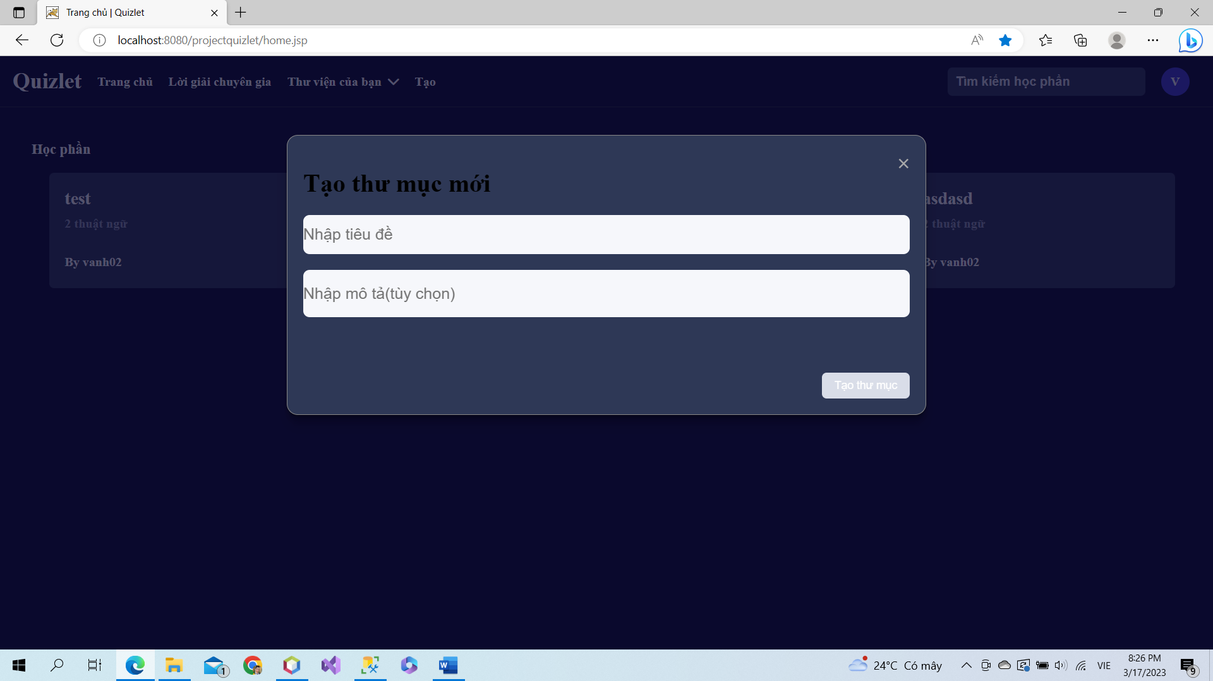

Input title and description of new folder.

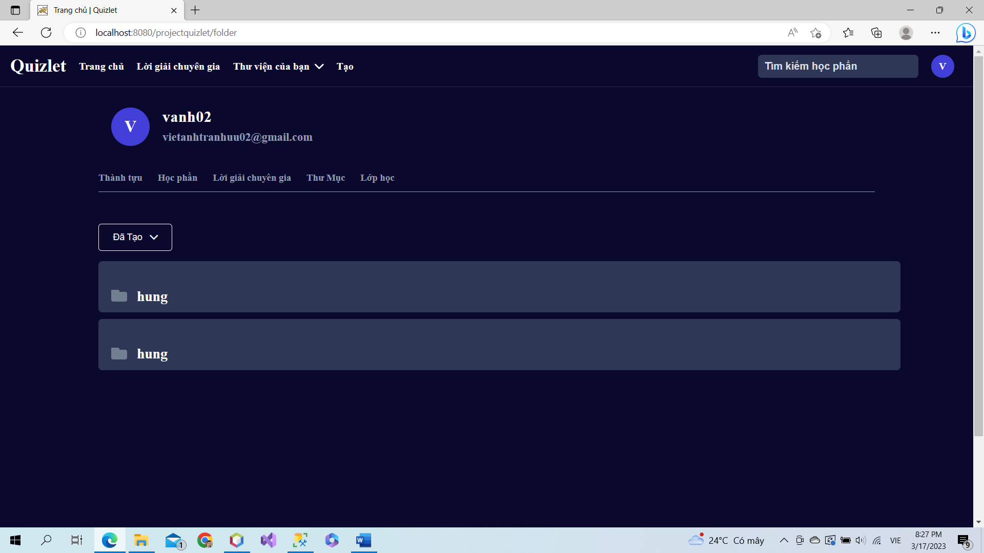

New folder will be added to folder set.

### a. Class Diagram

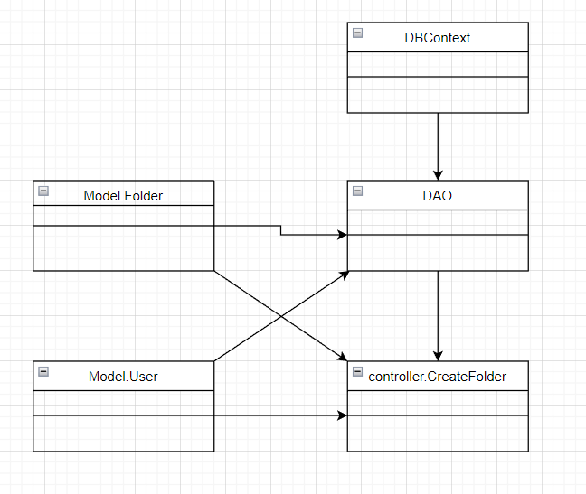

### b. Class Specifications

### User Class

|  |  |  |
| --- | --- | --- |
| **No** | **Method** | **Description** |
| *01* | *User(){}* | Default constructor |
| *02* | *User(….){}* | *Parameterized constructor* |
| *03* | *getName(){}* | *Getter of Name* |
| *04* | *setName(string name){}* | *Setter of Name* |
| *05* | *getPass(){}* | *Getter of Pass* |
| *06* | *setPass(string pass){}* | *Setter of Pass* |
| *07* | *getEmail(){}* | *Getter email* |
| *08* | *setEmail(string email){}* | *Setter of email* |
| *09* | *isIsActive(){}* | *Getter of isActive* |
| *10* | *setIsActive(Boolean isActive){}* | *Setter of isActive* |
| *11* | *getAvatar(){}* | *Getter of avatar* |
| *12* | *setAvatar(string avatar)* | *Setter of avatar* |
| *13* | *getLanguage(){}* | *Getter of language* |
| *14* | *setLanguage(string language){}* | *Setter of language* |

#### DBContext Class

|  |  |  |
| --- | --- | --- |
| **No** | **Method** | **Description** |
| *01* | *DBContext(){}* | *Connect to database* |

#### CreateFolder controller Class

|  |  |  |
| --- | --- | --- |
| **No** | **Method** | **Description** |
| *01* | *doGet(){}* | *List all folder by user id* |
| *02* | *doPost(){}* | *Create new folder* |

#### DAO Class

|  |  |  |
| --- | --- | --- |
| **No** | **Method** | **Description** |
| *01* | *getAllFolderByUserId(int id){}* | *Get all folder by user id after creating* |
| *02* | *CreateFolder(Folder f){}* | *Create a new folder* |

### 

### 

### Folder Class

|  |  |  |
| --- | --- | --- |
| **No** | **Method** | **Description** |
| *01* | *Folder() {)* | *Default Constructor* |
| *02* | *Folder(){.....}* | *Parameterized constructor* |
| *03* | *getId(){}* | *getter of CardId* |
| *04* | *setId(int id){}* | *setter of CardId* |
| *05* | *getTitle(){}* | *getter of Title* |
| *06* | *setTitle(string term){}* | *setter of Title* |
| *07* | *getDescription(){}* | *getter of Description* |
| *08* | *setDescription(string Definition){}* | *setter of Description* |
| *09* | *getUserId() { }* | *getter of UserId* |
| *10* | *setUserId(int UserId) { }* | *setter of UserId* |

### 

### c. Sequence Diagram(s)

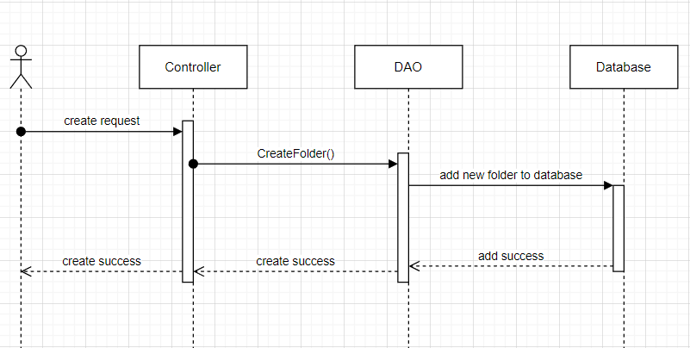

### d. Database Queries

*String sql = "INSERT INTO [dbo].[Folder]\n"*

*+ " ([title]\n"*

*+ " ,[description]\n"*

*+ " ,[userId]\n"*

*+ " ,[isShare])\n"*

*+ " VALUES\n"*

*+ " (?\n"*

*+ " ,?\n"*

*+ " ,?\n"*

*+ " ,?)";*

## 21. Reset studied Cards

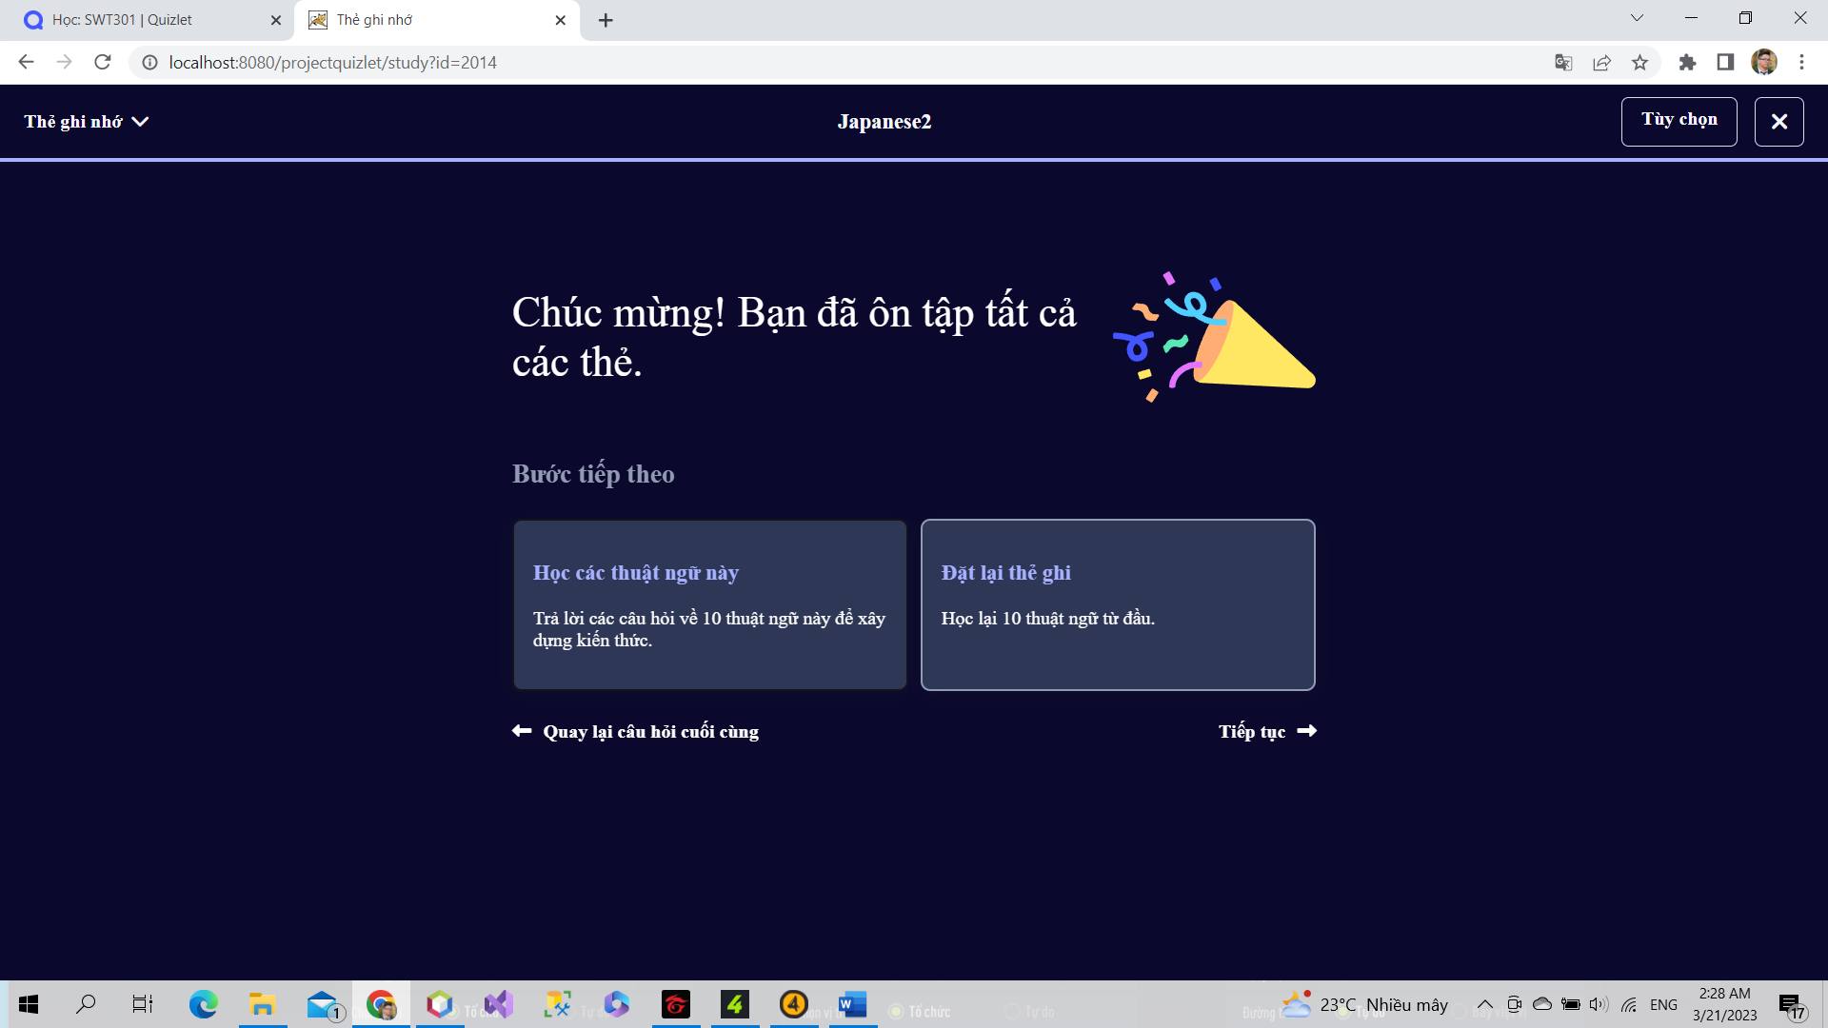

When users study all cards in study set, user will can reset studied cards to study again by click to Reset cards.

### a. Class Diagram

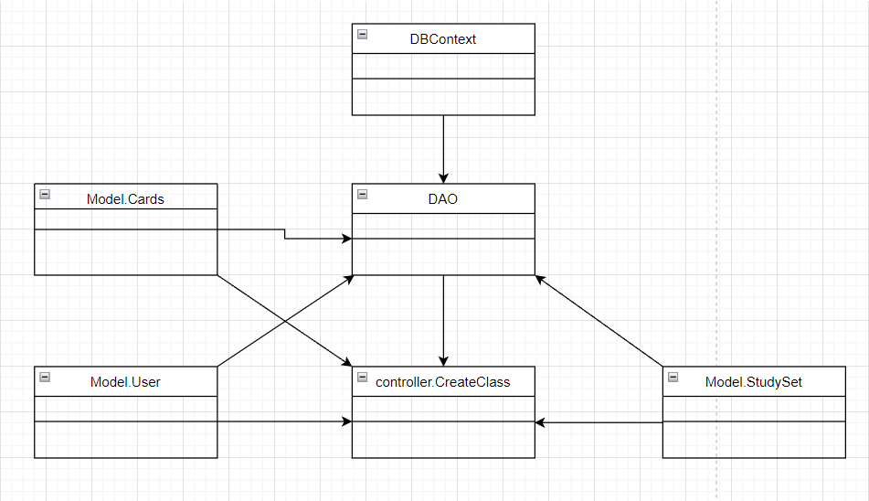

### b. Class Specifications

### User Class

|  |  |  |
| --- | --- | --- |
| **No** | **Method** | **Description** |
| *01* | *User(){}* | Default constructor |
| *02* | *User(….){}* | *Parameterized constructor* |
| *03* | *getName(){}* | *Getter of Name* |
| *04* | *setName(string name){}* | *Setter of Name* |
| *05* | *getPass(){}* | *Getter of Pass* |
| *06* | *setPass(string pass){}* | *Setter of Pass* |
| *07* | *getEmail(){}* | *Getter email* |
| *08* | *setEmail(string email){}* | *Setter of email* |
| *09* | *isIsActive(){}* | *Getter of isActive* |
| *10* | *setIsActive(Boolean isActive){}* | *Setter of isActive* |
| *11* | *getAvatar(){}* | *Getter of avatar* |
| *12* | *setAvatar(string avatar)* | *Setter of avatar* |
| *13* | *getLanguage(){}* | *Getter of language* |
| *14* | *setLanguage(string language){}* | *Setter of language* |

#### DBContext Class

|  |  |  |
| --- | --- | --- |
| **No** | **Method** | **Description** |
| *01* | *DBContext(){}* | *Connect to database* |

#### ResetStudiedCard controller Class

|  |  |  |
| --- | --- | --- |
| **No** | **Method** | **Description** |
| *01* | *doGet(){}* | *Reset studied cards in study set* |

#### DAO Class

|  |  |  |
| --- | --- | --- |
| **No** | **Method** | **Description** |
| *01* | *resetStudiedCard(int uid, int studysetId){}* | *Reset studied card to study again.* |

#### StudySet Class

|  |  |  |
| --- | --- | --- |
| **No** | **Method** | **Description** |
| *01* | *StudySet() {)* | *Default Constructor* |
| *02* | *StudySet(){.....}* | *Parameterized constructor* |
| *03* | *getId(){}* | *getter of StudySetId* |
| *04* | *setId(int id){}* | *setter of StudySetId* |
| *05* | *getTitle(){}* | *getter of Title* |
| *06* | *setTitle(string title){}* | *setter of Title* |
| *07* | *getDescription(){}* | *getter of Description* |
| *08* | *setDescription(string Description){}* | *setter of Description* |
| *09* | *isIsShare() {}* | *getter of isShare* |
| *10* | *setIsShare(boolean isShare) { }* | *setter of isShare* |
| *11* | *getUserId() { }* | *getter of UserId* |
| *12* | *setUserId(int userId) { }* | *setter of UserId* |
| *13* | *getNumberCard() {}* | *get number flashcard in studyset* |
| *14* | *String getAuthor() {}* | *get name of User created studyset* |

### 

### 

### 

### Card Class

|  |  |  |
| --- | --- | --- |
| **No** | **Method** | **Description** |
| *01* | *Card() {)* | *Default Constructor* |
| *02* | *Card(){.....}* | *Parameterized constructor* |
| *03* | *getId(){}* | *getter of CardId* |
| *04* | *setId(int id){}* | *setter of CardId* |
| *05* | *getTerm(){}* | *getter of Term* |
| *06* | *setTerm(string term){}* | *setter of Term* |
| *07* | *getDefinition(){}* | *getter of Definition* |
| *08* | *setDefinition(string Definition){}* | *setter of Definition* |
| *09* | *getStudySetId() { }* | *getter of StudySetId* |
| *10* | *setStudySetId(int studySetId) { }* | *setter of StudySetId* |

### 

### c. Sequence Diagram(s)

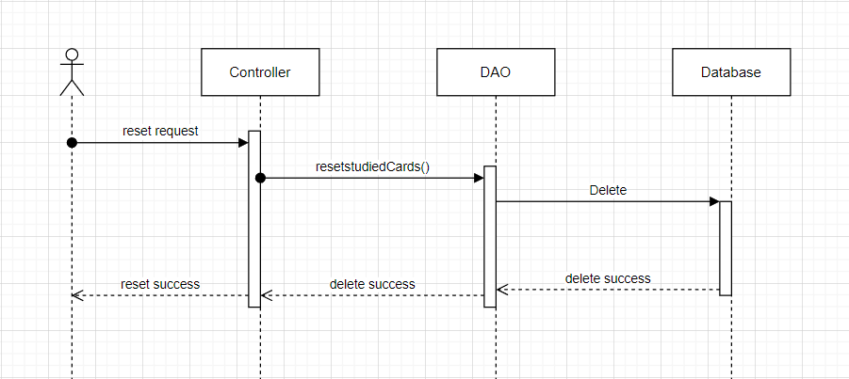

### d. Database Queries

*String sql = "DELETE FROM [dbo].[FlashCards]\n"*

*+ " WHERE userId=? and studySetId=?";*

## 22. Send email

### a. Class Diagram

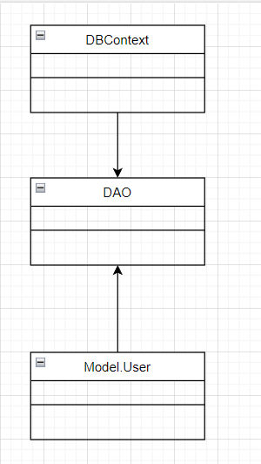

### b. Class Specifications

### User Class

|  |  |  |
| --- | --- | --- |
| **No** | **Method** | **Description** |
| *01* | *User(){}* | Default constructor |
| *02* | *User(….){}* | *Parameterized constructor* |
| *03* | *getName(){}* | *Getter of Name* |
| *04* | *setName(string name){}* | *Setter of Name* |
| *05* | *getPass(){}* | *Getter of Pass* |
| *06* | *setPass(string pass){}* | *Setter of Pass* |
| *07* | *getEmail(){}* | *Getter email* |
| *08* | *setEmail(string email){}* | *Setter of email* |
| *09* | *isIsActive(){}* | *Getter of isActive* |
| *10* | *setIsActive(Boolean isActive){}* | *Setter of isActive* |
| *11* | *getAvatar(){}* | *Getter of avatar* |
| *12* | *setAvatar(string avatar)* | *Setter of avatar* |
| *13* | *getLanguage(){}* | *Getter of language* |
| *14* | *setLanguage(string language){}* | *Setter of language* |

#### DBContext Class

|  |  |  |
| --- | --- | --- |
| **No** | **Method** | **Description** |
| *01* | *DBContext(){}* | *Connect to database* |

#### SendEmail Class

|  |  |  |
| --- | --- | --- |
| **No** | **Method** | **Description** |
| *01* | *getRandom(){}* | *Get a code 6 character reandom* |
| *02* | *sendEmail(user, code){}* | *Send code to email of user* |
| *03* | *sendEmailPass(id, to ,cid){}* | *Send link to change password to email* |

#### DAO Class

|  |  |  |
| --- | --- | --- |
| **No** | **Method** | **Description** |
| *01* | *Active account(string email){}* | *Update is active in database* |

### 

### c. Sequence Diagram(s)

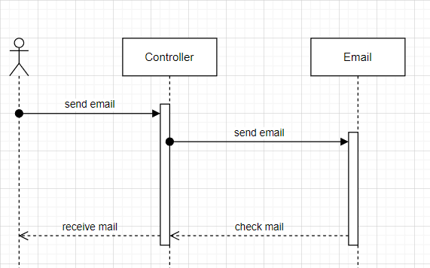

### d. Database Queries

*Send email function do not use database queries.*

## 23. Study

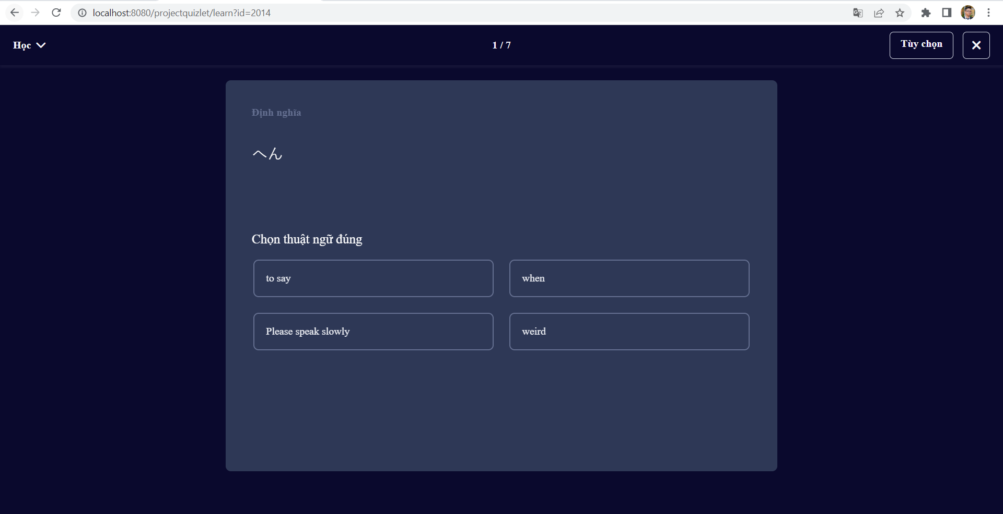

When users choose study method in flash card, system create cards to mutiple choice question. User can choose answer to study.

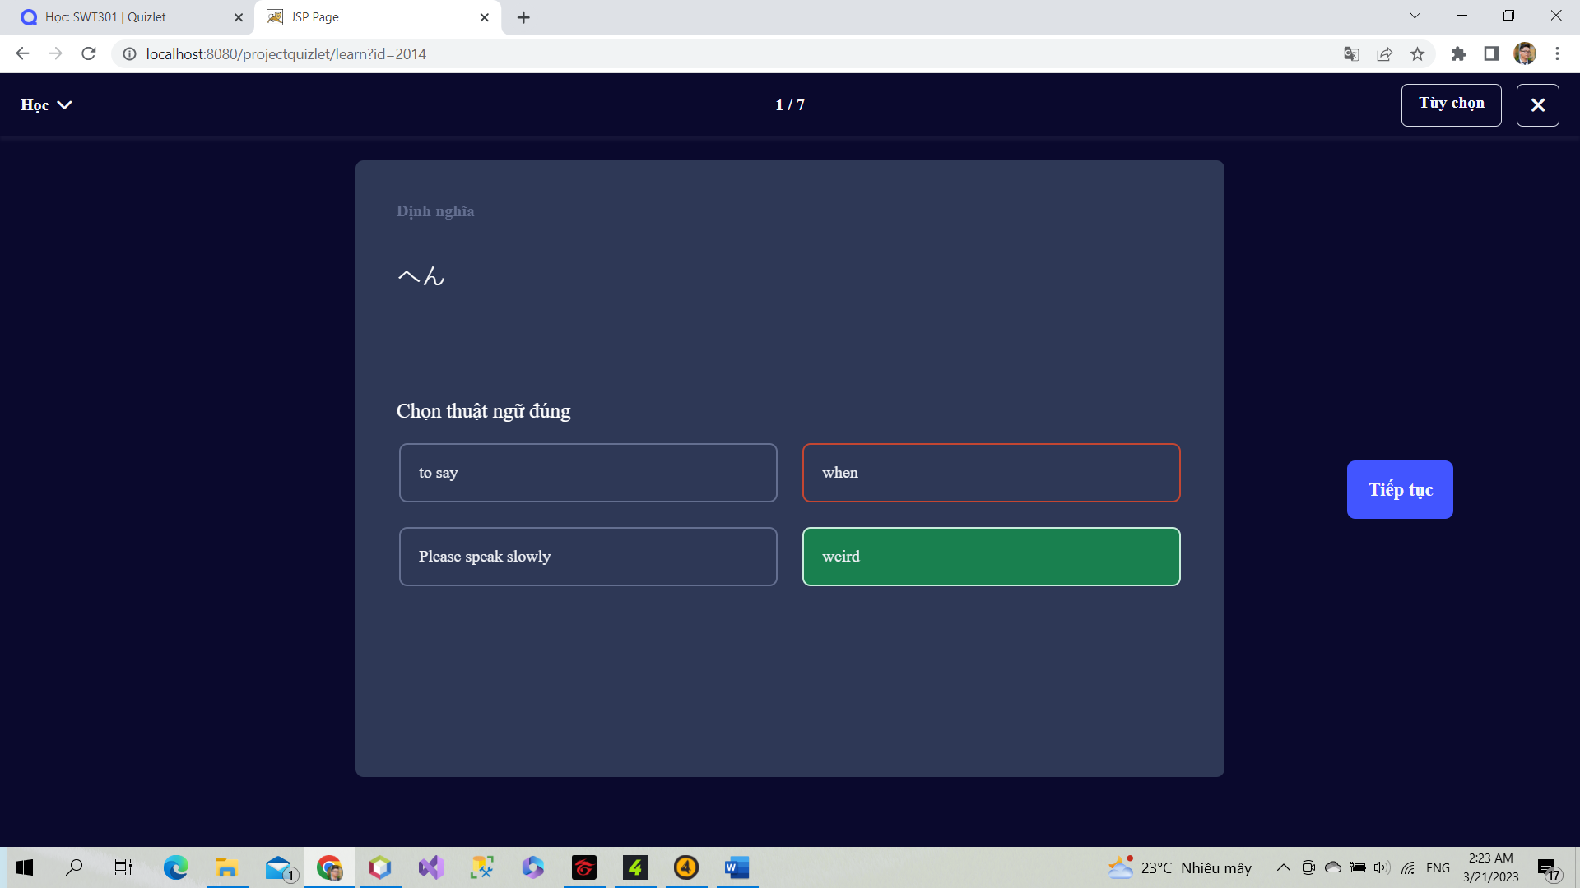

When users choose wrong, screen will present true answer and hightlight it by green and wrong answer by red. User can choose continue to change to next question or keep beck to review again.

If user choose correct, screen will present true and move next question. When users study completely each turn, system will present wrong question to practice again.

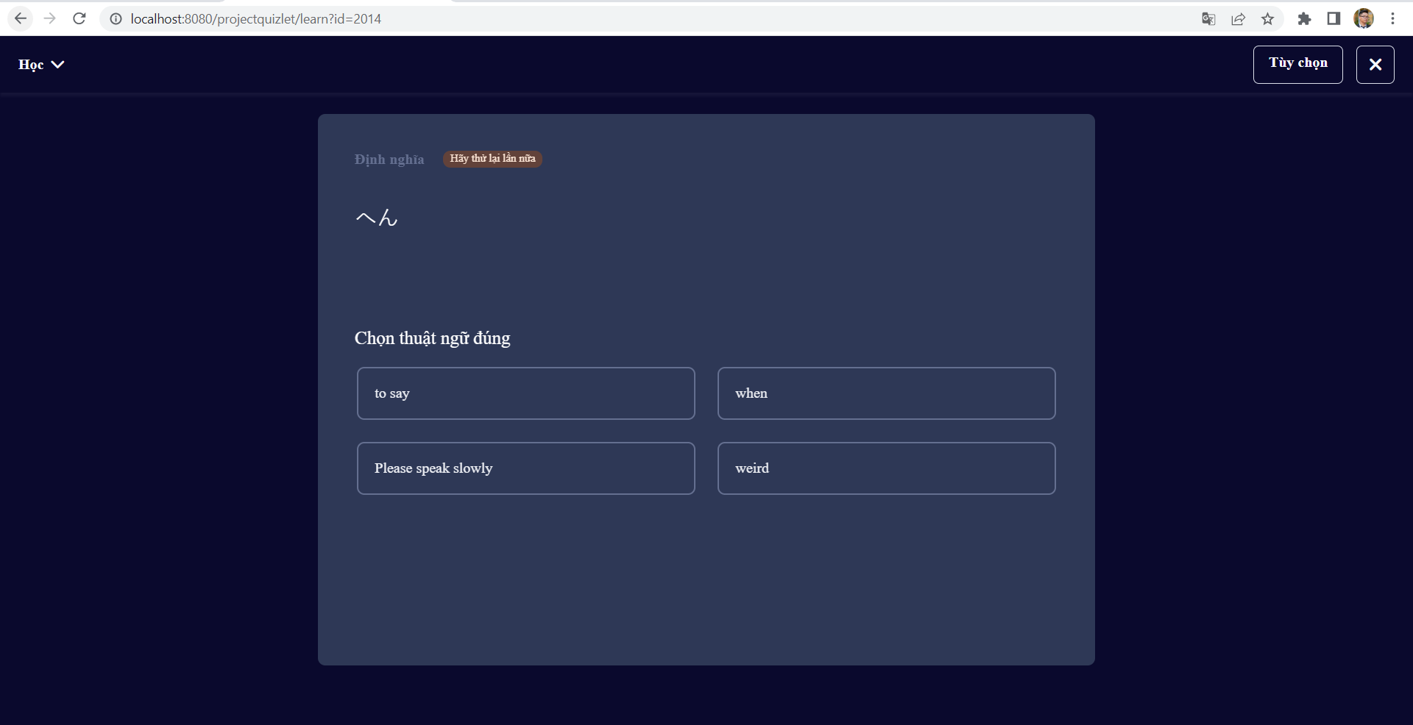

### a. Class Diagram

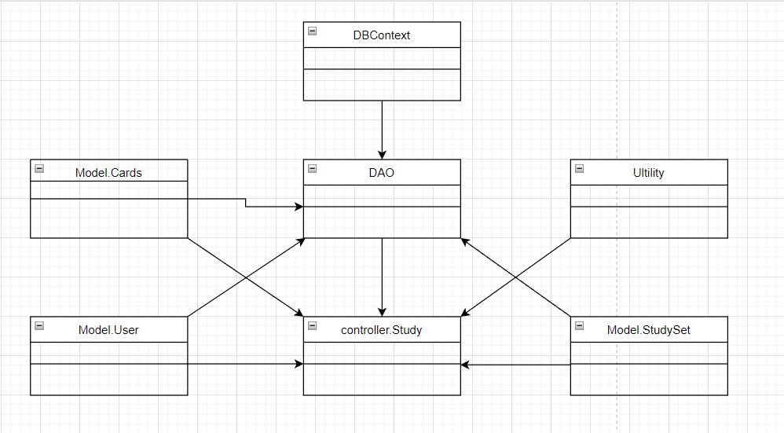

### b. Class Specifications

### User Class

|  |  |  |
| --- | --- | --- |
| **No** | **Method** | **Description** |
| *01* | *User(){}* | Default constructor |
| *02* | *User(….){}* | *Parameterized constructor* |
| *03* | *getName(){}* | *Getter of Name* |
| *04* | *setName(string name){}* | *Setter of Name* |
| *05* | *getPass(){}* | *Getter of Pass* |
| *06* | *setPass(string pass){}* | *Setter of Pass* |
| *07* | *getEmail(){}* | *Getter email* |
| *08* | *setEmail(string email){}* | *Setter of email* |
| *09* | *isIsActive(){}* | *Getter of isActive* |
| *10* | *setIsActive(Boolean isActive){}* | *Setter of isActive* |
| *11* | *getAvatar(){}* | *Getter of avatar* |
| *12* | *setAvatar(string avatar)* | *Setter of avatar* |
| *13* | *getLanguage(){}* | *Getter of language* |
| *14* | *setLanguage(string language){}* | *Setter of language* |

#### DBContext Class

|  |  |  |
| --- | --- | --- |
| **No** | **Method** | **Description** |
| *01* | *DBContext(){}* | *Connect to database* |

#### Verify controller Class

|  |  |  |
| --- | --- | --- |
| **No** | **Method** | **Description** |
| *01* | *doGet(){}* | *Send redirect to verify.jsp* |
| *02* | *doPost(){}* | *Active account by verify code* |

#### DAO Class

|  |  |  |
| --- | --- | --- |
| **No** | **Method** | **Description** |
| *01* | *Active account(string email){}* | *Update is active in database* |

#### StudySet Class

|  |  |  |
| --- | --- | --- |
| **No** | **Method** | **Description** |
| *01* | *StudySet() {)* | *Default Constructor* |
| *02* | *StudySet(){.....}* | *Parameterized constructor* |
| *03* | *getId(){}* | *getter of StudySetId* |
| *04* | *setId(int id){}* | *setter of StudySetId* |
| *05* | *getTitle(){}* | *getter of Title* |
| *06* | *setTitle(string title){}* | *setter of Title* |
| *07* | *getDescription(){}* | *getter of Description* |
| *08* | *setDescription(string Description){}* | *setter of Description* |
| *09* | *isIsShare() {}* | *getter of isShare* |
| *10* | *setIsShare(boolean isShare) { }* | *setter of isShare* |
| *11* | *getUserId() { }* | *getter of UserId* |
| *12* | *setUserId(int userId) { }* | *setter of UserId* |
| *13* | *getNumberCard() {}* | *get number flashcard in studyset* |
| *14* | *String getAuthor() {}* | *get name of User created studyset* |

### 

### Card Class

|  |  |  |
| --- | --- | --- |
| **No** | **Method** | **Description** |
| *01* | *Card() {)* | *Default Constructor* |
| *02* | *Card(){.....}* | *Parameterized constructor* |
| *03* | *getId(){}* | *getter of CardId* |
| *04* | *setId(int id){}* | *setter of CardId* |
| *05* | *getTerm(){}* | *getter of Term* |
| *06* | *setTerm(string term){}* | *setter of Term* |
| *07* | *getDefinition(){}* | *getter of Definition* |
| *08* | *setDefinition(string Definition){}* | *setter of Definition* |
| *09* | *getStudySetId() { }* | *getter of StudySetId* |
| *10* | *setStudySetId(int studySetId) { }* | *setter of StudySetId* |

### 

### c. Sequence Diagram(s)

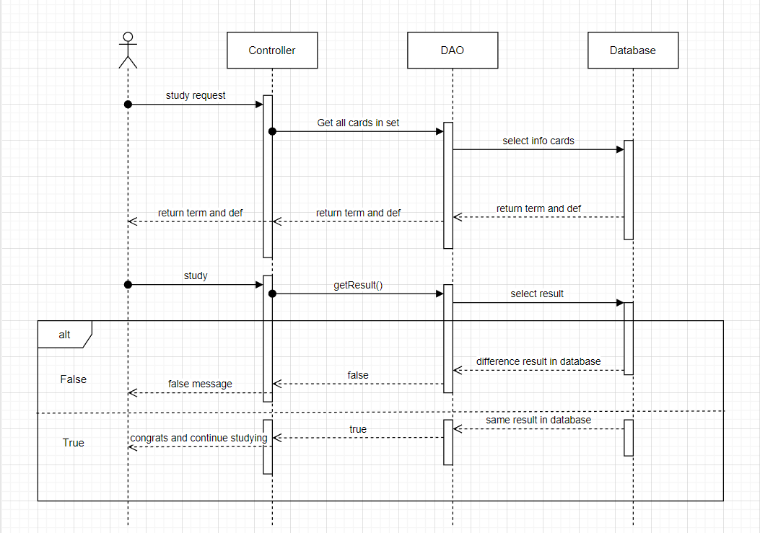

### d. Database Queries

*String sql = "SELECT [studySetId]\n"*

*+ " ,[title]\n"*

*+ " ,[description]\n"*

*+ " ,[isShare]\n"*

*+ " ,[userId]\n"*

*+ " FROM [dbo].[StudySet]\n"*

*+ " WHERE studySetId=?";*

*String sql = "SELECT [cardId]\n"*

*+ " ,[term]\n"*

*+ " ,[definition]\n"*

*+ " ,[studySetId]\n"*

*+ " FROM [dbo].[Card]\n"*

*+ " WHERE studySetID=?";*

*String sql = "SELECT [userId]\n"*

*+ " ,[cardId]\n"*

*+ " FROM [dbo].[FlashCards]"*

*+ " WHERE studySetId = ? and userId = ?";*

## 24. Test

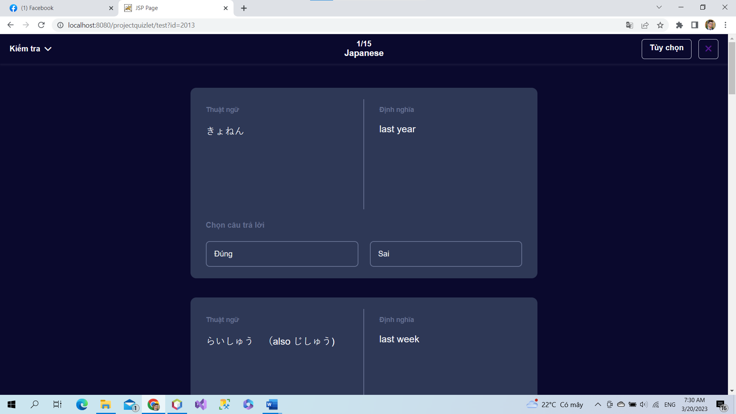

When user create a test, system will present random 10 questions to do. User will do test by multiple choice. When user finish doing test, system can return mark of test and user can test again or study again.

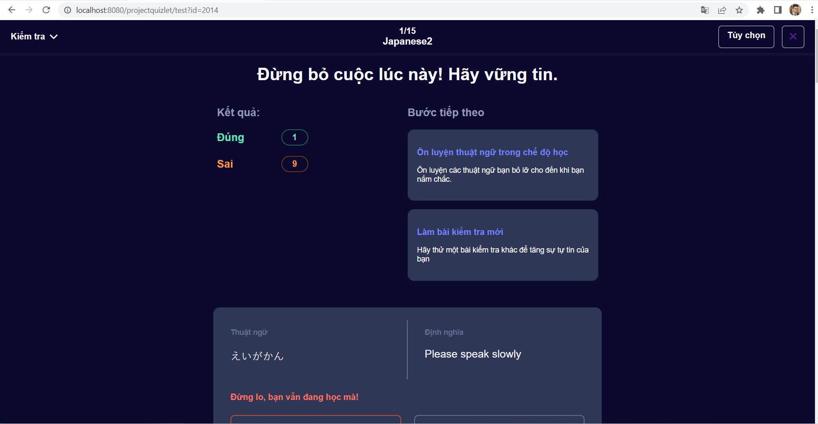

### a. Class Diagram

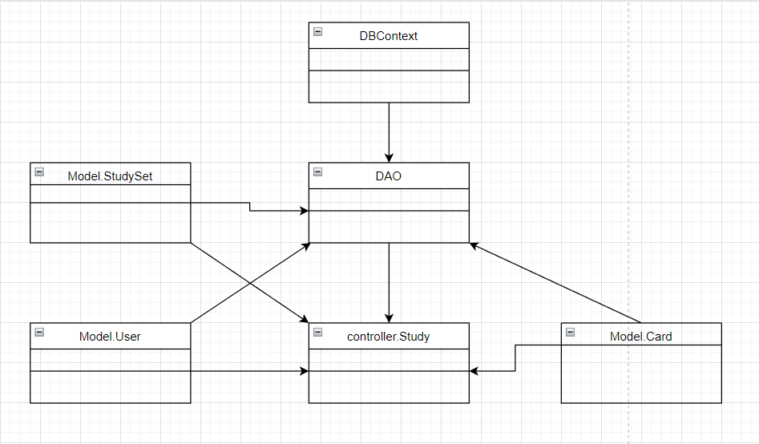

### b. Class Specifications

### User Class

|  |  |  |
| --- | --- | --- |
| **No** | **Method** | **Description** |
| *01* | *User(){}* | Default constructor |
| *02* | *User(….){}* | *Parameterized constructor* |
| *03* | *getName(){}* | *Getter of Name* |
| *04* | *setName(string name){}* | *Setter of Name* |
| *05* | *getPass(){}* | *Getter of Pass* |
| *06* | *setPass(string pass){}* | *Setter of Pass* |
| *07* | *getEmail(){}* | *Getter email* |
| *08* | *setEmail(string email){}* | *Setter of email* |
| *09* | *isIsActive(){}* | *Getter of isActive* |
| *10* | *setIsActive(Boolean isActive){}* | *Setter of isActive* |
| *11* | *getAvatar(){}* | *Getter of avatar* |
| *12* | *setAvatar(string avatar)* | *Setter of avatar* |
| *13* | *getLanguage(){}* | *Getter of language* |
| *14* | *setLanguage(string language){}* | *Setter of language* |

#### DBContext Class

|  |  |  |
| --- | --- | --- |
| **No** | **Method** | **Description** |
| *01* | *DBContext(){}* | *Connect to database* |

#### Test controller Class

|  |  |  |
| --- | --- | --- |
| **No** | **Method** | **Description** |
| *01* | *doGet(){}* | *Get all Cards to study* |

#### DAO Class

|  |  |  |
| --- | --- | --- |
| **No** | **Method** | **Description** |
| *01* | *Active account(string email){}* | *Update is active in database* |

#### StudySet Class

|  |  |  |
| --- | --- | --- |
| **No** | **Method** | **Description** |
| *01* | *StudySet() {)* | *Default Constructor* |
| *02* | *StudySet(){.....}* | *Parameterized constructor* |
| *03* | *getId(){}* | *getter of StudySetId* |
| *04* | *setId(int id){}* | *setter of StudySetId* |
| *05* | *getTitle(){}* | *getter of Title* |
| *06* | *setTitle(string title){}* | *setter of Title* |
| *07* | *getDescription(){}* | *getter of Description* |
| *08* | *setDescription(string Description){}* | *setter of Description* |
| *09* | *isIsShare() {}* | *getter of isShare* |
| *10* | *setIsShare(boolean isShare) { }* | *setter of isShare* |
| *11* | *getUserId() { }* | *getter of UserId* |
| *12* | *setUserId(int userId) { }* | *setter of UserId* |
| *13* | *getNumberCard() {}* | *get number flashcard in studyset* |
| *14* | *String getAuthor() {}* | *get name of User created studyset* |

### Card Class

|  |  |  |
| --- | --- | --- |
| **No** | **Method** | **Description** |
| *01* | *Card() {)* | *Default Constructor* |
| *02* | *Card(){.....}* | *Parameterized constructor* |
| *03* | *getId(){}* | *getter of CardId* |
| *04* | *setId(int id){}* | *setter of CardId* |
| *05* | *getTerm(){}* | *getter of Term* |
| *06* | *setTerm(string term){}* | *setter of Term* |
| *07* | *getDefinition(){}* | *getter of Definition* |
| *08* | *setDefinition(string Definition){}* | *setter of Definition* |
| *09* | *getStudySetId() { }* | *getter of StudySetId* |
| *10* | *setStudySetId(int studySetId) { }* | *setter of StudySetId* |

### c. Sequence Diagram(s)

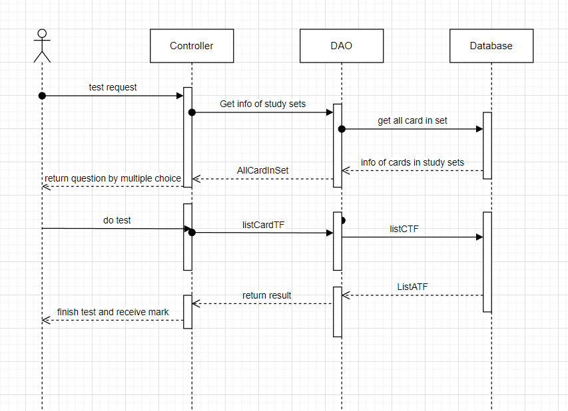

### d. Database Queries

*String sql = "SELECT [cardId]\n"*

*+ " ,[term]\n"*

*+ " ,[definition]\n"*

*+ " ,[studySetId]\n"*

*+ " FROM [dbo].[Card]\n"*

*+ " WHERE studySetID=?";*

String sql = "SELECT [cardId]\n"

+ " ,[term]\n"

+ " ,[definition]\n"

+ " ,[studySetId]\n"

+ " FROM [dbo].[Card]\n"

+ " WHERE studySetID=?";